RCH Pancake 25th Year
AT ROTARY CLUB OF HARRISBURG FLIPPIN’ CAKES MAKES HISTORY AND HELPS HARRISBURG STUDENTS SUCCEED
The ingredients are:
- A dedicated Rotary Club of Harrisburg (RCH) to the promise of Service Above Self
- Between 60 and 70 RCH pancake flippers, servers and all-around supporters
- Harrisburg School District students needing a steady home, weekend meals and/or need-based college scholarships or dictionaries
- A supportive Harrisburg School District (HSD) Administration including the Superintendent and kitchen staff
- An excellent kitchen and dinning facility at Harrisburg High
- HSC Homecoming, student talent, the school band
Mix these ingredients carefully with a highly experienced leadership team from RCH and you get 25 years…that’s 25 years… of Pancake Breakfast Successes!
Past President Karen Paris states, “ In 1997 when I was President, our Club had little in the way of community service projects. I felt strongly that we should better fulfill the community service lane of Rotary and at the Rotary President Elect Training Session (PETS), I heard that Pancake Breakfasts were popular.
Naively, I figured it couldn't be TOO hard to start such an event in our Club. Actually, many members were very enthusiastic. We teamed up with Lottsville Neighbors and the Fifth Street United Methodist Church and that Fall our Club held our First Pancake Breakfast. It continues to garner lots of participation by our members as well as supporting our community.”

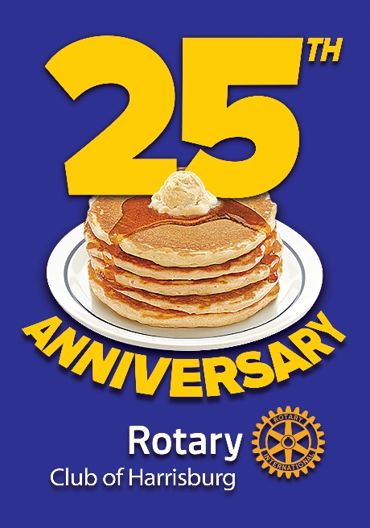

To celebrate the November 2023 success, Past President Andy Rebuck as one of this events major planners said, “We held a super nice celebration of our 25th pancake breakfast and were honored to have our District Governor Fredderick J. Gellert attend.” During that celebration, the School Superintendent, Eric Turman, accepted a $15,000 dollar support check for the School Foundation dedicated to help homeless students. Further funds will fund several outreach efforts for HSD students.

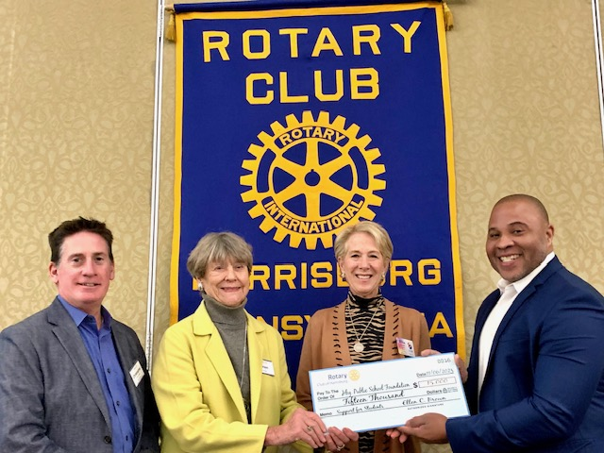
Chris Baldridge, Executive Director and Marion Alexander, Board Chair of the Harrisburg Public Schools Foundation and RCH President Ellen present a $15,000 check from the 25th Annual Pancake Breakfast proceeds to Mr. Eric Turman, Superintendent of the Harrisburg School District.

Celebrating another milestone, RCH members Karen Paris and Marion Alexander continued their powerful planning as Cheerleaders and Co-Chairs. To honor their incredible Service Above Self each received a commemorative bottle of maple syrup with the Rotary Club of Harrisburg’s 25th Pancake Breakfast anniversary logo.

Where do the proceeds go?

Following 25 years of pancake tradition, the proceeds from each years’ event are donated directly to the school district with the aim of supporting students.

The pancake breakfast has always been the annual events that engages the largest number of RCH members and, very often, members of their family…young and older. According to Rebuck, “By my count this year we had sixty-six members participating as pancake flippers, sausage baking, coffee brewers and servers.

RCH Members Pitch in Their Time and Donations

Each year RCH members are asked to pre-purchase a number of tickets that can be used by them or returned to the planning committee as donations for those needing tickets. Names of those members who make donations in 2023 were entered were entered into a drawing XX number of names were offered to have personalized billboards around town courtesy of Lamar Advertising’s General Manager…yes…our own Andy Rebuck. Ten of these superstars were drawn from the hat of sixty-six names and are being featured on area billboards.

Winners this year included:

Samara Scott, Frank Frailey, Ted Reese, Heather Eyster, Cheri Comasco and Exchange Student Manuel, Vlad Beaufils, Dan Zalewski, Mike Eby.

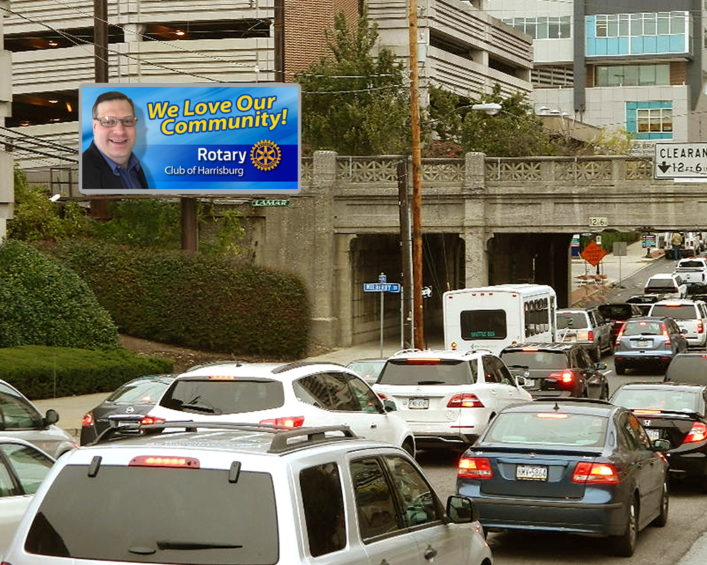

In 2023 Major RCH Donors and Advertisers Broke Records

A record level of support from sponsors exceeded $30.000. Top donor was UPMC at $5,000, TFEC at $2,500, United Concordia, R.E. Jones, Goodwill, DAZA, RCH member Peggy Grove, Sutliff VW, RKL, Patriot News, Parthemore Funeral Home, RCH member Wendell Hover, Heim Electric, Past President Sam Levin of Red Door, Harrisburg Public Schools, Mid Penn Bank, Homeland, RCH member Matt Tenny, Hilton Hotel, HCP, Reynolds Restore, Capital Blue Cross, Belco Community Credit Union, RCH member Connie Siegel and Harrisburg Pharmacy at $500 each.

Now What Happens for 2024?

When Rebuck was asked what it feels like to have celebrated the Big 25th, “I’m looking forward to RCH Pancake Breakfast Number 26 as we continue to live the Rotary motto of Service Above Self.” As you might expect, planning for the 26th has already begun and RCH members again will be asked to “save the date” and consider volunteering for the numerous activities needed to make the next one even bigger.

According to Alexander, “The pancake breakfast is the best way to work with your fellow Rotarians, have fun, really get to know each other, and be part of a team to raise money for a great cause. Please join us. Let’s make the 26th breakfast the best ever.

Contact Karen Paris, pariskmp@gmail.com or 717-566-0572 or Marion Alexander, mcalex3029@aim.com or 717-317-9902 to express your interest.

