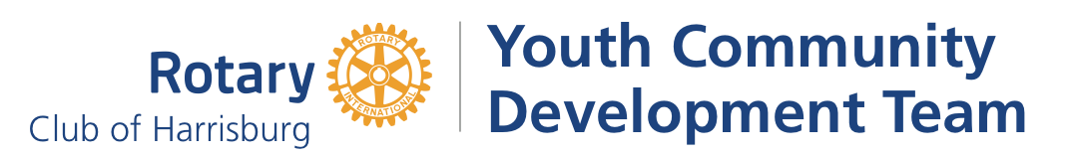

Youth Community Development Team Request for Proposal
Thank you for applying to the Rotary of Harrisburg’s Youth Community Development Team (YCDT) Request for Proposal (RFP). Each year, this youth driven grant opportunity awards $5,000 to address a community need as determined by the YCDT team.

COMMUNITY NEED
After considerable deliberation the YCDT seeks proposals that directly address the following community need:
Mental health services and supports being provided to residents of Dauphin County within Dauphin County
A preference will be given to organizations providing services and supports to individuals under the age of 25 years old

APPLICANT PROFILE
Applicant Organization Name
Click or tap here to enter text.
Provide your organization’s name as currently recognized by the IRS

Name, Title, Email, Phone of Executive Leader
Click or tap here to enter text.
Click or tap here to enter text.
Click or tap here to enter text.
Click or tap here to enter text.
All contracts and notifications of grant status will be addressed to the individual provided here

Applicant Organization’s Physical Address
Click or tap here to enter text.

Applicant Organization’s Address for Mailed Communications (if different from physical address)
Click or tap here to enter text.

Name, Title, Email, Phone of Contact Completing Application (If different from Executive Leader)
Click or tap here to enter text.
Click or tap here to enter text.
Click or tap here to enter text.
Click or tap here to enter text.
If application questions arise, this individual will be contacted by Rotary

Counties to be served as part of project; check all that apply
☐ Cumberland ☐ Dauphin ☐ Perry ☐ Other_______________________

NONPROFIT ORGANIZATION
This grant opportunity is available to a 501c3 nonprofit organization. Does your organization meet this expectation?
☐ Yes ☐No EIN # Click or tap here to enter text.
ACCESS & INCLUSION
The Rotary Club of Harrisburg fosters a climate of purposeful inclusion that values diversity of gender, age, race, ethnicity, national origin, range of abilities, sexual orientation, and socio-economic status. We anticipate that all organizations or programs/projects supported by grant funds will be made accessible to all individuals who qualify for participation. Does your organization meet this expectation?
☐ Yes ☐No

INTERVIEW
After the review of your RFP, and before money is allocated, applicants must be willing to be interviewed by the YCDT youth as part of the decision-making process. Is your organization willing to be interviewed as part of this grant application?
☐ Yes ☐No

NARRATIVE & ATTACHMENTS
The YCDT seeks a clear plan of action to directly address an identified community need. Answer the following in a few brief paragraphs; type into the provided fields.

State how you will provide mental health services and supports to residents of Dauphin County under the age of 25 years. Please indicate the program or method you will use and if this is a new or existing program. How will you know if you are successful? Please detail volunteer opportunities available to the YCDT youth via your program.

Click or tap here to enter text.

- Please include or attach a budget indicating how the $5,000 will be spent, should funds be awarded.

Click or tap here to enter text.

- Please indicate any additional information you deem relevant that the review committee should take into consideration when reviewing your grant application.

Click or tap here to enter text.

REQUIRED ATTACHMENTS
- Budget for the ($5,000); if provided as an attachment see Question 2
- 501c3 determination letter

SUBMISSION
Email your complete Youth Community Development Team Request for Proposal and Required Attachment(s) to info@hbgrotary.org. Email Addeline Alaniz Edwards, Executive Director, Rotary of Harrisburg at addeline@hbgrotary.org with any questions.

