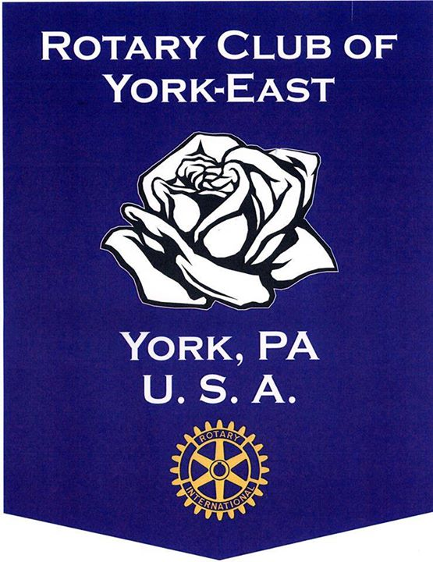

Welcome
Packet

Chartered in 1987, the Rotary Club of York-East is a proud member of District 7390. Our 70+ members personify the definition of service. Rotary has so many characteristics and activities that it is difficult to define. It is a service club, a fellowship, an international organization, a classification of vocation and professions, the development of goodwill and world understanding, the use of high ethical standards, and a concern for the welfare of others. The Board of Rotary International in 1976 drafted and adopted the following definition of Rotary:
“Rotary is an organization of business and professional persons united worldwide who provide humanitarian service, encourage high ethical standards in all vocations, and help build goodwill and peace in the world.”
These thirty-one words define Rotary in an easy to remember, succinct manner and make us proud to be a part of the world of Rotary.
Some of our many local projects include:
- Serving lunches at Our Daily Bread
- Annual “Day of Service” including cleaning roadways and the Gold Star Garden
- Supporting local non-profits with the York-East Rotary Golf Tournament
- Providing scholarships to the outstanding students in York Suburban and York County School of Technology
- Helping the needy at the Catholic Harvest Food Pantry
Our club works very closely with the Rotary Foundation to establish connections all over the world. Many of our Rotarians have selflessly given their time and talents by traveling on mission trips and serving numerous countries with medical aid and more.

General Information
As a Rotarian, you are encouraged to attend weekly meetings. Heritage Hills (2700 Mount Rose Ave, York, Pa 17402) hosts a breakfast meeting every Tuesday at 7:30am. There will be a small sign directing the club members where we will be meeting every week. This sign is placed at the median of the entrance of Heritage Hills. The rooms available are the Terrace Room (detached round building to the right of the parking lot), the Links Center (lower level meeting room to the left side of the parking lot, at the salon entrance) and the ballroom (straight in the parking lot, building to the left). During our weekly meetings we will have a guest speaker. All Rotarians are reminded to turn cell phones to silent during these presentations.

All information pertaining to the club can be found on our website or on Facebook: https://portal.clubrunner.ca/6535 YorkEastRotary Facebook page

Our 2020 - 2021 board consists of the following people:
President – Kyle King
President Elect – Sandi Graham
Vice President – Sheri Stamm
Treasurer – Diane Yocum
Secretary – Betsy Buckingham
Immediate Past President – Hunter Mink
Membership Chair – Sandi Graham
Public Relations Chair – Tim Koller
Club Administration Chair – Bill Gierasch, Jr.
Club Service Chair – Greg Kern
Fundraising & Giving Chair – Becky Kroft
Foundation Chair – Linda Gorter
Vocational Chair – Bon Straw
Sergeant at Arms – Ben Marchant
Members at large – Chris Beck, Angie Hartman, Chris Izzo, Ben Marchant and Kris Pollick

Our hope for each Rotarian is to be as involved with the Club as possible. We have strong ties to our community and would like to maintain these relationships by keeping a constant presence around the East York area. There are many opportunities for all members to participate in the wonderful programs our club offers. The following is a list of the committees that our club offers. Each has a unique purpose and together, they make our club what it has become today.
Committees

Membership: Chair – Sandi Graham
sgraham@progressiveleadership.net
Reviews all applications, welcomes new members and continues to recruit new faces to our club.

Public Relations: Chair – Tim Koller
tlkoller@comcast.net
A great opportunity to LEARN about York East Rotary and the many ways our membership interacts with our local community as a reflection of the values, traditions and purposes of Rotary International.
Like any good Public Relations effort, Committee members quickly learn about Rotary International, the organization of our local Club, our members, our various outreach projects, programs and activities, and the stated purposes of our Club and members. The purpose of our Committee is to "get the word out" about our Club, about Rotary International and our many projects, activities, weekly meetings and guest speakers. While much of our effort provides information to others on the outside, the Public Relations Committee also provides useful information to Club members through our website and facebook page.
One need not be an expert at PR. This is an opportunity to learn about Public Relations by and through our diverse efforts to communicate with others through Press Releases, Photo Journalism and the newest trends in Social Media. Along the way, you'll be learning all about our Club, our members and our activities.

Club Administration: Chair – Bill Gierasch, Jr.
bill.gierasch@verizon.net
Liaison between hotel for weekly meetings and also between the Club and the District, recruiter for officers and board members & coordinator for weekly speakers.
Club Service: Chair – Greg Kern
gkern@shilohlandscape.com
Coordinates all service projects and continuously looks for new ways for our club to help the community.
Fundraising & Giving: Chair – Becky Kroft
bkroft@pawv.wish.org
Organizes the annual golf tournament and other fundraisers that benefit the club and local charities.
Foundation: Chair – Linda Gorter
lgorter@bbbsyorkadams.org
Works directly with the Rotary Foundation to raise money for our mission of service and completes our grant applications.
Vocational Services: Chair – Bob Straw
strawcem@aol.com
Works directly with York Suburban and York County School of Technology to select candidates for our “Student of the Month” Program and RYLA Program. Also organizes the “Group Vocational Service Exchange” and the foreign exchange students.

Weekly Job Duties
Rotating schedule will be listed in newsletter and announced in emails

Greeter: (2 per meeting) Arrives at 7am - Welcomes all attendees, hands out badges, checks in Rotarians and guests, sells 50/50 tickets and distributes winning money
Invocator: Gives short prayer, inspirational quote or poem. See non-denominational samples at:
https://clubrunner.blob.core.windows.net/00000002837/en-us/files/homepage/invocations/Sample-Invocations.pdf

Our service projects
Our Daily Bread Soup Kitchen (6 volunteers) Catholic Harvest Food Pantry (5 volunteers)
Coordinator: Wendy Keesee Coordinator: Kris Pollick
331 S George St., York, PA 17405 628 E. Market St., York, PA 17403
5th Tuesday of the month: 10:45am – 12:15pm 5th Monday of the month: 6pm – 8pm

My Club:
My mentor’s name: ____________________________________________________________
Mentor’s phone number: ________________________________________________________
My notes: ____________________________________________________________________








