Literacy Project
Rotary Club of Antigua Sundown together with the Rotary Club of Bethlehem Morning Star in Bethlehem Pennsylvania, were able to get a Reading Specialist Dr Matz to visit and make preliminary assessments on three primary schools in Antigua.
Dr. Matz identified that there were weaknesses in phoneme development and would be willing to train the Reading and Kindergarten Teachers. The Clubs have partnered to purchase the Heggerty Curriculums for the Schools, and this will be used in conjunction with the Jolly Phonic program to aid the kindergarten students in letter sound development.
The training materials were presented on October 8, 2022. The Teachers were trained virtually by the Reading Specialist on October 12&13.
Principal Christian believes “A project like this is exactly what Green Bay Primary needs, we will accept whatever help we can get in the area of reading and literacy.”
President Nircree “This project is a gentle giant; its impact is far reaching. Green Bay Primary is our pilot school, once the assessments proves that it is working, we plan to approach the Villa and Golden Grove primary schools. We will not stop until we have assisted every Government primary school in the nation of Antigua & Barbuda”
Pictures: Below is a presentation of the Heggerty Curriculum to Green Bay Primary School.

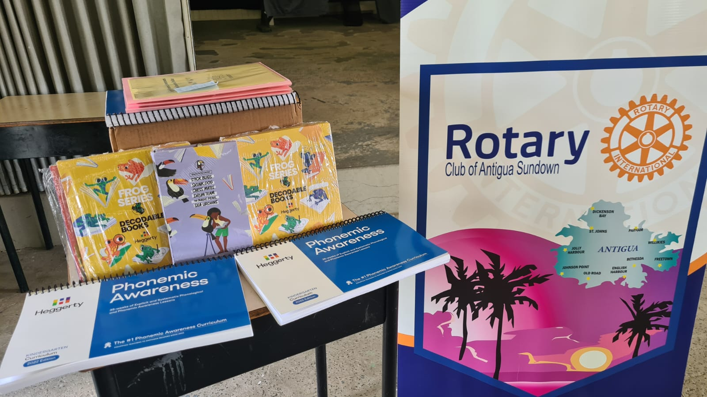
Pictured Above: The Heggerty Phonemic Awareness Curriculums
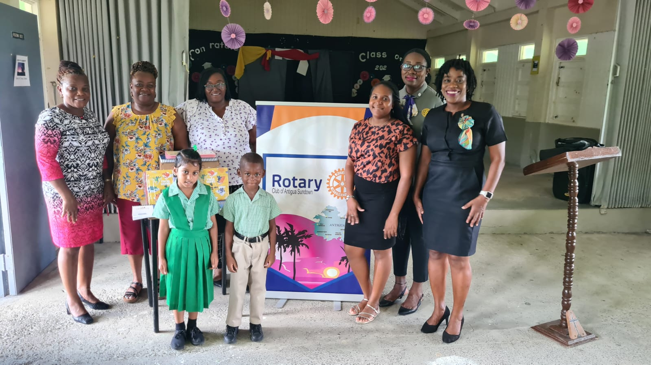
Pictured Above from Left to Right: Principal Christian, Ms. Pelle, Ms Goodwin, 2 Kindergarten Students of Green Bay Primary, Past President Rotaract Club of Antigua Rickisha Terry, Assistant Governor Evangeline Allen; President Nircree Mills-Jno Baptiste

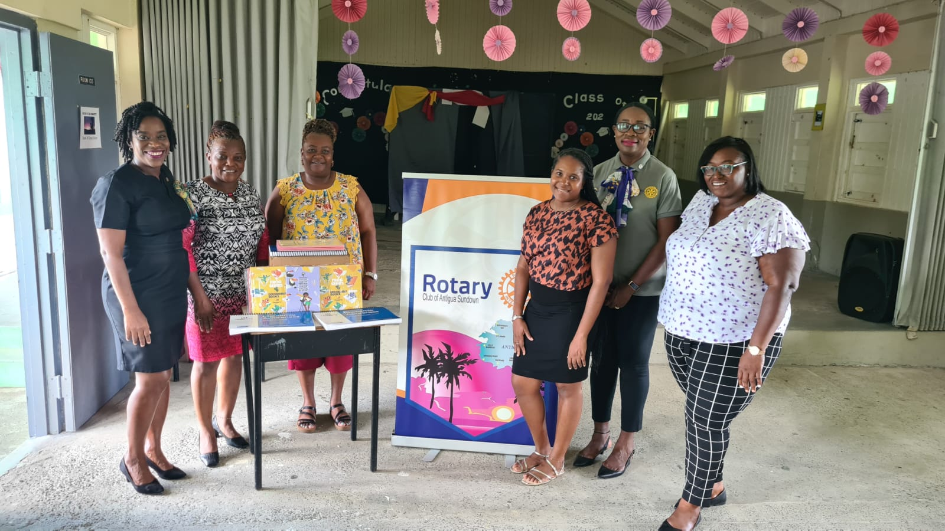Pictured Above from Left to Right: President Nircree Mills-Jno Baptiste, Principal Christian, Ms. Pelle,Past President Rotaract Club of Antigua Rickisha Terry, Assistant Governor Evangeline Allen; Ms. Goodwin

