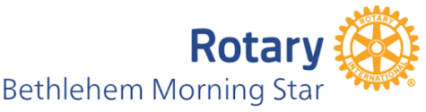

Morning Star Rotary Scholarship in memory of Ben Tenaglia

ABOUT Ben Tenaglia: Ben Tenaglia was a proud 3rd generation Rotarian who followed Rotary’s motto “Service Above Self.” He participated in Rotary Club service projects and fundraising and served the Bethlehem community as a school board member, trustee, and treasurer; board member of the BAEF; and treasurer for the Bethlehem Boy Scouts of America. Ben was a proud Navy veteran and a graduate of the US Naval Academy and Villanova University, working in the finance and investment fields.

CRITERIA: Eligibility is limited to qualifying high school seniors who are students at Freedom High School. Students must exemplify the Rotary principle of “Service Above Self,” being defined as “unselfish leadership and performance in academic, athletic, religious and community activities and all other relevant school extracurricular activities.” In addition, the recipient must be entering a college program majoring in education.

AMOUNT: One Scholarship of $1,000.00 will be awarded.

QUESTIONS: Jennifer Cunningham, Youth Services Chairperson, Bethlehem Morning Star Rotary RotaryJBL29@gmail.com

APPLICANTS: Submit a college acceptance letter and an 100-150 word paragraph about why you’re choosing to study Education to Autumn Edwards : aedwards@basdschools.org

