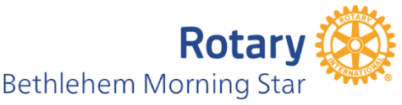

Morning Star Rotary Scholarship

in memory of Ronald C. Searfoss

ABOUT Ron Searfoss: Ron Searfoss endlessly served his community as a Rotarian, including as Bethlehem Morning Star Rotary Club’s past president and chair of the Salute the Troops concert. He was also a volunteer Santa Claus, a youth sports coach, a Mason, a member of Porsche Club of America’s Riesentöter region, and a Green Bay Packers owner. He worked as a CPA, corporate controller, entrepreneur, non-profit financial manager, and college professor, and served his country in the US National Guard.

CRITERIA: Qualified students for scholarship must exemplify the Rotary principle of “Service Above Self,” by demonstrating exemplary humanitarian service in their school, religious, and/or community activities with an emphasis on personal volunteer efforts and active involvement in
helping others.

AMOUNT: One Scholarship of $1,000.00 will be awarded.

QUESTIONS: Jennifer Cunningham, Youth Services Chairperson, Bethlehem Morning Star Rotary RotaryJBL29@gmail.com

APPLICANTS: Submit a college acceptance letter and an 100-150 word paragraph about why you care about community service to Autumn Edwards : aedwards@basdschools.org

