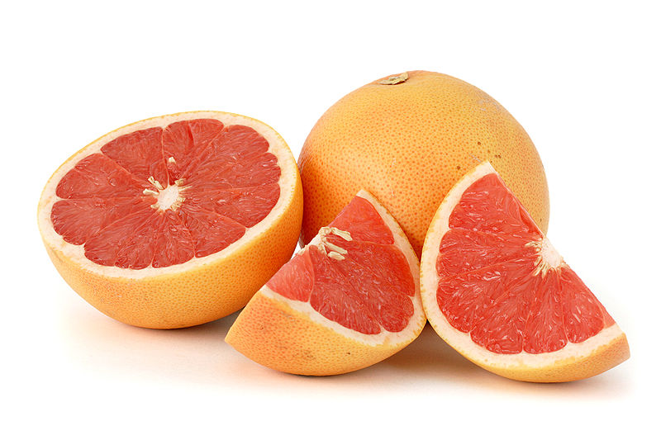
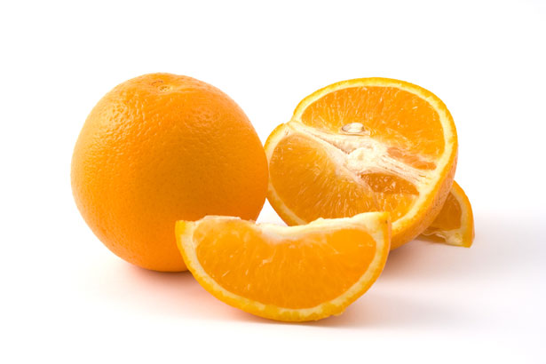

ANNUAL HOLIDAY CITRUS SALE 2015

Exceptional fresh fruit from Texas! Choose from sweet oranges or grapefruit

Ruby Red Grapefruit, 20 lb. Box……………$20.00
Navel Oranges, 20 lb. Box………………….. $20.00

PLACE ORDERS no later than: NOVEMBER 20th, 2015
(see order form below) PRE PAYMENT REQUIRED

PICK UP ORDER at Clyde S. Walton warehouse / 400 S. Broad St Lansdale, PA on Saturday, December 12th 8am – 12pm

Questions? Call Sam Dugan 215-230-2876
email: samuel.dugan@wellsfargoadvisors.com

*************************************************
DETACH AND USE THIS ORDER FORM
Date: ________________________

Name of Purchaser:________________________________________

Address: _______________________________________ Phone: _____________________

Ordering: _______boxes of Ruby Red Grapefruit @ $20.00 per box $ _______________
______ boxes of Navel Oranges @ $20.00 per box $ _______________

Total Amount Enclosed $ _______________

Payment is required with the order. Checks shall be made payable to the Rotary Club of North Penn. To assure delivery, submit orders with payment by November 20th

TO: Sam Dugan, 143 Pinecrest Lane, Lansdale, PA 19446

