Sunday, July 3, 2016

Rotary Volunteers Help Drive Walking School Bus

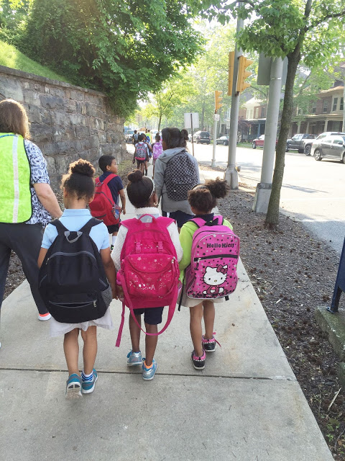
The Pottstown Rotary Club stepped up with several other local organizations to provide volunteers for the Walking School Bus program sponsored by the Pottstown School District during the 2015-2016 school year at Rupert Elementary School.
The Walking Bus became a reality in 2015 after the Pottstown School District took the position that encouraging more students to walk to school could reduce absenteeism and tardiness, increase fitness, reduce vehicle congestion at the school, and perhaps trade some of that endless young energy for a readiness to learn.
After promotion of the program to parents and kids, and design of the “safe” routes to Rupert Elementary which varied from 1 to 1.5 miles, the remaining critical need was for the bus ‘drivers”.
That’s where Brooke Martin of the Pottstown Rotary Club came in with about five of her colleagues, to be part of the total of 40 volunteers eventually signed on individually or from the other eight local participating organizations and employers.
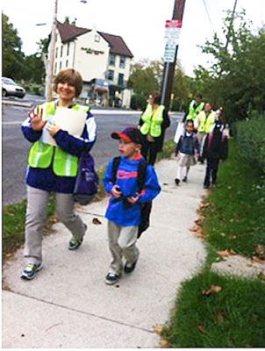
Each week over the length of the school year, rain or shine, anywhere from 3 to 6 Rotary members would meet their early morning ‘passengers’ on their assigned route to school.
Most members walked one day a week, some more, all were available as substitutes, and all were at least as excited about snow-days as the kids. The shortest route with just a couple of kids only needed two volunteers each day; the longer route with 20 kids enrolled usually needed four volunteers.
Adding up three routes on five days for 25 weeks brought the total trip length to 425 miles that were covered over the duration of the Walking School Bus program.
Two of those Rotary members have bragging rights for being present for 50 of those miles, in a new definition of community service.
A Rotary goal in the coming school year is to expand its involvement with this worthwhile program.
The mission of Rotary is to provide service to others, promote integrity, and advance world understanding, goodwill, and peace through its fellowship of business, professional, and community leaders.
The Pottstown Rotary is committed to working both globally and locally.

