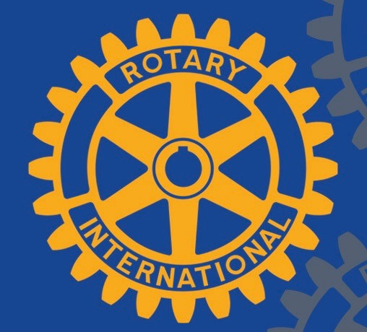
NEWS RELEASE
NH Seacoast Rotary Clubs
Dover . Durham-Great Bay . Exeter . Hampton . Portsmouth/Seacoast . Rochester

Date: May 13, 2019
Contact: Noreen Biehl, President, Rotary Club of Dover, NH
noreen.biehl@yahoo.com

Dover, Durham-Great Bay & Rochester Rotaries present a “Recovery with Hope and Dignity” educational forum on June 3
An educational forum will be held on June 3, 2019 at Wentworth-Douglass Hospital, Garrison Wing Auditorium, 6-8 p.m. to further awareness of the opioid epidemic and substance use disorders.
Sponsored by N.H. Seacoast Rotary Clubs, this is the fourth Recovery with Hope and Dignity educational forum to highlight N.H.’s new hub and spoke system of care for people suffering with substance use disorders. The forums are designed to discuss treatment and recovery options and educate attendees on how they may one day save a life.
The June 3rd forum will feature five presenters:
Peter Fifield, Licensed Clinical Mental Health Counselor, Master Licensed Alcohol and Drug Counselor from Dover’s Doorway-NH, will discuss NH’s nine-hub system to provide screening, evaluation, treatment, and connection to community resources.
Leah Rothchild, a recovery coach, will tell her personal and passionate story of addiction and her road to recovery; Kennebunk, ME Police Chief & Rotarian Robert MacKenszie will focus on the costs and challenges of the epidemic and the role of International Rotary in disease prevention.
John Burns, Director of SOS Recovery Community Centers and a person in long term recovery, will discuss his role as a volunteer and advocate in the community with a focus on prevention, treatment, recovery and harm-reduction.
Jim and Jeannie Moser will also speak about their personal campaign, Zero Left, to safely dispose of unused prescription drugs from medicine cabinets to reduce the opportunity for harm. The Mosers are the parents of Adam Moser, who was only 27 when he died from a fentanyl overdose in 2015.
There is no charge to attend.
Recovery with Hope and Dignity forums were recently held in Exeter, Portsmouth and Hampton as part of wider initiatives sponsored by Rotary District 7780 to save lives and reduce the stigma associated with substance use disorder.

About Rotary
Rotary is a global network of 1.2 million neighbors, friends, leaders, and problem-solvers who see a world where people unite and take action to create lasting change – across the globe, in our communities, and in ourselves.
Solving real problems takes real commitment and vision. For more than 110 years, Rotary's people of action have used their passion, energy, and intelligence to take action on sustainable projects. From literacy and peace to water and health, we are always working to better our world, and we stay committed to the end. Rotary members believe that we have a shared responsibility to take action on our world’s most persistent issues. Our 35,000 clubs work together to: Promote peace, Fight disease, Provide clean water, sanitation, and hygiene, Save mothers and children, Support education and Grow local economies.

###

