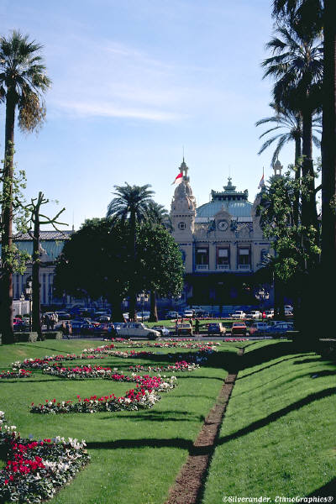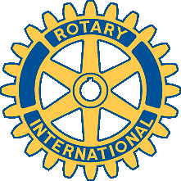

**Tickets $85 Black Tie Optional**

**Price includes Unlimited Buffet & One Free Drink**

**Free Parking**

[**Click Here to Buy Tickets Online**](https://www.eventbrite.com/e/18th-annual-rotary-clubs-of-northern-virginia-monte-carlo-night-2015-tickets-18164449357)

***Gaming with Prizes!***

***Blackjack, Roulette, Craps &***

***Texas Hold-em, Poker***

***Live Entertainment & Dancing***

***The Loudoun Jazz Ensemble***

***International Food Stations***

***Silent Auction***

***Live Auction with Once in a Lifetime Travel Opportunities***

***to benefit Educational and Civic Programs***

***A portion of the proceeds will support Rotary International’s Program to eliminate Polio worldwide***

**For information on Tickets, Auction Donations, and Sponsorships, contact:**

**Burt Heacock**

**Tysons Rotary Club**

**(703) 442-0500 x225**

**burt@paul-tittle.com**

**November 6, 2015**

**6:30 to 11:00 p.m.**

**Fairview Park Marriott**

**3111 Fairview Park Drive**

**Falls Church, Virginia**

[**www.marriottfairviewpark.com**](http://www.marriottfairviewpark.com)

***Eighteenth Annual Rotary***

***Monte Carlo Night***