Plymouth Police Chief Honored with ‘Paul Harris Fellow Award’ by Rotary Club
City of Plymouth, MN Website - Posted Date: 7/15/2015
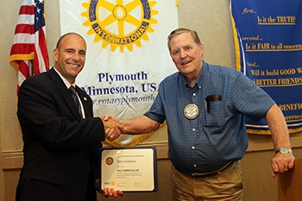
Plymouth Police Chief Mike Goldstein was recently presented the Paul Harris Fellow Award by the Rotary Club of Plymouth.
The Rotary Club of Plymouth selects two award winners annually – an outstanding member of the community and a current member of the club. Goldstein was chosen as an outstanding community member because of his service to Plymouth.
“Mike Goldstein was named a Paul Harris Fellow because of the support he’s given the Rotary Club and in honor of his new position as the Director of Public Safety, as well as his contribution to the community as the chief of police,” said Steve Beachler, immediate past-president of the Rotary Club of Plymouth.
Goldstein is an honorary member of the Rotary Club of Plymouth, as is Fire Chief Rick Kline and Mayor Kelli Slavik.
In order to recognize an individual as a Paul Harris Fellow, which began in 1957, Rotary clubs must make a contribution of at least $1,000 to the Rotary Foundation of Rotary International – in honor of the individual named. The Rotary Foundation raises funds for charitable causes including eradicating polio, promoting peace, providing clean water and supporting education.
“It’s a way for the club to donate money that can be used by Rotary International for a worthy project in the name of someone,” said Beachler.
The Rotary Club of Plymouth has named two Paul Harris Fellows each year for about two decades. This year’s honored club member was Norm Okerstrom for his involvement in Heart Safe CPR training. He helped provide CPR and AED training to about 3,000 people – earning the City of Plymouth the Heart Safe Community designation.
Notable previous Paul Harris Fellow Award winners include U.S. President Jimmy Carter, Mother Teresa, Russian President Boris Yeltsin, U.S. Astronaut James Lovell, UN Secretary-General Javier Perez de Cuellar and Polio Researcher Jonas Salk.
About the Rotary Club of Plymouth
Rotary is an organization of business and professional leaders united worldwide who provide humanitarian service, encourage high ethical standards in all vocations, and help build goodwill and peace in the world. The Rotary Club of Plymouth, chartered in 1978, meets for lunch at noon Thursdays at the Crowne Plaza, 3131 Campus Drive, Plymouth. In 201 countries worldwide, approximately 1.2 million Rotarians follow the theme "Service Above Self."

