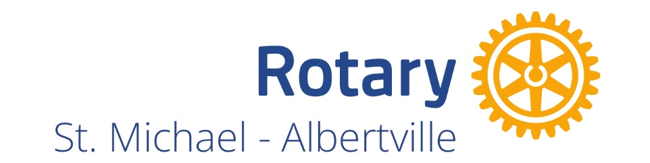
Application for Membership
“Service Before Self”

To be considered for membership in the St. Michael - Albertville Rotary Club, please provide as much of the following information as is possible:

Name
Home Address
Home Phone Number
Personal E-mail address
Business/Organization Name
Business Web Site
Your Business Title
Business Address
Work Phone Number
Work E-mail address
Mobile Phone Number
Previous Rotarian? Where?
Describe personal interest in STMA Rotary Club
Describe how you can contribute to the STMA Rotary Club

The St. Michael - Albertville Rotary Club meets most Tuesdays from 12-1pm at the Liberty Restaurant in St. Michael, MN.

Membership dues are $400/year, which includes Rotary District and International dues.

Should you have questions about this membership application, direct them to Kim Young kyoung@bravera.bank or 763-400-8950.

Please send your completed application to stmarotary@gmail.com

