Page 1
Pledge
Inspiration
Singing
Guests

Page 2
George's Musings
Recognition Raffle
Raffle
Rotarian of the Month

Page 3
Speaker

Page 4
Announcements

Pledge of Allegiance led by Princess Bea Seppi with a little help from her Father Will Seppi.

Inspiration
Presented by George Dutton, quoted Tom Brokaw,
"It's easy to make a buck, it's a lot harder to make a difference."

Singing
Our Musical Magician Doug Pile led the club in a seasonal rendition of Rudolph the Red Nosed Reindeer. He also told us next week he plans on singing Frosty the Snowman and the following White Christmas. He suggested we practice these songs at home and get into voice for the latter.

Guests
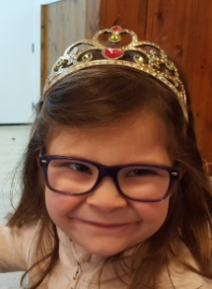
Princess Bea Seppi joined us
as her father's special guest.

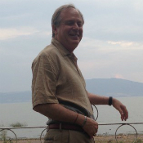

Howard Sapper joined us as a guest
speaker and guest of George Lawson.

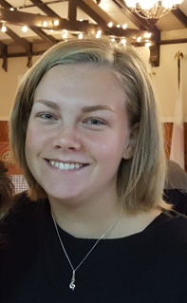

Betty Ottoson our visiting Exchange Student
from Sweden joined us as a guest.

George's Musings
George Dutton asked President Dan Erickson if he is getting ready for Christmas? Dan answered, "Not yet." George said, "Well you're a finance man, spent most of your career in finance? Dan replied "Well, the latter half, yes." George asked, "Did any of your clients ever ask you how Santa computes the value of the gifts in his sleigh?" Dan replied, "No. Actually I've never had that question asked." George informed Dan, "Santa values the gifts by determining the net present value (NPV) of each present."

Then George told a story about an older couple who had been together for many, many years and the wife is having more difficulty hearing him. The husband was concerned because communication is so important in everything. While visiting the family doctor he says to the doctor, "You know it's getting more and more difficult because my wife just can't hear, what should I do? The doctor said, "Well, why don't you try to determine at what distance your wife can hear, then we can come up with a solution. Here's what I want you to do. Go home and when you have a chance ask your wife a question from three or four different locations in the house. Then tell me how close you are when she can hear you." That evening when his wife is cooking dinner in the kitchen he goes to the entry way and yells out, "What's for dinner?" He hears nothing. Goes into the family room and yells, "What's for dinner?" hears no response. Goes into the kitchen gets almost right next to her yells, "What's for dinner?" She turns around and says, "For God's sake for the third time, spaghetti, meatballs and salad."

Recognition

Vince Dougherty's picture was recently featured in our local newspaper not wearing a Rotary Pin. He tried to blame it on his old friend Harry, a WWII veteran. Dan Erickson wasn't buying it. $50 toward Paul Harris.

Larry Mills was forced to admit he vacationed in Palm Springs last week with his son. His wife is having a birthday on the 9th and they just celebrated their 24th wedding anniversary. $50 toward his Paul Harris.

Shaun Shields tried to remember what he was doing on the 4th of December. He was playing with his dog. When he was asked about his birthday he said the dog didn't know it was his birthday. $100 toward his Paul Harris.

Brad Benson volunteered the fact that he has met the challenge made last Christmas by his kids to walk 10,000 steps a day. Since starting in March he has lost 20 pounds by just walking. Averages around 50 miles a week. Hasn't changed his diet. When he starts watching TV at the end of the day he checks to see how far he's walked and then goes out and walks until he meets his goal. $20 toward his Paul Harris.

Lance Cottrell volunteered that his house no longer smells like a campfire. His insurance company paid for a large crew to spend a week there cleaning everything. $25 toward his Paul Harris.

Will Seppi put a dollar for each year for his daughter princess Bea who will have her 5th birthday on Saturday.

Raffle,
The winning ticket number ended with 9541. George Lawson had the winning number. He dug in the bag but could not come up with the red nose quarter.

Rotarian of the Month
Dan Erickson presented the Rotarian of the Month pin to Terry Tremblay.

Speaker

Howard Sapper is a 40 year veteran executive of the music industry with extensive experience with brain therapy and related issues. He has been the CEO for Harmony Festival, Inc., Global Pacific Records, Inc. and is currently the President of Extrordinaire Media. He co-founded Global Pacific Records and Distributors in 1979 and owned Hawaii Artist Recording Studio from 1980 through 1998. He has acquired extensive experience in all aspects of the entertainment business from marketing, promotion, financial forecasting, as well as negotiating domestic and international recording licensing, distribution agreements and live concert and festival operations. He has had the honor of managing many internationally known artists and working with producers from around the world. Sapper's extensive production skills are visible in prerecorded music, live concerts and festivals, film and TV production.

Since 2014 he co-founded and is the Executive Director of Everybody Is A Star which provides opportunities for artistically gifted youth and young adults with special needs a medium to shine in an all live performance. As the father of a daughter who suffered a stroke at birth, Mr. Sapper, was initially drawn to the mission of Everybody Is A Star because of the amazing impact that music and art has had on her life. Since that time he has devoted over two decades towards research in brain therapy, medicine, and alternative treatments and the role of art, music and theatre as a therapeutic tool.

He started talking about the reasons he became involved in the Special Needs Community. He became involved . "...She can't do calculus but she can sing. Her science homework wasn't the best but she can dance." She found that through the neuro-pathways of art she was able to find a place in this world. Her senior project was to make music; song - she wanted to sing "Love Story" by Taylor Swift. School starts and they show up for the senior project and there is no mentor. He called the school to find out what was going on. He was told the Special Needs kids aren't really a part of the school they are just on our campus. He thought that was odd since their family did a lot to support the activities of the school. They basically told him to do it themselves. He and his wife got the binder and the day it was due her binder was ready. They presented it to her Special Ed Teacher. As the end of the school year approached his film client in LA asked what he was doing this weekend. Howard explained that he would be looking for a studio for his daughter to record "Love Story". His client said, "No, no, no. Bring her to LA." They drove to LA and when they arrived to the studio there were 4 cameras set up. The client said, "We are going to make a music video for Eva." They made the video which they put on YouTube and Facebook and it went viral nationally. All of a sudden media starts calling. They called the school and the Principal stared taking credit for the video by saying, "... when I saw the video the hair on my arms started standing up and that's the reason I went into education." He held the job for another 3 months.

The result is a spark went off in his client . Six weeks later he called and said, "I want to do for kids all across the country what we did for Eva. Can you help me?" He thought about how busy he was and immediately decided it was what he should do. They started by making one video at a time. They started with a couple of friends of Eva's. He visited the Giants as he was producing events for them, the Warriors and the As. He left his card and told them, "...this is great. I love doing this." 2 weeks later the Giants contacted him asking if he would like to do the Community Club House. This is an opportunity to sit behind home plate and present information to any who stop by. He also was able to arrange for 30 seconds on the scoreboard. His partner made a short promo video and they showed it. After the game this woman came running up to him with her daughter. She explained that her son has Cerebral Palsy and you need to meet my husband Patrick. Six weeks later he's at the Healdsburg Jazz Festival as Patrick's guest and he becomes Howard's business development director and he now produces live events for them. They do 3 events a year for the Giants, the Warrior's and the As. It is what they call Special Needs Family Appreciation Night. They bring about 40 special needs kids and do the National Anthem, they perform, and show their art. They've gone all over the country now. To Boson, Charlottesville VA, Los Angeles, and the Ashland Film Festival. Through this work they have been able to impact not only the children but their families.

He talked about a nine year old boy who is blind, speaks 5 languages, and the Warriors asked if he had one more place in his choir for this child. They did. His daughter took him under her wing. His mother said, "...my son is sort of talented." speaking about the nine year old boy. It turns out that he does Beethoven, Bach, and Lady Gaga and he "mosh" them together. He talked about a 36 year old man in Suisun who couldn't speak at all. At 16 a music teacher in Cincinnati showed him a few music chords. Three weeks later he came back after carving a piano out of a bar of soap and played Moonlight Sonata. The point was the talent was in this man but someone had to find the key to release it. What they are doing is creating circles. The first circle is within the family, then the circle is all the people they touch through social media, and third is the circle of all the families they work with connecting with each other.

Then he showed some of the videos he and his partner made. I recommend going to http://www.everybodystar.org to view them. It is amazing what these people can do.

Announcements

December 11, Healdsburg Literary Guild
Date: December 11
Time: 7:00 PM
Location: The Shed, 25 North Street, Healdsburg, CA
Cost: $20
Tom Pinney author of The City of Vines, his latest book. He has written many others including but not limited to A History of Wine. He will be talking about the wine industry in California. The wines of Carol Shelton will be featured at the event. Tickets available at Shed.com/tickets

For more information contact Ted Calvert at (707) 433-2211,

December 13 Club Meeting Location
Date: December 13
Time: 7:00 AM
Location: Rio Lindo Adventist Academy
3200 Rio Lindo Avenue
Healdsburg, CA 95448
Directions: Healdsburg Avenue to Bailache Avenue. Follow Bailache to the end and your destination. Turn left at the first stop sign and look for the flag pole in front of the Administration Building. The Library is in the Administration Building where we will initially meet . After the meeting we will adjourn to the auditorium where the music department will entertain us. Allow 15 to 20 minutes to drive to and park. Brad said there are no short cuts to the school.
It would be very helpful if you could RSVP with Brad Benson at (707) 695-8369.

Christmas Caroling
Date: December 13
Time: 4:30 PM
Location: Healdsburg Senior Living Community
725 Grove Street
Healdsburg, CA 95448
The plan is for our group to meet at HSLC between 4:30 and 5:00 p.m. on December 13th to practice (outside!) and determine our repertoire of Christmas carols. Then, promptly at 5:00 p.m. we will begin singing while the residents are being served and eating supper. We will sing at four different locations for 10 minutes each. Wear your Jester Hats.

Adopt a Family in Need

If you would like to help a family in need this Christmas Season contact Colleen Carmichael at Reach for Home at (707) 433-6161. Christmas is very challenging for these families. Colleen has a lot of information about what these people need.

Help Needed December 16.

Jay Beckwith knows a family who is being forced out of their apartment due to the high rents available because of the fire. This family needs to move about 4 blocks and needs able bodied people to help. If you can help contact Jay at 479 2554.

Community Band Concert
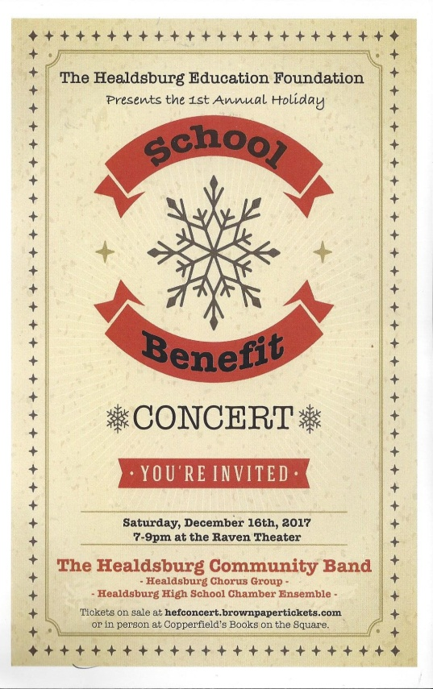

Contact Doug Pile at 953-1580.

Dark Days for Healdsburg Rotary Club Sunrise
The Rotary Club of Healdsburg Sunrise will be dark on December 27th in honor of Christmas.

District 5130 Ethics Seminar
Date: Saturday, January 6, 2018
Time: 9:00 AM to 3:00 PM
Location: China Village Restaurant
8501 Greenstein Highway, Cotati, CA.
Cost: $35 includes lunch

Who should attend: Rotary Club Presidents, Club and District RYLA, Interact, Rotaract, and Youth Exchange Chairs and Rotaract Officers.

Why Should You Attend: To help promote ethics in your RYLA, Interact, Rotaract, and Youth Exchange programs. The Ethics Initiative has created ethics modules, scenarios and surveys that help you introduce these topics into your youth based programs.

Why it started: A survey conducted by the Josephson Institute showed that 90 percent of youth proclaimed they were satisfied with their ethics and character. The survey went on and found that six of ten admitted they cheated on a test. Imagine nine out of ten thought they were ethical and yet 60% admitted to cheating.

What you will learn: How can Rotary better make The Four-Way Test come alive in its youth programs and Rotary Clubs.
For more Information or to Register Contact:
Keith Schoenthal, District Ethics Initiative Chair (Rotary Club of Rancho Cotati)
keithsrotary@gmail.com.

Rotary Friendship Exchange
Group being formed to visit France sometime in the April and May time frame. This is a great opportunity to see a foreign country from the native's view point. If you would like to participate contact Dan Erickson for more information.

Looking for a laptop
For presentations we have been using Shaun's business laptop. We would like to have our own for presentations. Often guest speakers come with a thumb drive ready to give a talk. If there is a virus or some other malware in the thumb drive it will be transferred to the host machine and it may be there without the owner's knowledge. If you have or know of someone who has an old laptop they would be willing to donate let Dan or Shaun know.

Buy In Dinner. Pacific Coast Air Museum
Date: Saturday, April 21, 2018
Time: 5:00 PM
Location: Pacific Coast Air Museum, 1 Air Museum Way, Santa Rosa, CA 95403
Cost: $100 per person. Includes tour of the museum and dinner with lots of wine.
Proceeds go to the Drew Esquivel Scholarship Fund. Questions should be directed to Andy Esquivel at (707) 433-4207 or by e-mail at andy@andyesquivel.com.

