2022 Rowell Ranch Rodeo Parade Art and Essay Winners Theme: Back in the Saddle Again!

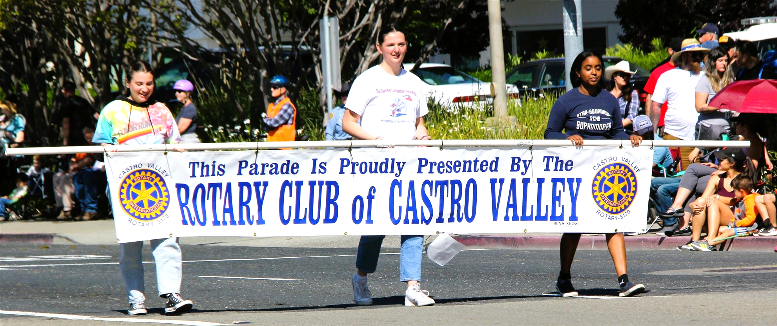

K-1st GRADE: ART

1st Place: Ariana Castaneda | Redwood Christian | 1st Grade
2nd Place: Sinai Sanders | Redwood Christian | 1st Grade
Honorable Mention: Jessa Fletcher | Redwood Christian | 1st Grade
Honorable Mention: Maxwell Busch | Redwood Christian | 1st Grade

2nd – 3rd GRADE ART

1st Place: Rajiv Jain | Proctor | 3rd Grade
2nd Place: Olivia Trimiew | Redwood Christian | 2nd Grade
Honorable Mention: Paige Johnson | Redwood Christian | 2nd Grade
Honorable Mention: Terilynn Nguyen | Redwood Christian | 2nd Grade

4th-5th GRADE ART

1st Place: Juliana Munos | Independent | 4th Grade
2nd Place: Clair Huitsing | Redwood Christian | 4th Grade
Honorable Mention:  Peter Rafferty–Fuentes | Palomares | 5th Grade
Honorable Mention: Madison Jones | Redwood Christian | 4th Grade

ESSAY WINNERS

K-1st GRADE
1st Place: Victoria Faith Kumiko Tomita Palomares. 1st Grade

2nd -3rd GRADE
1st Place: Sara Choi Redwood Christian 2nd Grade 2nd Place: Clara Grace Atanque Redwood Christian 2nd Grade Honorable Mention: Della Wadsworth Redwood Christian 2nd Grade Honorable Mention: Elaria Abdelnour Castro Valley 2nd Grade Honorable Mention: Alexandra Buzatu Marshall 3rd Grade

4th – 5th GRADE
1st Place: Aaron Paul Montemayor Redwood Christian 4th Grade 2nd Place: Emily Severson Redwood Christian 4th Grade Honorable Mention: Ethan Azraei Redwood Christian 4th Grade Honorable Mention: Noah Choi Redwood Christian 4th Grade Honorable Mention: Matthew Cecchi Redwood Christian 5th Grade

