Rotary Club of Castro Valley
Meeting Highlights – April 11, 2017

Mary Ann DeGrazia, President of Castro Valley Arts Foundation (CVAF)
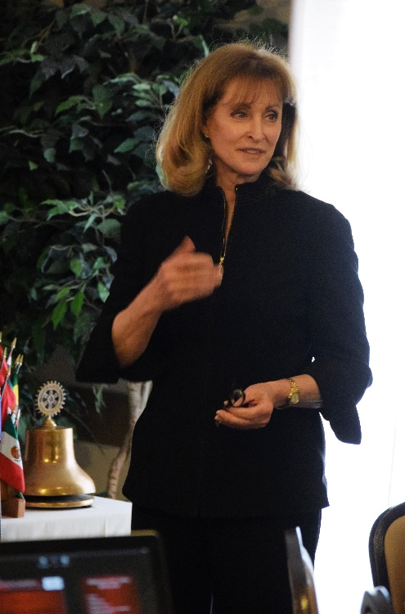
Mary Ann shared the mission of the Castro Valley Arts Foundation, which is to provide our students and community with artistic experiences that educate, enrich, and entertain by securing resources for the Castro Valley Center for the arts. The fourteen-member Board of Directors currently includes Rotarians Candi Clark, Bernie Kempen, Murline Monat, Bill Nott, and Randy Vanderbilt. Rotarian Parvin Ahmadi is an ex officio member. Randy Vanderbilt and Jim Negri (ex officio) are also past board members. The Rotary Club of Castro Valley is well represented on the CVAF boar. Erma Smith and Terry Liebowitz (founders and Past-Presidents) also serve on the board.

The Castro Valley Arts Foundation (CVAF) has a unique partnership with the Castro Valley Unified School District. The Foundation is committed to augment the Center for the Arts (CFA) infrastructure; ensuring requisite staffing, program development, equipment replacement, and facility enhancements.

EDUCATION:
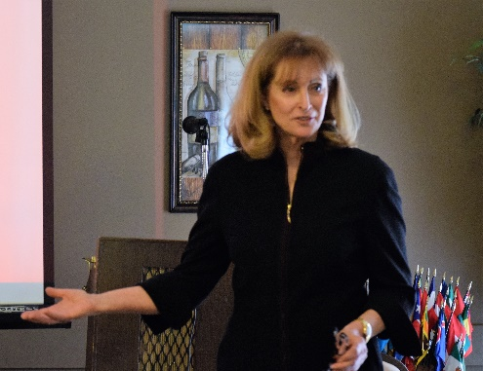
Providing arts education to students is a keystone of the CVAF mission. Actors, directors, and the technical team for Golden State Theatre Productions share their expertise with high school students in workshops and on-the-job training. Artists exhibiting in the Exhibition Room offer workshops to the Castro Valley High School visual arts classes. CVAF sponsors musical theater technique workshops for the middle school students during the school year and a Musical Summer Camp, staging a fully produced musical every year. CVAF also organizes special workshops/ assemblies, demonstrating cultural arts such as Mexican dance with Ballet Folklorico and Celtic music/dance with Golden Bough for the elementary school children. The afterschool musical theater workshop, combines elementary and middle school age children resulting in a show each semester.

ENRICHMENT:
The CVAF provides additional opportunities for the students by engaging with local artists to display in the Exhibition Room and with receptions that facilitate direct access to the artists as well as collaborating with community groups and local businesses to obtain substantial gifts for the CFA, such as pianos, drum sets, and acoustic shells. CVAF provides scholarships to graduating seniors who have contributed time and talent to the Center and has produced the "Light the Lights" concerts, which offer students the opportunity to perform and see a professional performance.

ENTERTAIMENT:
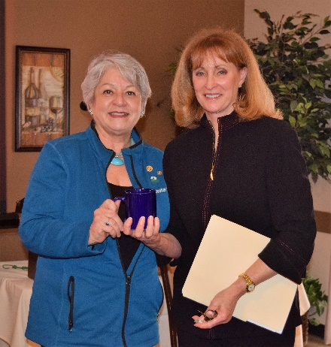
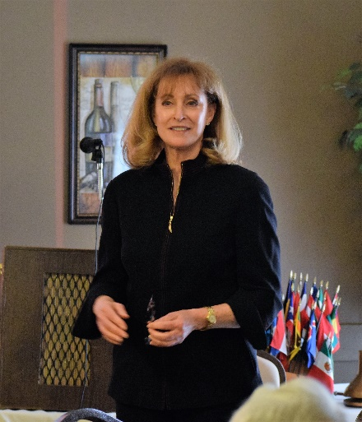
Local audiences have enjoyed live concerts with international opera star Federica Von Stade, Grammy Award winning San Francisco Girl Chorus, Beach Blanket Babylon phenom Val Diamond and many others. CVAF has partnered with Golden State Theatre Productions shows such as Rent, Carousel, Joseph and the Amazing Technicolor, Dreamboat and Oklahoma. Though the cast includes actors from all over the West Coast , Castro Valley actors and sometimes community leaders share the stage. Each season CVAF presents a series of varied performances including music, dance, lecture, and theater.

Additional information for the upcoming CVAF programs for the 2017-2018 of CVAF can be obtained by either visiting www.cvaf.com or by calling 510-537-3335. Mary Ann provided a sneak provide of the outstanding lineup of shows.

Don’t miss Rick Gunn, CVHS graduate, who has bicycled around the world on April 30 at 2:00 p.m. at the CFA.

Welcome Rayya
Cliff Sherwood introduced Obse’s newborn son, Rayya, and Obse's mother. As part of a Club tradition, the members contributed $226 Obse and Rayya.
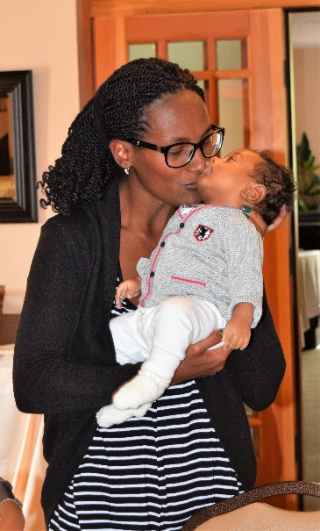
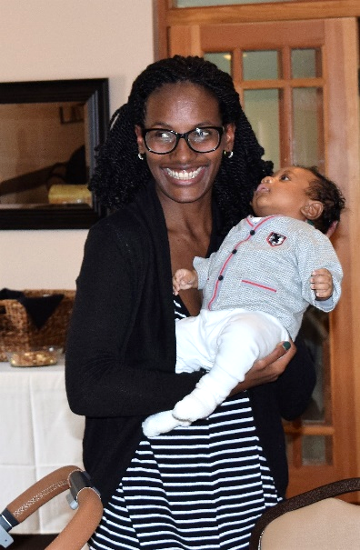
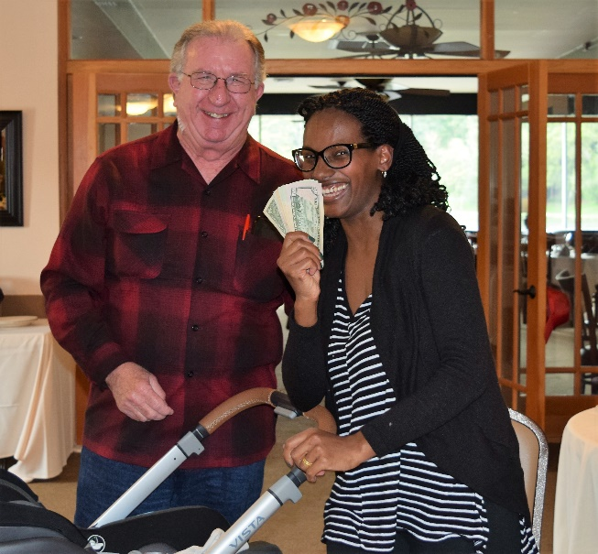

Birthdays and Anniversaries
President Carol announced the recent and upcoming birthdays: Ken O'Donnell (April 1), John Courtney (April 3), Jerome Blaha (April 6), Gary Bosley (April 11), Jim Philips (April 16), and Mathilda Schmidt (April 21). She wished all Happy Birthday on behalf of the CV Rotary Club.
In addition, she wished Happy Anniversaries to Jeff and Allyson Moore (April 17), Kern and Olga Lewis (April 17), KJ and Thomas Page (April 21), and Hafsa and Eduard Burt (April 28).
Chili Cook-off and Rodeo Parade
Twenty-six days to the Chili-Cook-off on May 12 at 5:00-9:00 p.m. at Rowell Ranch. Randy Vanderbilt passed around a signup sheet. This is an “All Hands on Deck” Club event. Profits from the Chili Cook-off help sustain our Club’s work. Please volunteer ASAP. The next Planning Meeting is April 27 at 5:00-6:00 p.m. at Direct Sales.

Rodeo Dinner – May 13
Cliff Sherwood announced the Rowell Ranch Rodeo Dinner. For further information, please contact him.

District Governor’s Wife Project
In October, DG Jeff Orth visited the Club. At the time, his wife described her project for the year – collecting funds to provide students with outstanding picture books. At the District Governor’s meeting, Heidi Hausauer received the books designed for the Rotary Club of Castro Valley and presented them to CVUSD Assistant Superintendent Candi Clark to present to the District students.

Up Coming Programs
April 18: Lunch Meeting with Dr. Bruce Roberts on Integrative Holistic Medicine. Finding your Unique Path to Health and Happiness
April 25: Lunch Meeting with Michael Kusiak from Castro Valley Matters
April 27: Chili Cook-off Planning Meeting at 5:00 p.m. at Direct Sales
May 4: Rodeo Parade Meeting at 12:00-1:00 p.m. Watch for details.

