Rotary Club of Castro Valley
Meeting Highlights – April 16, 2019

Patty Goodman – A Child Polio Victim and Survivor
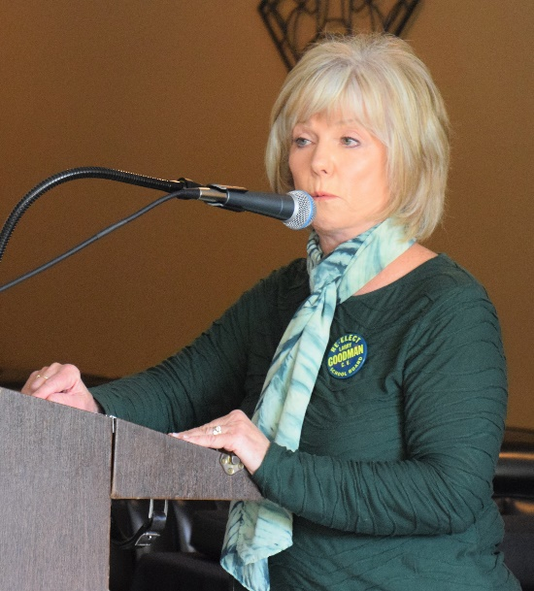
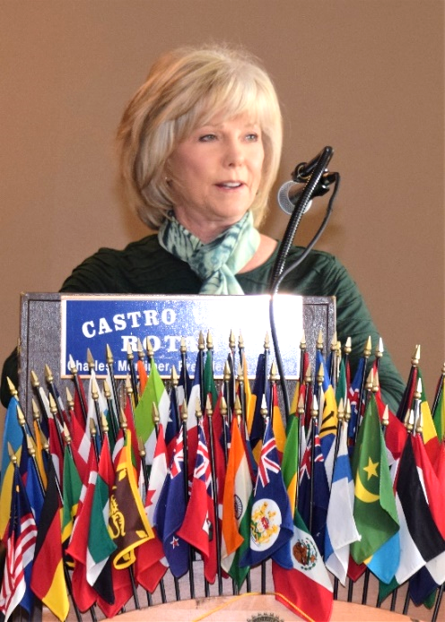
Patty was fourteen years old living in Lima, Peru with her family when she was first afflicted by polio. Her father was a pilot stationed at an air base in Peru. Patty remembers clearly that it was early in the morning and she was just waking up when her father entered her bedroom. She tried to rise to greet him as she normally did each morning but fell back in the bed. She developed high fever and was diagnosed with the flu. When the fever did not subside after a few days, her father flew in a doctor and Patty was diagnosed with polio.

Eventually, they brought her back to US where she went through all kinds of treatments, including massages, electric shock treatment and many operations. The doctors installed rod just above her ankle to make both legs straight and of equal length. Even now she cannot put pressure on one foot for a long time. Swimming and massage seemed to provide some relief, but in general it hurt a lot.

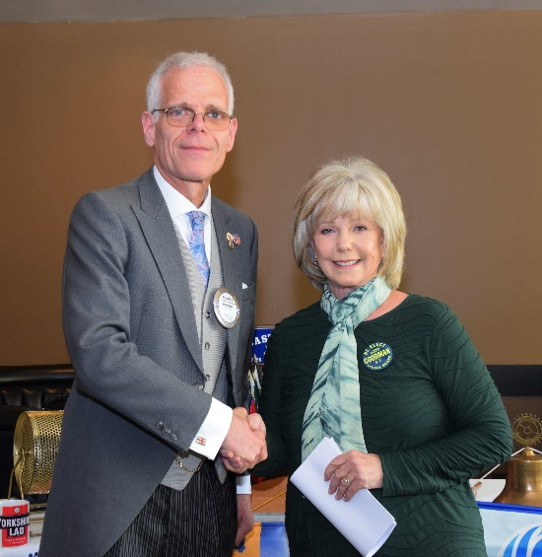
After all these treatments, she was lucky to be able to recover from the effects of Polio; however, Patty shared the taunts and name calling that she had to endure growing up. She graduated from Hayward High School. Patty is a longtime friend of Rotary, longer before women were allowed into Rotary. She worked for almost sixteen years at Great Western Savings and Loan and many interactions with the Rotary Club of Castro Valley and its members.

Patty married Castro Valley native Larry Goodman who was in attendance and who served as a Trustee on the Castro Valley Unified School District Board and later as an Alameda County Superior Court Judge.

Patty’s story of her challenge to overcome polio and lead a useful and productive life was inspiring?

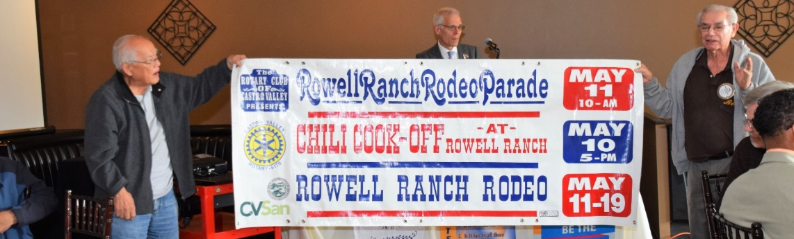
Ben Gurule displays the 2019 Rowell Ranch Rodeo Parade, Chili Cook-off and Rowell Ranch Rodeo banner. Thank you to everyone who assisted Ben in cleaning the banners. Don’t forget to sign-up as a volunteer for the Chili Cook-off and Parade.

Upcoming Events – Check ClubRunner for more details and more events
April 24 | Board meeting at Don Jose’s at 5:30 pm
April 30 | Lunch meeting ABC7 weatherman Spencer Christian
May 1 | Chili Cook-off and Rodeo Parade Meeting at 5:30 pm at Direct Sales Floors
May 10 | Chili Cook-off at Rowell Ranch at 5:00-8:00 pm – Sign-up to be a volunteer
May 11 | Rowell Ranch Rodeo Parade at 10:00 am on Castro Valley Blvd. - Sign-up to be a volunteer

Scenes from the Meeting
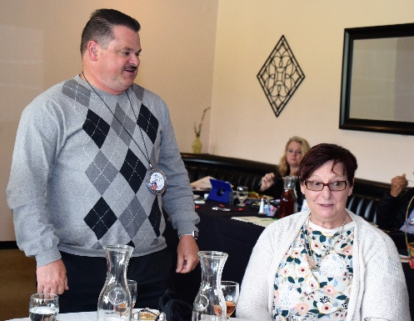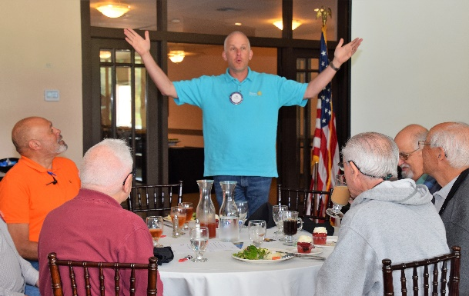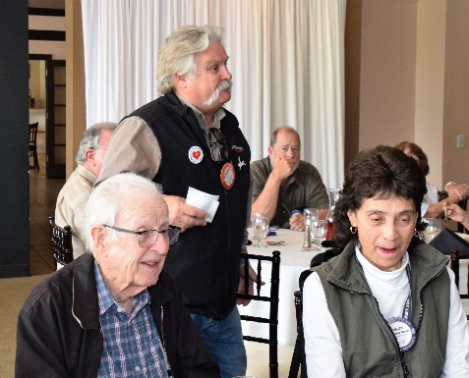
(L-R): Todd Anglin introduces his guest, Sue Alvarado who has worked for Honorary Castro Valley Rotarian Walt Schneider, in the same office as Todd. Dan Willits leading the Hello Song. Brian Morrison Paying it Forward for his anniversary and for his son-in-law becoming the youngest Captain in the Alameda Fire Department.

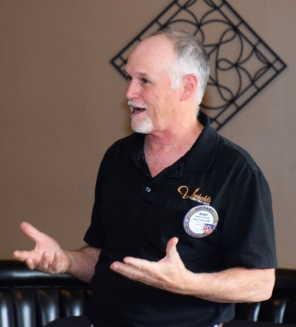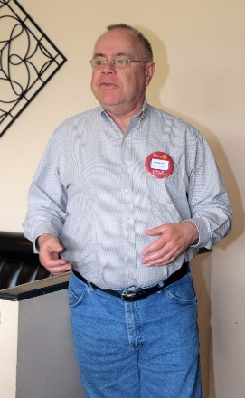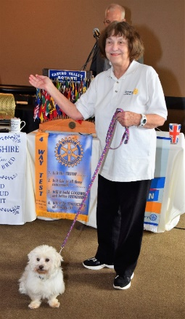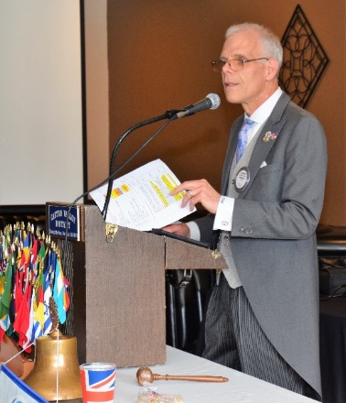
(L-R): Ray Wallace describing the revitalization of the Rotaract Club in the area. If you want to learn more about Rotaract, click here or talk to Ray. Watch for details about how you can be involved. Randy Vanderbilt talking about the upcoming Chili Cook-off. If you have not volunteer, do so today. Gary Howard describing his encounter with the Castro Valley High School Garden Club that was working to raise $300. President Charles used his monthly President’s account to fund the project. Ceta Dochterman showing off her foster dog. President Charles being presidential.

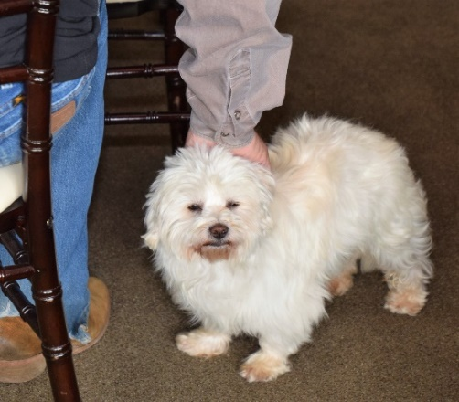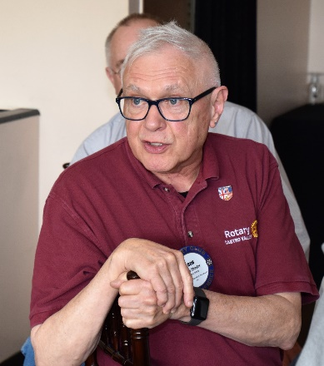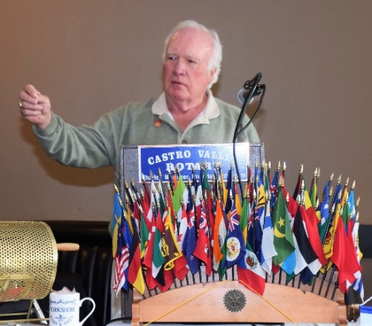
(L-R): Rotarians giving Ceta a helping hand. Bob Shayler relating how the presentation on stem cell research had a practical impact on one of his dogs. Dwight Perry introducing his good friend and speaker for the day, Patty Goodman.

