Rotary Club of Castro Valley
Meeting Highlights - April 17, 2018

Michael Kusiak – Legislative Issues Impacting Castro Valley
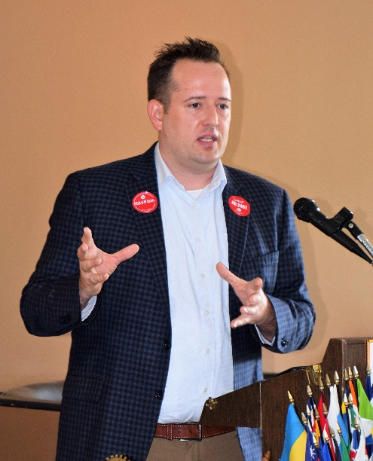
Michael Kusiak has been and continues to be very active in community, school, and political activities in Castro Valley since he and his family moved here in 2009. Michael has been very active with Castro Valley Matters (check the website at www.castrovalleymatters.org) and was the driving force behind the Castro Valley Stands United Against Hate signs displayed across Castro Valley. Michael served at the chair of the Yes on Measure G bond campaign for the Castro Valley Unified School District.

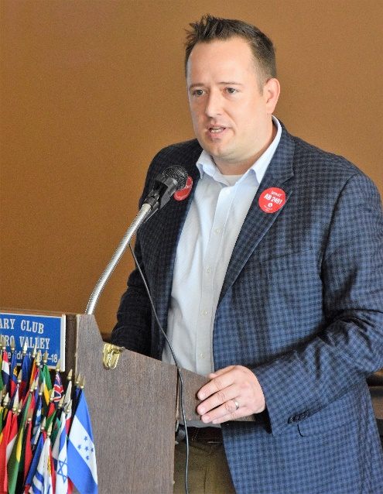
Since moving to Castro Valley, Michael has been actively advocating for the incorporation of Castro Valley. He acknowledged to someone new to the community, Castro Valley appeared to be a closed community for a long time. Michael shared anecdotes about the history of racism in Castro Valley, but noted that Castro Valley has become a very diverse community (i.e., “melting pot”) that is reflected in classrooms across the Castro Valley Unified School District, which is an excellent school district.

While Michael has advocated for incorporation, he acknowledged that incorporation is not in the cards at the present time due to a 2011 Assembly Bill that changed the state funding model making incorporation of new communities all but impossible. State funding for newly incorporated cities/town simply does not exist. As a result, 6.8 million Californians live in unincorporated areas of the state, which limited their ability to impact local decisions.

To correct this situation, Assembly Members Bill Quirk (Assembly District 20 which includes Castro Valley and the Eden Area) and Ken Cooley (Assembly District 8 in the Sacramento area) introduced Bill AB 2491, which would change the state funding model and enable unincorporated communities to receive funding that would allow incorporation. The bill has passed the Local Governance Committee in the California Assembly and been referred to the Appropriations Committee. This bill would provide proposed new cities/towns with a revenue stream that every existing city in California already has. When the bill is passed and signed into law, it would open the door for incorporation of unincorporated areas like Castro Valley.

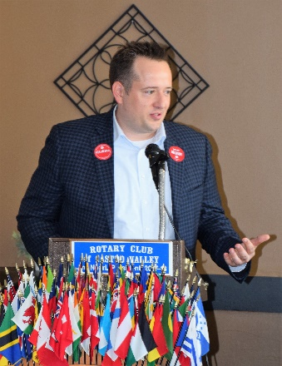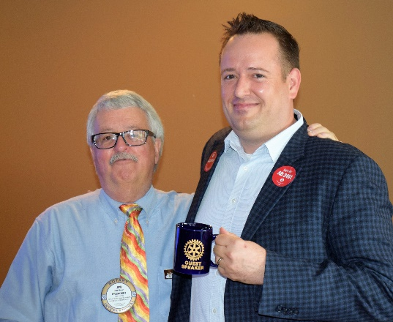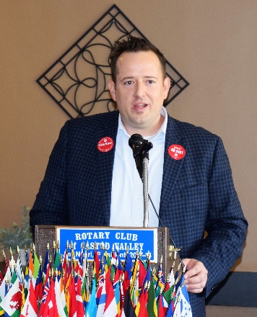

Membership Moment: Ashley Strasberg
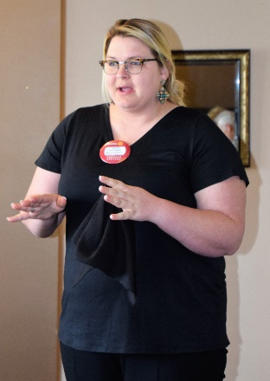
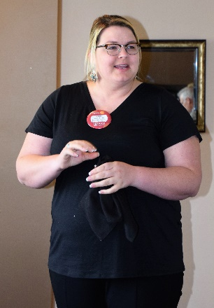
Ashley, who serves as the Executive Director of the Castro Valley/Eden Area Chamber of Commerce, shared her experience with the California Junior Rodeo Association (CJRA). She spends many weekends throughout the year working with young cowboys and cowgirls. The CJRA was founded in 1968 and continues to thrive. Its mission is to provide high quality rodeos and promote an environment where good sportsmanship are the core values to a healthy competitive event for our young cowboys and cowgirls. Contestants are encouraged to support each other and often build lasting friendships.

Chili Cook-off & Rodeo Parade Updates
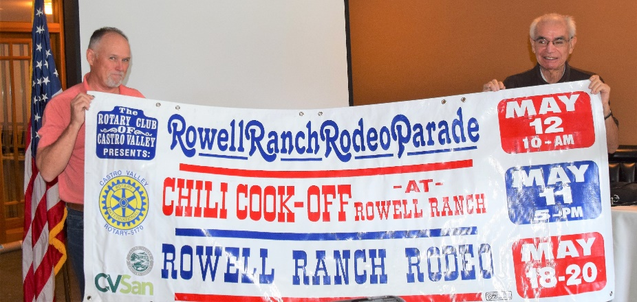
Ben Gurule unveiled the 2018 Chili Cook-off (May 11), Rodeo Parade (May 11), and Rowell Ranch Rodeo (May 18-20) banner. Planning is well underway. The Club is looking for chili cookers, parade entrants, and sponsors. Detailed information is posted on the Club website (www.castrovalleyrotary.org). Be sure to share the information with colleagues and friends.

Both the Chili Cook-off and Parade at ALL HANDS ON DECK events for Club members. There are more volunteer spots to fill then members. Look for an email within the week with details on how to volunteer online.
We need all members to volunteer to ensure the success of these events.

District 5170 End Polio Now Flash Campaign
Every Rotarian has been asked to donate $50 to the Campaign, which ends April 30. Just bring a check made out to TRF to the next meeting or mail it to the Post Office Box. Donations will be gladly accepted after the April 30th deadline. Your donation will be matched 2:1 by the Bill and Melinda Gates Foundation to End Polio Now.

Upcoming Speakers and Upcoming Events are posted on the Rotary Club of Castro Valley website, www.castrovalleyrotary.org. No password is necessary to access the information. Be sure to check the website for current details on lunch meetings and Club events.

Making a Difference Starts in Castro Valley

