Rotary Club of Castro Valley
Meeting Highlights for April18, 2017

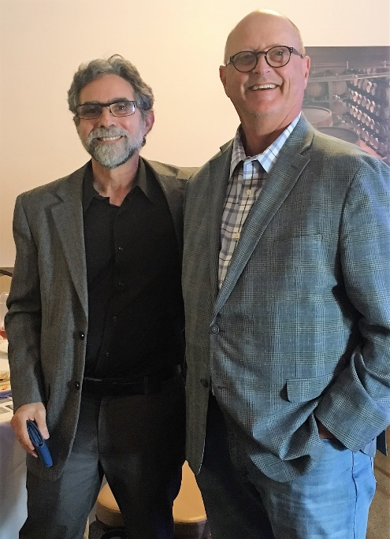
Dr. Bruce Roberts of Integrative Holistic Medicine
Finding your Unique Path to Health and Happiness

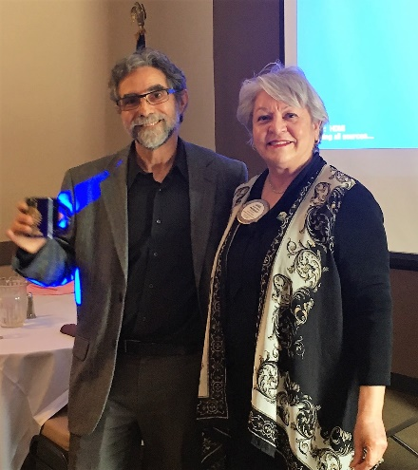
Dr. Bruce Roberts graduated about 35 years ago and joined a HMO as a Family Physician. As a Family Physician, he was expected to see 20-25 patients every day. With the 15 minutes he had with each patient, he was expected to interview and diagnose the patient in that time. He soon became very frustrated with the system because he wanted to treat the patients and not just their symptoms. Dr. Roberts realized that a person is not just a machine made up of various body parts, rather the health of a person is a composite of the body, mind, and the environment. At this stage of his career, he quit his job and started studying how the other systems address the health and wellbeing of a person. He came to the realization that the health of an individual depends on the physical body, the mental body. and the environment.

Dr. Roberts started studying health treatment concepts from other cultures (e.g., Chinese, Indian), and using these practices to treat the whole person as a whole. He feels that an Integrative Holistic approach that addresses physical, emotional, mental, and spiritual imbalances can help each of person to find his/her unique path to health and happiness. Dr. Roberts plans to expand his practice by offering online courses on Integrative Holistic approach to treatment of disease.

For further information regarding the online courses on the online courses and the Integrative Holistic approach, contact Dr. Bruce Roberts at Bruce@lightheartedmedicine.com.

2017-2018 Rotary Club of Castro Valley Board of Directors
Nominating Committee Chair Kern Lewis presented the slate proposed by President-Elect Jim Negri for the 2017-2018 Rotary Club of Castro Valley Board of Directors. The slate included:

President Jim Negri
President-Elect Charles Mortimer
Secretary Ajay Ahluwalia
Treasurer Todd Anglin
Past President Carol Wikle
Director Gary Bosley
Director Ceta Dochterman
Director Heidi Hausauer
Director Ken O' Donnell
Director Dawn Ortiz
Director Ray Wallace

On a motion by Cliff Sherwood and a second by Bill Nott, the slate for the 2017-2018 Rotary Club of Castro Valley Board of Directors was approved by a voice vote without any discussion.

Announcements
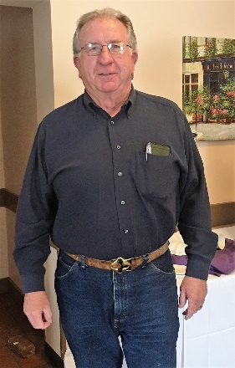
- President Carol Wikle and Cliff Sherwood announced that the "Breathing for Life" grant application was completed and submitted last week. Thank you to everyone who has worked on the grant, especially Obse.
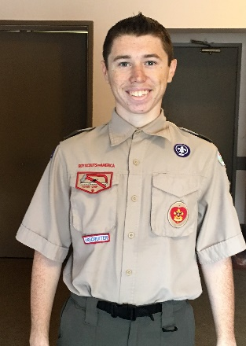
- Luc Dochterman made an appeal for help in his Eagle Scout project for building a storage shed and had a signup sheet for volunteers.
- Bill Nott and Michela Thompson reported on preparations for the Rodeo Parade (May 13) and the Chili Cook-off (May 12) are in full swing and requested all the volunteers to attend the upcoming meetings. Both events are all hands-on-deck events for Club members.

Up Coming Events:
April 25: Lunch Meeting with Michael Kusiak from Castro Valley Matters
April 27: Chili Cook-off Meeting at Direct Sales at 5:00-6:00 p.m.
May 3: Rodeo Parade Planning Meeting at Chamber Officers at 12:00-1:00 p.m.

