Rotary Club of Castro Valley
Meeting Highlights – April 2, 2019

California Water: One Man’s View of Thoughtful Californians Should Know About California Water Issues Today – Robert Maddow
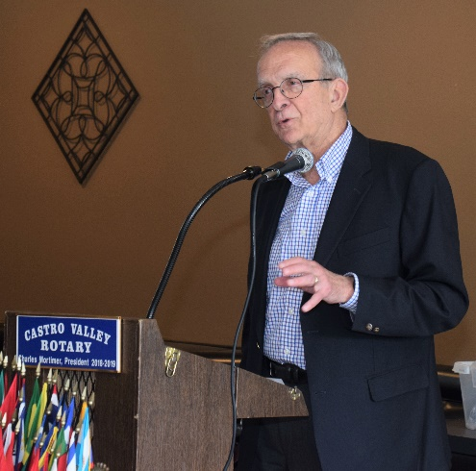
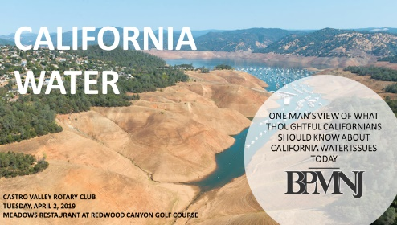
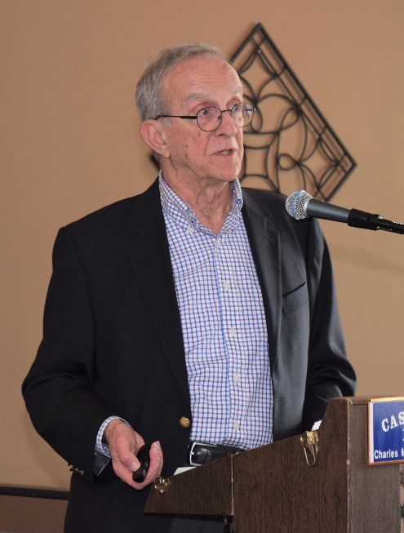
Cliff Sherwood introduced Bob Maddow, who he has known since their days as parents at Clifton Elementary School in Castro Valley. Clifford provides a great intro. Bob’s official bio states: Robert Maddow, a partner in BPMNJ, joined the firm in 1993. Before joining the firm, he was General Counsel for EBMUD for 9 years and was an attorney for EBMUD for 12 years prior. He has extensive legal experience in all phases necessary to establish, govern, operate, and maintain a publicly owned water utility to supply municipal and industrial water, and has also worked on a wide variety of water supply issues related to surface water, ground-water, and recycled water used for irrigation, both public and private clients. His areas of concentration have included water rights, water supply and quality, wastewater and recycled water, capital improvements programs and projects, real property acquisition, governmental organization and operation, environmental law, public finance, rates and charges, and customer services regulations.

The key points that on which Bob focused in the presentation included:
- To illustrate that California is no longer in a drought, he referenced the title slide (see above) that showed Oroville Dam 20 months ago and mentioned that today water was being released over the rebuilt spillway.
- That 75% of state’s water is in the north while 70% of the population is in the south, which has led to an era of long pipes.
- Over the years, California has re-engineered the natural water system to serve the population and agriculture of California.
- Colorado River system, which is critical to California serves seven states.
- In the Bay Area and Norther California, there are multiple reservoir and water conveyance systems.
- The state’s current population 40 million and is expected to grow to 50 million by 2050, which means increased demands for water.
- Governor Ronald Reagan removed 60% of water capacity planned on the Eel River and other sources proved unfeasible to make up the difference.
- The state and federal Endangered Species Acts, signed by Governor Reagan and President Nixon, have impacted water supply.
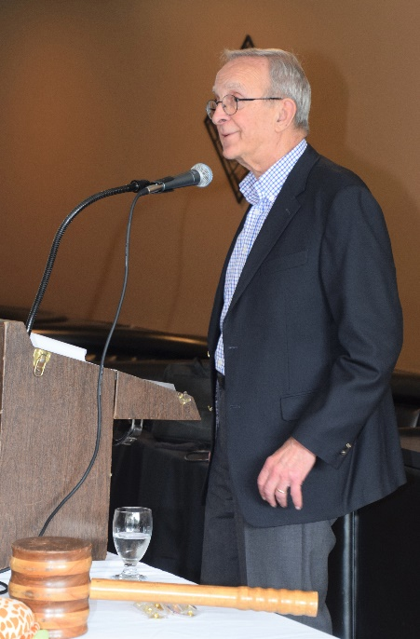
- The Peripheral Canal was controversial. With recent actions by Governor Newsome on the Twin Tunnels, plans are now uncertain.
- The future for the Bay Area is to tie together the various water systems that currently existing (see the slides below).
- In conclusion, Bob noted that global climate change will force us to make many changes in our planning and water use.

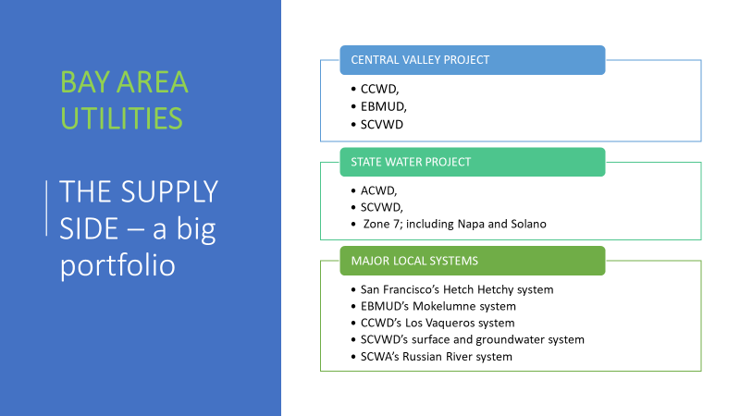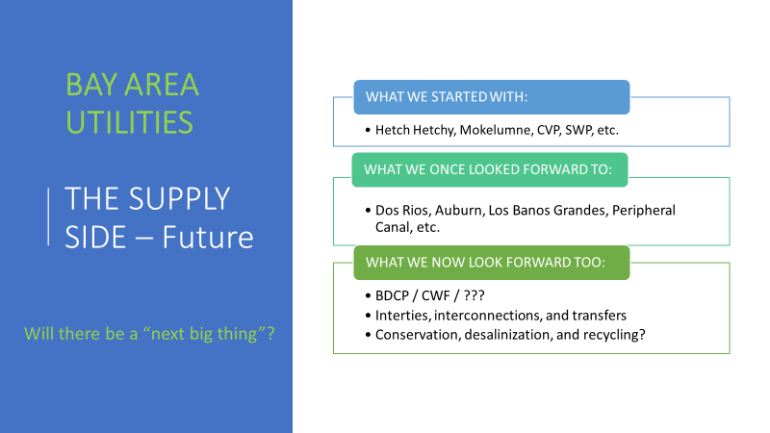

Another Busy Day in the Neighborhood – Scenes from the Meeting
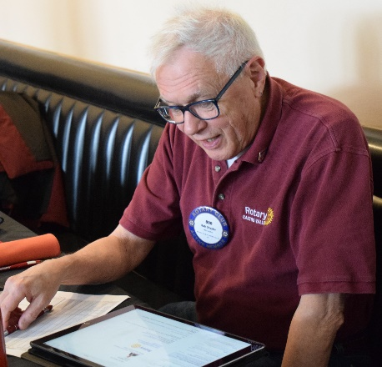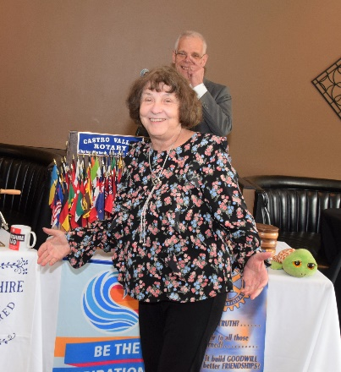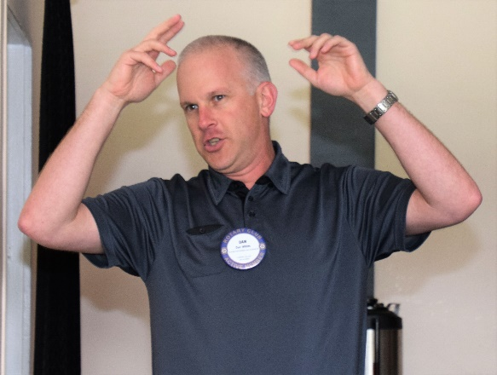
(L-R): Bob Shayler sharing the Thought for the Day and he paid it forward since he purchased earthquake insurance based on Todd Anglin’s presentation last week. Ceta Dochterman leading the Song of the Day (the little man in the Pink Section would probably be asleep in his chair). Dan Willits in his usual role of leading the Hello Song for the guests pictured below.
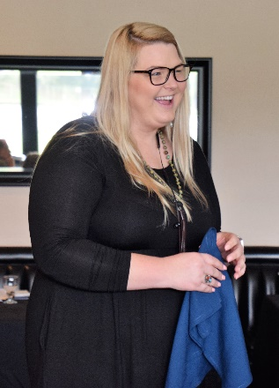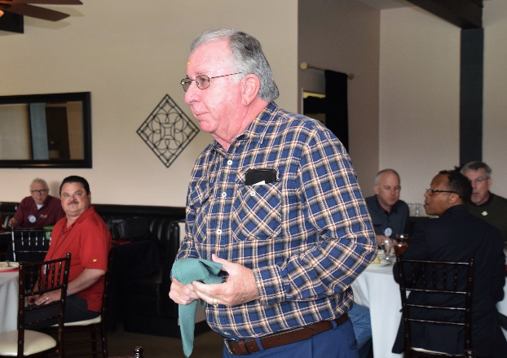
(L-R): Ashley Strasburg introducing the newest member of the Chamber staff, Emily Hatton (middle), who started today as Allie Field leaves for new endeavors. Ashley also noted that a new flier for the Chili Cook-off, Rodeo Parade and Rodeo is completed and will be sent to members. Cliff Sherwood introducing Kayla Hale, an attorney with BPMNJ, who the photographer failed to get a photo.
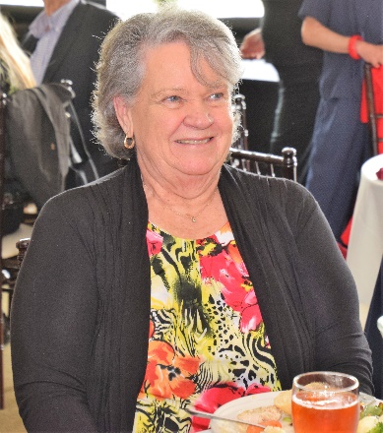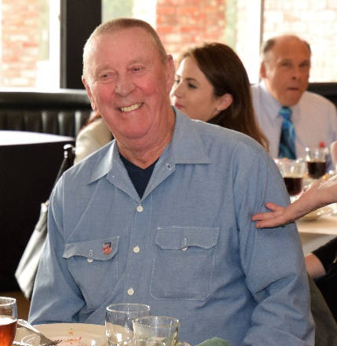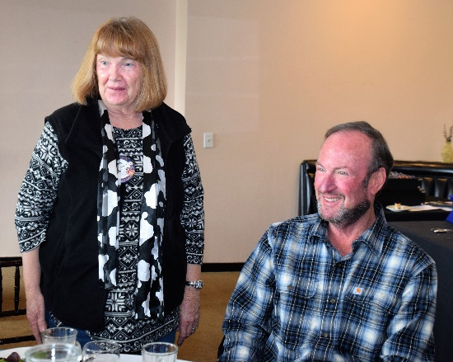
(L-R): Michaela Thompson’s guest Pat Barker. Virginia Degner’s husband and regular guest, Dwayne Degner. Membership Chair Virginia Degner introducing Dave Sadoff, who will be inducted into the Club on April 9.
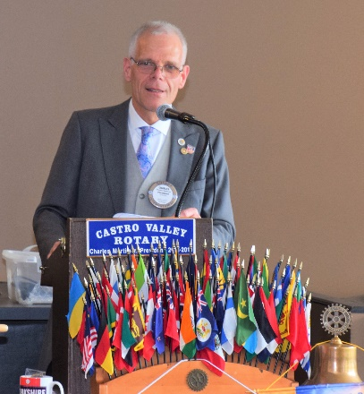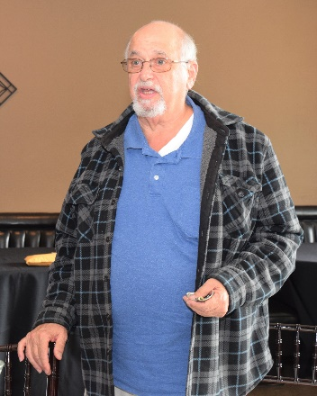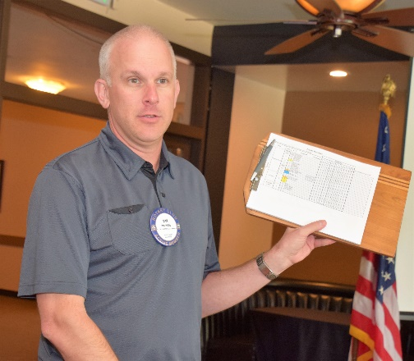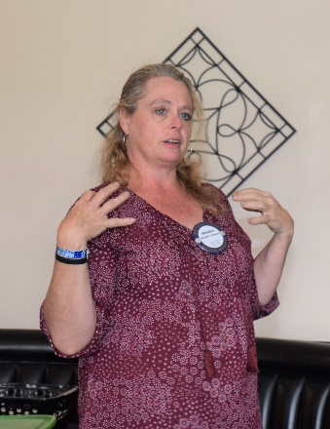
(L-R): President Charles sharing that he will be leaving right after the meeting for London to be with his father as his father received an Order of the British Empire (OBE). The Club sends its thoughts and prayers for Kay. Bill Nott paying it forward for a successful Robotics competition last week. Dan Willits soliciting volunteer marshals for the Rodeo Parade on May 11. Watch for Chili Cook-off and Rodeo Parade sign-up sheets and emails. Michaela Thompson describing a chocolate fundraising event that she is sponsoring at the home of Dawn Ortiz to raise funds for women who are being sex-trafficked in Uganda. More details and a speaker at the April 9th meeting.
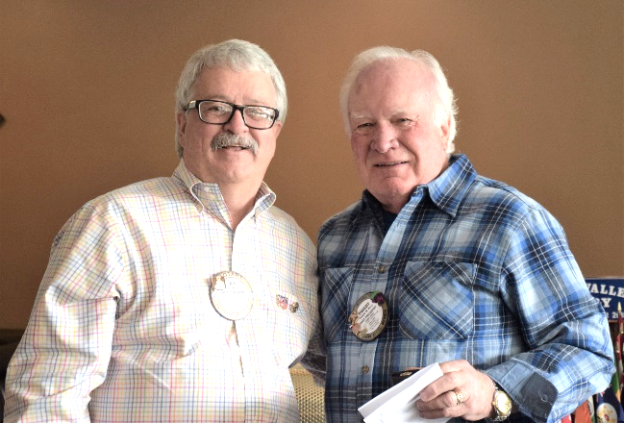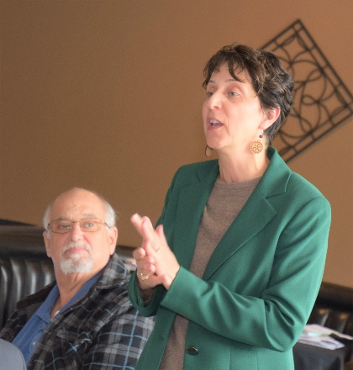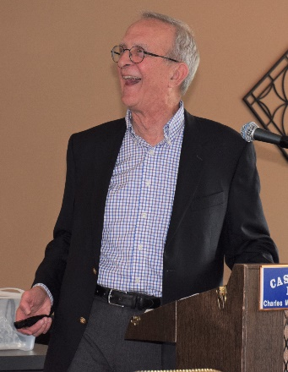
(L-R): Foundation Chair Dwight Perry presenting Jim Negri with his Paul Harris +4 Pin. Parvin Ahmadi describing the Castro Valley Unity Walk on April 5 at 6:00 pm and a rally in Sacramento on April 3 for increased funding for K-12 education. Bob Maddow laughing at one of Bill Nott’s puns.

Upcoming Events – Check ClubRunner for more details and more events
April 5 | Castro Valley Unity Walk at the Castro Valley Library at 6:00 pm - See separate email.
April 6 | District 5170 Training Assembly at Biltmore Hotel in Santa Clara
April 6 | Eden Awards at Our Lady of Grace - Details here.
April 9 | Lunch meeting with Kevin McCormack from the California Institute of Regenerative Medicine
April 16 | Lunch meeting with Patty Goodman, a survivor of childhood polio
April 16 | Castro Valley Eats starts at the Adobe Center – Details here.
April 17 | Chili Cook-off and Rodeo Parade Meeting at 5:30 pm at Direct Sales Floors
April 23 | Lunch meeting with Assistant District Attorney Robert Warren on the Alameda County Grand Jury
April 23 | Demotion Planning meeting at Direct Sales Floors at 5:30 pm
April 24 | Board meeting at Don Jose’s at 5:30 pm
April 30 | Lunch meeting ABC7 weatherman Spencer Christian
May 1 | Chili Cook-off and Rodeo Parade Meeting at 5:30 pm at Direct Sales Floors
May 10 | Chili Cook-off at Rowell Ranch at 5:00-8:00 pm – Be sure to sign-up to be a volunteer
May 11 | Rowell Ranch Rodeo Parade at 10:00 am on Castro Valley Blvd. - Be sure to sign-up to be a volunteer

