Rotary Club of Castro Valley
Meeting Highlights – April 24, 2018

Steven Hendee – Director of Bands at Castro Valley High School
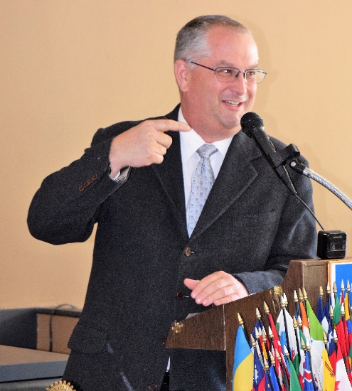
Steve Hendee, Director of Bands at Castro Valley High School (CVHS) was the replacement speaker for David Judson, Managing Director of the Castro Valley Center for the Arts (CFA), who was involved with his students with the State testing program. Since Steven spends a great deal of time in the CFA, he was the perfect fill-in speaker. Prior to CVHS, Steven served 12 years as the Director of Bands at San Francisco Unified School District’s School of the Arts (SOTA), six years in the same position at Hayward High School. In addition, he held positions in Oakland Unified School District and briefly left teaching to become an education consultant for Byron Hoyt Music Company. Steven has taught at CVHS for the past six years.

High-quality student shows are regularly presented at the CFA with students staffing the technical positions, which provides real world learning experience and potential employment opportunities. The CVHS music and drama programs has received numerous accolades. Steven noted that while the student productions use in-house talent, they do go outside for choreographers and other technical skills (e.g., flying apparatuses).
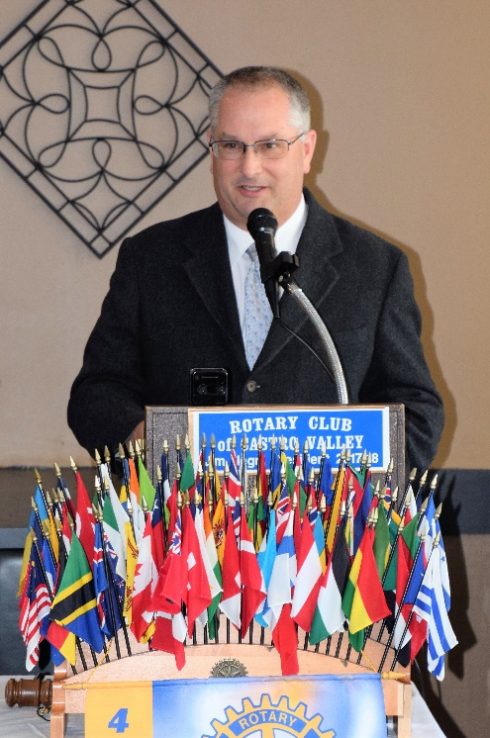
Steven shared information regards the operation of the CFA as well as video clips from recent CVHS musical productions. As many Rotarians know from first-hand experience, Steven noted that the CFA is a great venue for performances, not only for students, but major productions sponsored by the Castro Valley Arts Foundation (CFA) – many Rotarians have served or are serving on the CVAF Board of Directors. Steven shared that the gross revenue for the CFA has been steadily increasing from $35,851 to over $120,000 last year and is projected to be $200,000 by 2020.

As with any performing arts venue, ongoing equipment (e.g., sound, lighting, stage, curtains, backdrops) repair and upgrading of is a continuous challenge for the CFA, which is funded by the Castro Valley Unified School District (it’s a classroom at CVHS) and the CVAF. The Rotary Club of Castro Valley has contributed to several projects at the CFA (e.g., storage areas, Green Room). The CFA maintains an Equipment Repair Reserve Fund to assist with continuous upgrading. A current project is a wireless sound replacement on cell phone frequency as well as upgrading the interior house lighting is also being upgraded. The new LED main lights are already operating.

Steven noted that the CFA is rented by many outside arts groups. Feedback from user survey continues to be extremely positive. As members testified, the CFA is a great venue to see great performances.

One of the major challenges for the CFA is balancing the demand for the facility between student performances and the demand from outside groups wanting to rent the excellent facility, which is a good challenge to have.

For more information on shows at the CFA, go to http://www.cv.k12.ca.us/district/center-for-the-arts.

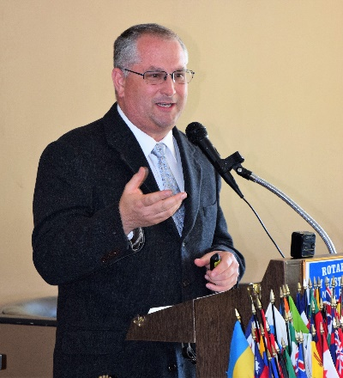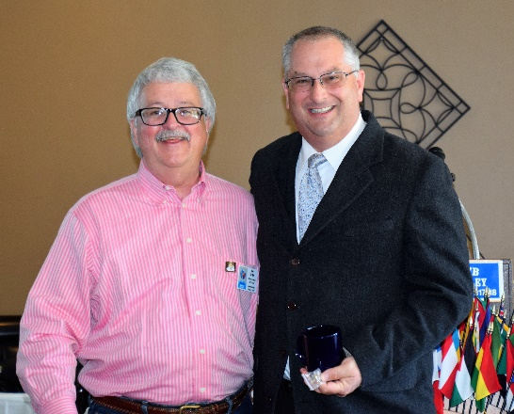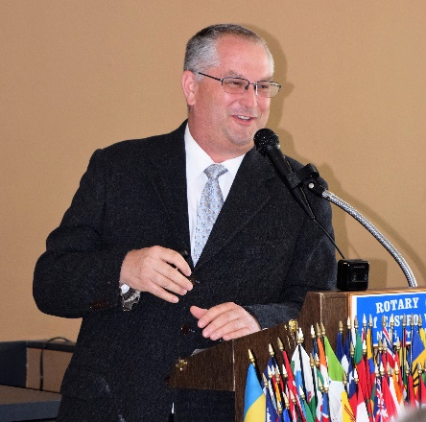
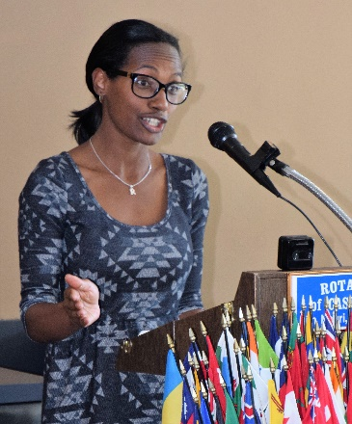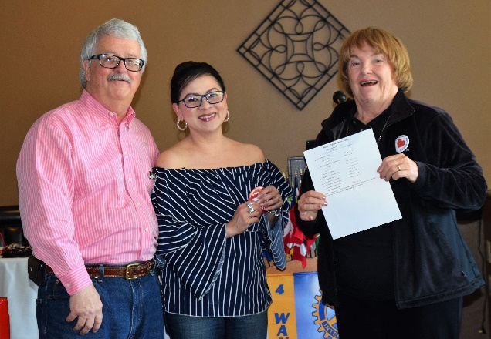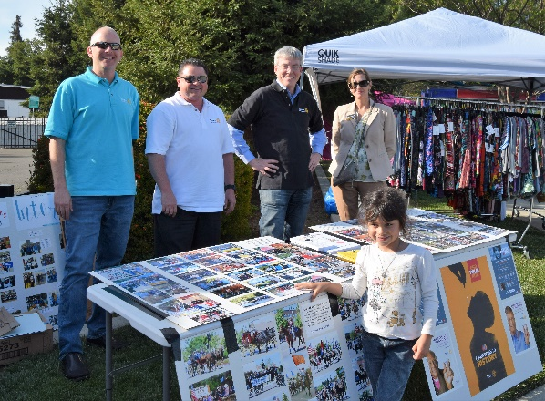
(Left to Right): Obse Lupo provided an update on the Breathing for Life (BFL) Project. Rotary International has conducted a site visit in Nejo, Ethiopia, and all the approvals are moving forward. Hopefully, the final approval will be given in June. President Jim Negri and Membership Chair Virginia Degner presented Bettina Tunggal her Red Membership Badge as the new member of the Rotary Club of Castro Valley. Bettina makes jewelry. On the evening of April 24th, the Rotary Club of Castro Valley hosted an informational table at Castro Valley Eats! (i.e., Food Trucks) in Adobe Park. Thank you to Dan, Todd, Kern, Saundra, Gary Howard (later shift) and Michaela Thompson (later shift) for joining President Jim to share the Rotary story and promote the Chili Cook-off and Rodeo Parade.

Castro Valley/Eden Area Chamber of Commerce Student Citizen of the Year Award
Every year, the Rotary Club of Castro Valley sponsors a school as part of the Castro Valley/Eden Area Chamber of Commerce Student Citizen of the Year Award. Once again, the Club sponsored the student from Castro Valley Adult and Career Education (CVACE). Gary Howard represented the Club at the Awards Lunch on April 26th at Redwood Canyon.

Here is the Award Program write-up regarding the student, Sean Chappell.
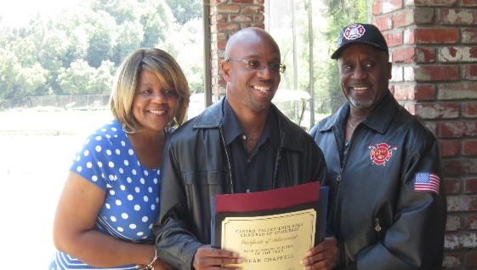
Sean Chappell is an exceptional student in Castro Valley Adult & Career Education’s Strides program for adults with special needs. He is always kind to others, compassionate and respectful. He is highly conscientious in his new part-time paid job at Direct Sales Carpet One in Castro Valley. He learned his job duties quickly and learned how to get to work on his own. Although he has some physical challenges, he never lets them get in the way of doing the tasks asked of him. He shows determination and perseverance, doing all he can to get the job done. He is highly dependable and responsible, has very good attendance, and demonstrates enthusiasm both in school and on the job. At school, he always greets staff and fellow students warmly, never complains or gossips, is respectful to all, and will defend others when someone else is being unkind. He sets an excellent example for others in his compassion, positivity, hard work, kindness and helpfulness. CVACE is thrilled to elect Sean for this year’s Student of the Year Award.
CVACE Director Susie Passeggi sent the Club the following thank you note and the above photo.
Jim and Rotary Members,

Thank you so very much for sponsoring our lunch table at today’s Student of the Year award ceremony. It was a special event, as always, and I know our teacher, student and his family were especially appreciative to be there, have lunch provided by you, and be able to celebrate their son/nephew/brother. Your Rotary club does so much for the CV community and our school district. I hope you know how much we appreciate each of you and your contributions. Thanks again for supporting Castro Valley Adult & Career Education today and the Student of the Year event.

Susie Passeggi, Director

