Rotary Club of Castro Valley
Meeting Highlights – April 25, 2017

Lunch Speaker: Michael Kusiak, President of Castro Valley Matters
April Speaker Chair Bernie Kempen introduced Michael Kusiak, President of Castro Valley Matters (CVM), which is a membership-based, community organizing group that empowers Castro Valley citizens to assert greater control over our community’s municipal affairs and will plan for and seek to implement a vision for Castro Valley’s future by
- Wanting democratic representative and accountable governance for the unincorporated area;
- Seeking greater place-making in CV by having more public art and influencing how the public spaces are developed; and
- Seeking greater civic engagement by participating in community meetings and regularly discussing community affairs at www.castrovalleymatters.org and on Facebook page at https://www.facebook.com/CastroValleyMatters.

CVM is a 501(c)(3) community non-profit organization established in 2014 that engages and participates in the community through the following examples:

- Leading the movement for the election of the Castro Valley Municipal Advisory Council (MAC);
- Hosting Candidates Forum for 2016 Alameda County Board of Supervisors, District 4 and including candidate statements on the CVM Blog;
- Advocating for and working with Alameda County for a mural at 580 and Redwood Road (project to start in 2017);
- Providing original blogging for the SF Homeless Project along with San Francisco Chronicle and KQED;
- Hosting a “Meet and Greet” with CVUSD Superintendent Parvin Ahmadi;
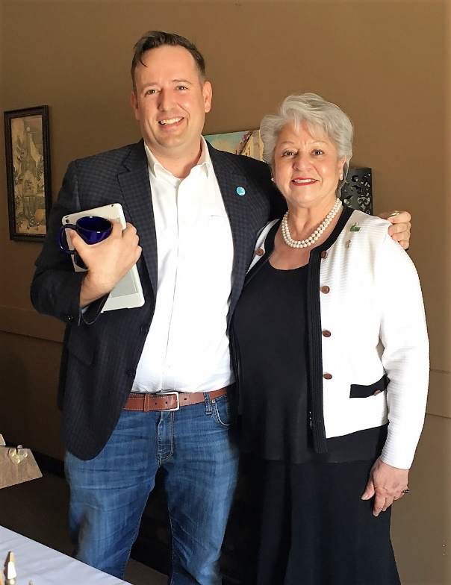
- Collaborating with Caltrans to install a Castro Valley sign on Interstate 580 entering Castro Valley;
- Regularly promoting, broadcasting, and reporting on local meetings, including CV MAC, Board of Supervisors, CVUSD, CVSAN, HARD, EBPRD, Eden Valley Area Liability Initiative(EALI), and other agencies of interest to the community; and,
- Consistently participating in community events, including CV Earth Day Cleanups, CV Light Parade, CV Rotary Chili Cook-off, and the Rowell Ranch Parade.

Additionally,
- CVM President Michael Kusiak was the featured speaker at the Town Hall sponsored by Alameda County and League of Women Voters on whether the CV MAC should be elected or appointed; and,
- CVM was awarded “Heroes Award” by State Senator Bob Wieckowski.

The current Castro Valley Matters Board of Directors consists of Michael Kusiak, President; James Herron, Treasurer and Vice President; Carey Sanchez Para, Vice President; Ellen Griffin, Secretary; Rebecca Stanek-Rykoff, Editor; and Michael Baldwin, Tomoko Ha, Peter Rosen, and Marta Zaelaya as Directors.

Announcements
- Bill Nott was in Houston to attend the Robotic Competition. The event was a great success and all the awards were won by West Coast teams from California and Washington.
- Bill Nott requested volunteers for the Rodeo Parade on Saturday, May 13th. Randy Vanderbilt requested volunteers for the Chili Cook-off on Friday, May 12th.
  - Both events are All Hands-on Deck events for all Rotarians.
  - It’s not too late to volunteer. Just show up and you will be put to work.
- John McPartland provided an update on the investigation of the BART robbery. BART has identified most of the 40 to 60 participants in this robbery and are in the process of apprehending these individuals with the help of local police. He emphasized that the BART police were at the scene of the crime within 5 minutes of first report. He reported that BART security staff has about 20 vacancies. (

