Rotary Club of Castro Valley
Meeting Highlights for April 3, 2018

Graham Lustig - Artistic Director of Oakland Ballet Company
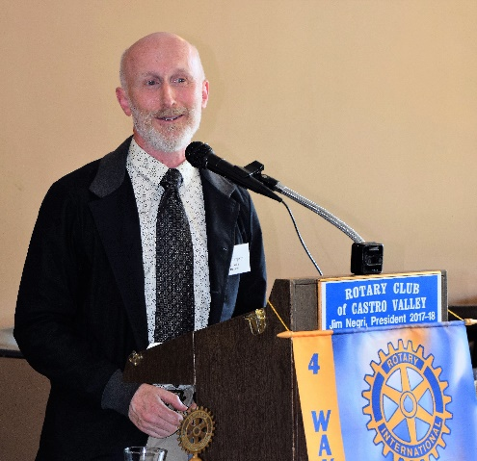
Graham always was interested in dancing. From the early age of 5, all he wanted was to dance. He left school at 16 and joined a Dance Academy where he learned various forms of dancing and participated in many dance performances. Graham’s most memorable experience was a dance performance in the Philippines in 1980. Over his career, Graham has participated in many professional programs and traveled all over the world with various dance companies.

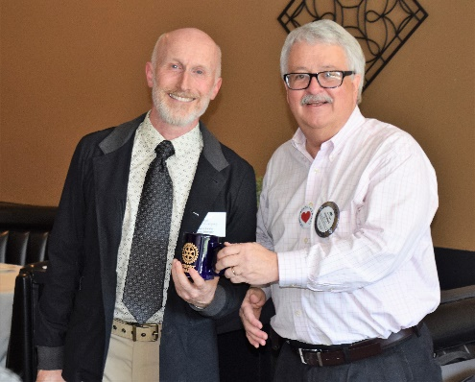
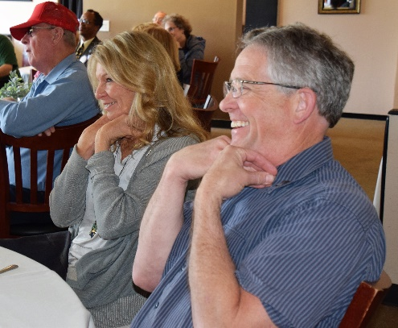
Since 1999, Graham has been a Dance Director. About a year ago, he moved to California and was appointed the Artistic Director at Oakland Ballet Company where he has experimented with merging ballet with other forms of traditional dance. He recently brought his program Jangla (The Jungle Book) to the Castro Valley Center for the Arts (CVFA). The program was an experiment in usion between traditional ballet and traditional Indian dance, Bharayt Natyam. The program was enthusiastically received including presentations to over 1000 Castro Valley students. As the Artistic District, Graham is committed to bringing ballet to the schools. The Oakland Ballet currently partners with five schools district is the Bay Area to present ballet to students. Graham is planning many innovative dance experiments in the future.
Members participating in activities that the Oakland Ballet using with working with students.

Graham’s presentation was very entertaining regarding his career in dance and enlightening regarding what the Oakland Ballet is doing. We are looking forward to more of these innovative performances. Is a night at the Oakland Ballet in the works for the Rotary Club of Castro Valley?

Al Proietti - What’s Happening in the Castro Valley?
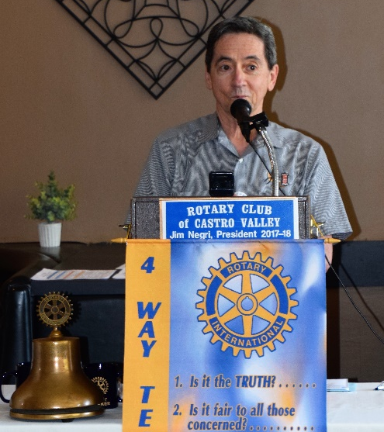
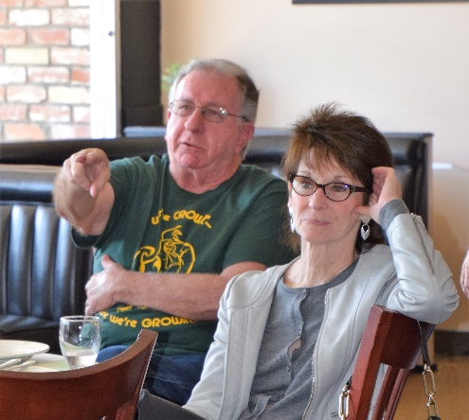
Al Proietti, owner of Al’s Barbershop in Castro Valley Village provided the latest What’s Happening in Castro Valley update. Al is a longtime member of the community who has been very active in Castro Valley. Many community members know Al for his Charley Chaplin impersonations. After a brief personal history – real estate agent, barber in San Leandro and Castro Valley, member of the Castro Valley/Eden Area Chamber of Commerce – Al provided an update on activity and issues in Castro Valley Village. Al’s Barbershop, which is one of the oldest businesses in the community and which many Rotarians and spouses of Rotarian frequent. Al described the many changes that are occurring with businesses in the Village including the opening of several new businesses. He touched on parking as one of the main problems faced by the patrons of Village businesses. The lack of parking dissuades people from shopping in the Village. While various parking options have been explored, no solution is in sight, though Rotarians offered several innovative suggestions (e.g., using the AC Transit Flex service, parking on nearby streets, using other parking areas after business hours, stacked parking structures. Overall, everybody agreed that there is a parking problem in Castro Valley Village.
Rotarians are never at a loss for suggestions.

Announcements
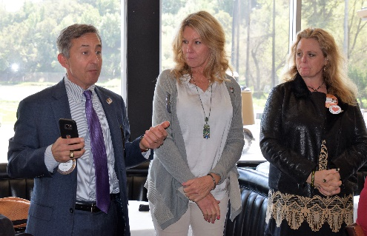
- Mark Poniatowski, Dawn Ortiz, and Michaela Thompson described the Texas Hold ‘em Fundraiser as a major success. While the numbers have not been finalized, it appears that the event will net approximately $15,000, which will cover the projected $10,000 net plus the $4,000 revenue that did not materialize from a Fall and Spring Fundraiser. The success of the dinner only option (58 diners) indicates that there appears to be demand for dinner/dance social event. The team acknowledged contributions of Randy Vanderbilt, the fourth committee members, and other volunteers who made the event a success.

- Dwight Perry reminded members again about the District 5170 Flash Campaign to End Polio Now that runs through April 30th. Each Rotarian is asked to donate $50 per member or whatever one can contribute. Each donated $1 is matched by $2 from the Bill and Melinda Gates Foundation. We are this close.

- Michaela Thompson displayed and distributed the posters/fliers for the Chili Cook-off (May 11) and Rodeo Parade (May 12). To have successful events, every member needs to recruit chili cookers, parade entries, and sponsors as well as volunteer for the numerous volunteer positions that need to be filled. Information regarding both events is posted on the Club’s website.

- Cliff Sherwood reminded members of the upcoming Rowell Ranch Rodeo, requested sponsors, and informed members that he has tickets for the BBQ.

Meeting Highlights for April 10, 2018

Katie Annand of KIND (Kids in Need of Defense)
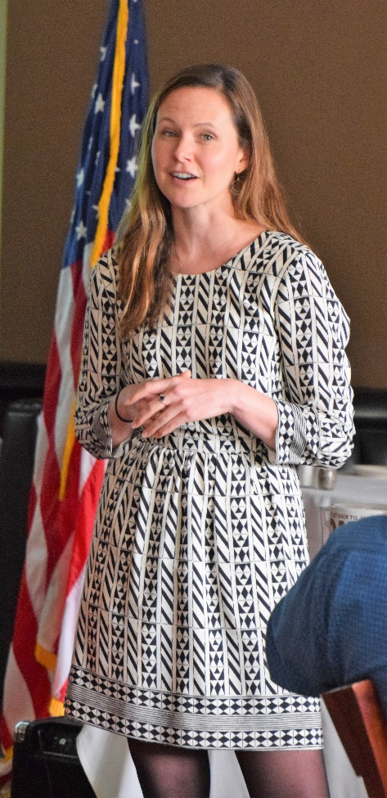
Katie Annand is the Supervising Attorney for Pro Bono Programs at Kids In Need of Defense (KIND) that provides pro bono representation to unaccompanied immigrant minors who are facing deportation hearings. Rotarian Bernie Kempen has been trained by KIND to represent these youth in Immigration Court. The kids represented by KIND are below the age of 18, who are without any parents or legal guardians in the United States, and have entered the U.S. due to persecution, poverty, and hunger, and in many cases are victims of brutal gangs in some of the most dangerous countries in the world.

U.S. immigration law does not provide these youths the right to legal representation in Immigration Court. Youth as young as 3 or 4 years old must legal represent themselves in court. Historically, there is no concept of children's rights or established procedures for handling such cases in Immigration Court. This is where KIND has stepped in throughout the country, by provided pro bono representation for kids in the immigration proceedings. Immigration law only requires the court to explain the law to the kids, who Katie noted are often 3, 4 or 5 years old. KIND volunteers take the cases to represent the interest of the kids.

KIND worked with the Immigration Courts to
- Find temporary housing till cases are heard and decided;
- Make arrangements for the kids to be able to attend school;
- Provide school supplies and summer activities, and seek donations to support these programs; and
- Provide career guidance and mentoring programs.
While providing services to kids facing deportation, KIND works with volunteers to engage Congress and make its members aware of the need for legal action to provide legal representation for these kids in Immigration Court.
KIND volunteers have established ten centers in San Francisco, Los Angeles, Washington D.C., Baltimore, New York, Newark, Seattle, Atlanta, and Houston. All these Centers are short of volunteer lawyers and are in need of donations to support the activities of KIND.

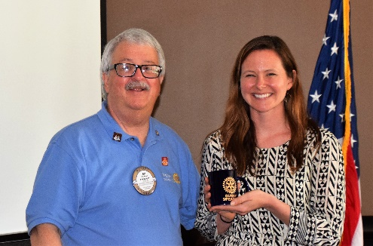
Katie shared her PowerPoint presentation including the video that she was not able to share as well as another video clips. They are available here:

- PowerPoint presentation
- Video #1
- Video #2

Katie responded to numerous questions regarding a controversial issue facing the country at this time. In her responses, Katie strove to adhere to Is it the Truth? and Is it fair to all concerned? in a balanced, factual manner. The Club thanked Katie for her powerful and timely presentation.

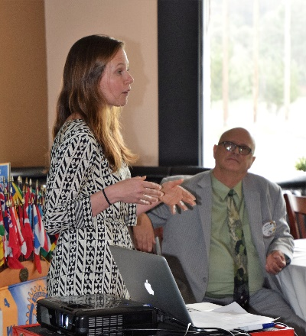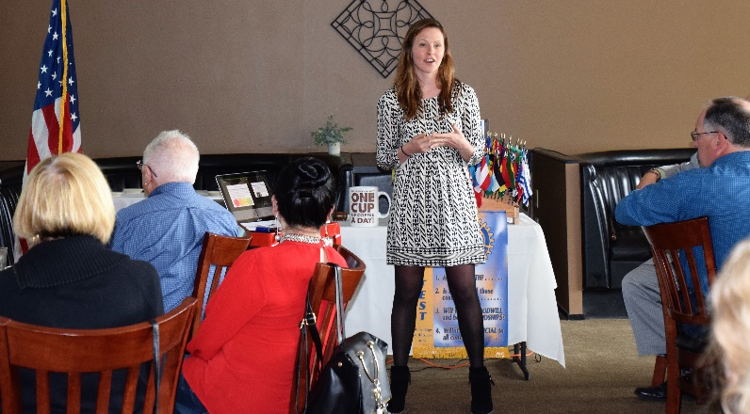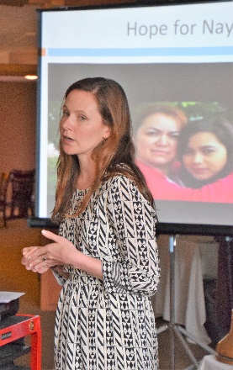

Announcements
President reminded Club members to
- Support the Rotary Club of Castro Valley by signing up to volunteer on CVSAN’s Clean Up Day on April 28. If you volunteer at one of many local sites and indicated the Rotary Club of Castro Valley as your preferred organization, CVSAN will donate to Rotary. Information available on ClubRunner.
- Recruit participants and sponsors for the Chili Cook-off and Rotary Parade. Information available on ClubRunner.
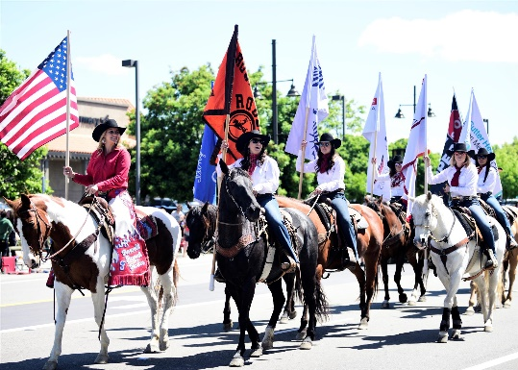
- Volunteer to work the information table at Castro Valley Eats on April 24 at Adobe Park to promote Rotary and its events.
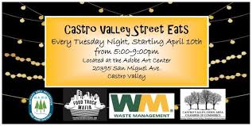

Upcoming Speakers and Event
- April 17 - Carolina Salazar and Michael Kusiak on Assemblymember Quirk’s legislative agenda and its impact for Castro Valley at lunch.
- April 19 – Castro Valley/Eden Area Chamber of Commerce Mixer at Rowell Ranch Rodeo grounds at 5:30-7:30 pm.
- April 24 – David Judson, Managing Director of the Castro Valley Center for the Arts on programs and the facility at lunch.
- April 24 – Rotary information table at Castro Valley Eats at the Adobe Center at 5:00-9:00 pm. Volunteers needed. See President Jim.

