Rotary Club of Castro Valley
Meeting Highlights - April 30, 2019

Spencer Christian - KGO-TV Weather Forecaster
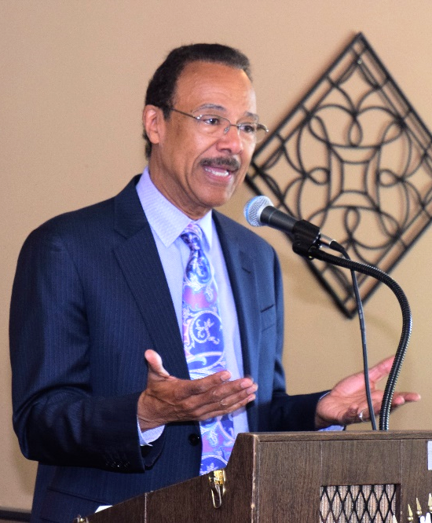
Spencer Christian, best known as the former weather forecaster for ABC's Good Morning America (1986-1998) and current weather forecaster for ABC-owned KGO-TV in San Francisco.

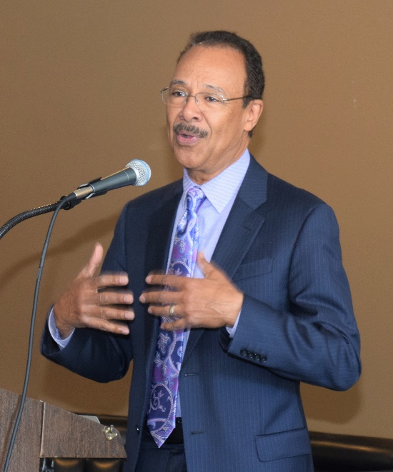
Spencer was born in 1947 in Newport News, Virginia. He grew up in the south during the 60's among all the activist movements and racial struggles. He attended Hampton University and received a B.A. degrees in English and Journalism. In 1971, he began his television career Richmond, Virginia as a news reporter covering local and state politics. During his stint there, he was asked to fill in as the temporary weather forecaster for about two weeks. Spencer was quite successful as a weather forecaster and even though he did not have any formal training as a weather forecaster, he was offered a permanent position as a weather forecaster at double his reporter’s salary.

From there, Spencer moved on to become a weather forecaster in Baltimore where also hosted a talk show, Spencer's World. Throughout his career, Spencer has won numerous awards including the Better Life Award in Richmond for his reports exposing abuses in Virginia's nursing homes and an Emmy Award in Baltimore for a series on declining language skills among America's youth.
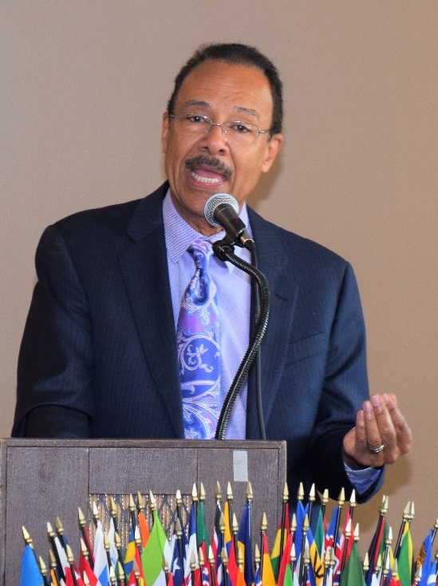
In 1977, Spencer moved to ABC News in New York and served as a national weather forecaster on Good Morning America program where he also had the opportunity to interview many celebrities and politicians (including Richard Nixon and five other U.S. Presidents) in addition to his weather reporting. During his presentation, he shared numerous stories about these interviews including one involving his friendship with Muhammed Ali. Another great story involved Bill Murray telling the Today Show that he based his Groundhog Day character on Spencer Christian. Spencer moved to San Francisco in January 1999 as the weather forecaster for ABC 7 News at 6:00 and 9:00 p.m. where he continues to report on Bay Area and national weather.

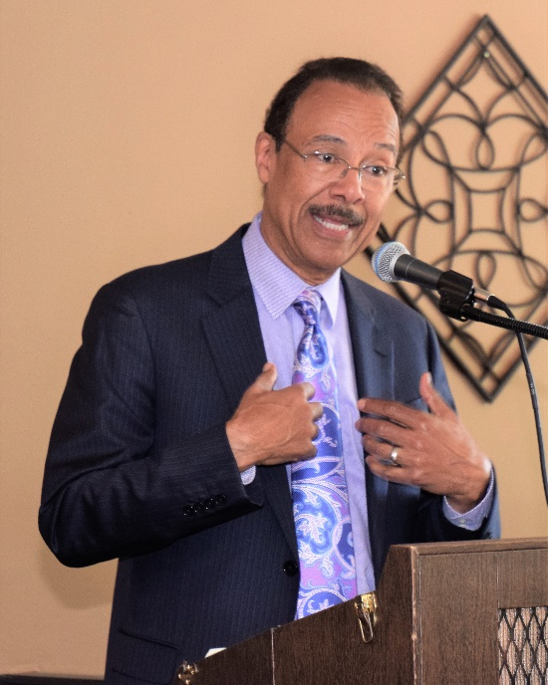
Spencer shared a personal crisis that almost destroyed his life and career. During his time in New York, he was invited by his colleagues at Good Morning America for a friendly game of poker that was his first experience with gambling. Spencer says that gambling gave him a unique experience and he was hooked. He started gambling regularly in New Jersey casinos and became a high roller gambler. Slowly the debts started mounting and one time he was so enamored by gambling that he had 14 overdraft accounts in 14 different casinos. He started juggling these accounts and was gambling up to $20,000 per month. Spencer noted that his property was seized, and he filed for bankruptcy. In 2007, at the age of 60, he became aware of his morality and gambling habit. During this period, Spencer was divorced from his first wife.

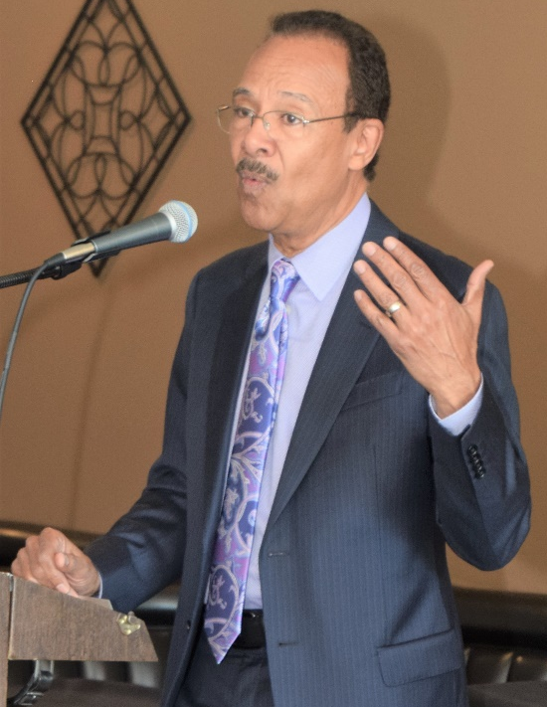
In 2010, Spencer had what he calls a "Jessica moment," when he had a heart-to-heart talk with his daughter, Jessica, and she said, "You do not want to be remembered as a gambler". That comment touched him, and Spencer quit gambling from that point onwards. Soon afterwards, he met his second wife Lynette Courtney, and is happily married. They have homes in Castro Valley and San Francisco. Spencer is planning to sell his home in San Francisco when retires and move permanently Castro Valley. He invited to become a member of the Rotary Club of Castro Valley.

Spencer devotes a good deal of his time to the March of Dimes, Special Olympics, the American Cancer Society, Big Brothers, Boy Scouts and Girl Scouts of America, the United Negro College Fund, the Make a Wish Foundation and volunteer and charitable organizations. In addition, he has served as the ABC spokesperson for children's literacy and authored several books including:
- You Bet Your Life: How I Survived Jim Crow Racism, Hurricane Chasing, and Gambling
- Can it Really Rain Frogs: The World's Strangest Weather Events?
- Is There a Dinosaur in Your Backyard: The World's Most Fascinating Fossils, Rocks, and Minerals?
- Shake, Rattle, and Roll: The World's Most Amazing Volcanoes, Earthquakes, and Other Forces
- What Makes the Grand Canyon Grand? The World's Most Awe-Inspiring Natural Wonders
- Spencer Christian's World of Wonders, a series of children books
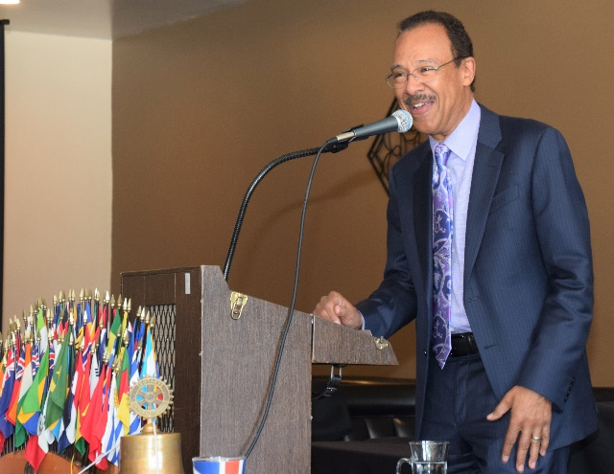
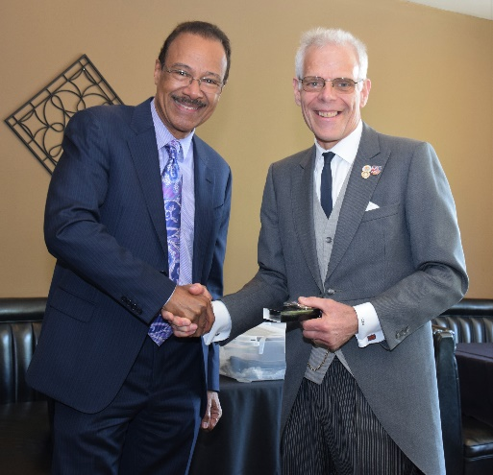
Spencer is an avid sports fan and a wine enthusiast and private collector. He noted that while he is a person of color from the South, he says he never felt like a trailblazer. Spencer’s talk was not only informative, but inspiring.
Thank you, Spencer!

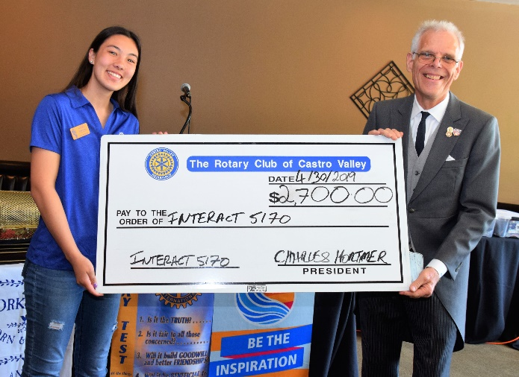
Scenes from the Meeting President Charles Mortimer presents Castro Valley High School Interact Club Vice-President Elena Lottich with a check for $2,700 to support her trip to the Rotary International Conference in Hamburg, Germany. Elena is attending the Conference in her role as the District 5170 Outreach Coordinator. District 5170 has the largest number of Interact members in Rotary International with over 7,000 members. The CVHS Interact Club also sponsors a Junior Interact Club at Canyon Middle School. For more information on Interact Clubs and their work in District 5170, go here.
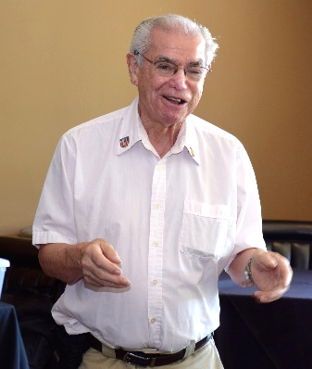
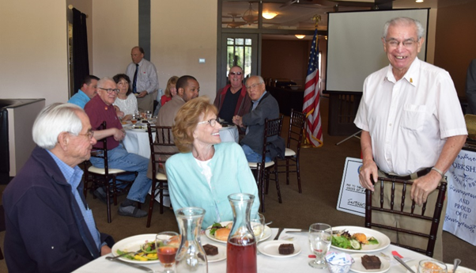
Ben Gurule introduces his brother and sister-in-law as his guests for the day and then leads the Hello Song for all the guests.

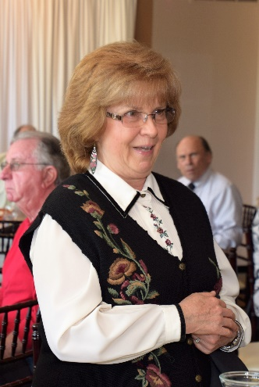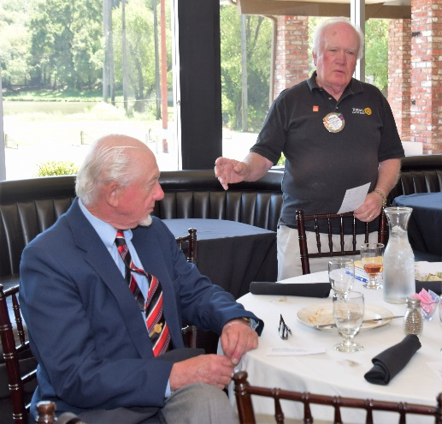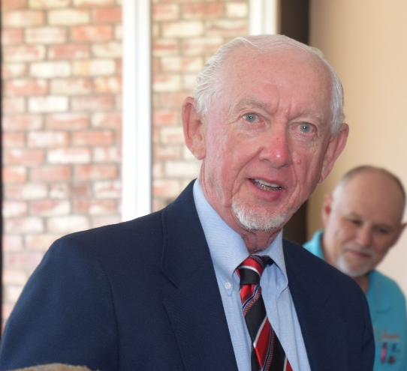
Scences from April 23rd Meeting
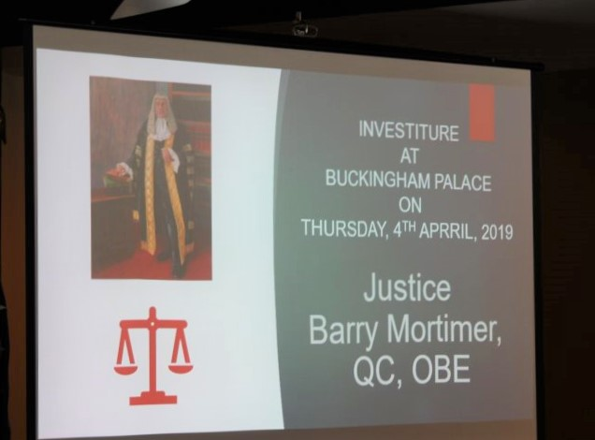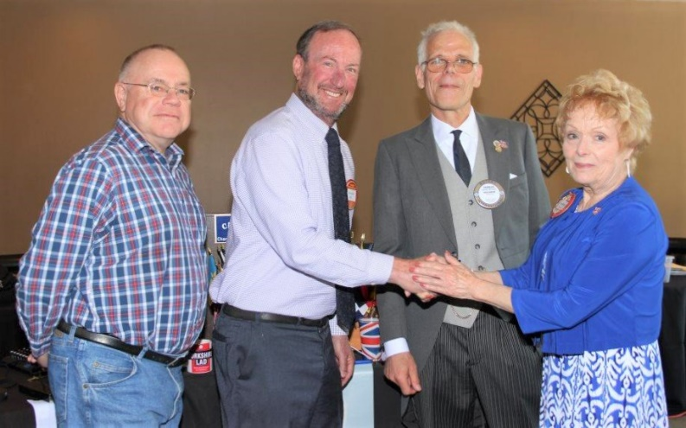
(L-R): There are no Meeting Highlights from April 23 when President Charles described the expereience fo attending the Investiture of his father, Justice Bary Mortimer, receiving the Order of the British Empire. Dave Sadhoff is presented his Red Badge by Membership Chair Carol Bigelow, President Charles Mortimer and his sponsor, Gary Howard. Welcome, Dave!

