Rotary Club of Castro Valley
Meeting Highlights – April 4, 2017

Dr. David Berke - Health After 50
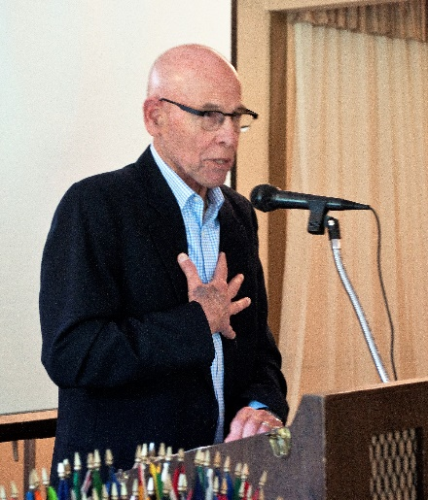
Dr. David Berke, a practicing cardiologist, was introduced by his wife, Terry Liebowitz, who is well-known by many Club members for her tireless efforts as a founding and contributing member of the Castro Valley Arts Foundation (CVAF).

When Dr. Berke graduated from Columbia University and started practicing, after a four-year residency program, he was what is now known as General Cardiologist. There are very few General Cardiologists and most require six or more years of residency programs. Most present-day cardiologists specialized in one area of the heart. It is almost impossible to find a cardiologist who can deal with all heart related problems.

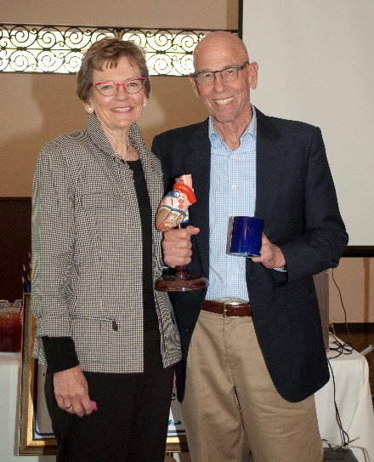
Now days, treatment generally involves preventive intervention by surgery or medication, and sometimes both. Open heart surgeries are becoming less frequent in response to cardio-vascular conditions, even though the main cause of heart related problems remain plaque deposition (i.e., cholesterol) and hypertension. The safe level for hypertension is now around 130/70 and the below 110 for the LDL. There are now special emergency units to handle stroke victims.

Both medical and surgical intervention in the form of advanced diagnostic evaluation and prevention are responsible for reducing open heart surgeries and the number of stroke victims. Even though there have been significant improvements in preventive evaluations and treatment, resulting in less emergency cases and emergencies, patient care can be further improved with co-operation of patients, hospitals, attending cardiologists, and advanced research in the causes and methods of controlling these conditions in potential patients.

Chili Cook-off
Randy Vanderbilt updated the Club on the planning for the Chili Cook-off (May 12 at 5:00 p.m. at Rowel Ranch) and Rodeo Parade (May 13 at 10:00 a.m.). Posters have been printed and volunteers are visiting other Rotary Club to spread the word. To date, Randy, Michaela Thompson, President Carol Wilke, and Jerry Soohoo have helped to distribute posters and spread the word.

Both the Chili Cook-off and Rodeo Parade are
ALL HANDS ON DECK events for Club members.

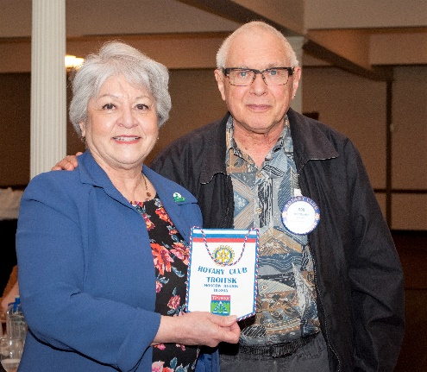
Upcoming Speakers, Meetings & Events
April 10: Board Meeting at 6:00 p.m. at the Chamber of Commerce.CV Rotary Club Board Meeting
April 11: Lunch Meeting with Mary Ann DeGrazia from the Castro Valley Arts Foundation
April 12: Parade Planning Meeting at 12:00-1:00 p.m. at Direct Sales
April 13: District 5170 Assembly at 5:00-9:00 p.m. at the Indian Culture Center, Milpitas
April 18: Lunch Meeting with Dr. Bruce Roberts on Holistic edicine
April 25: Lunch Meeting with Michael Kusiak from Castro Valley Matters April 27: Chili Cook-off Meeting at 5:00 p.m. at Direct Sales
Bob Shaylor presents President Carol with a banner from a 1990’s visit to the Rotary Club of Troitsk (Moscow Region).

