Rotary Club of Castro Valley
Meeting Highlights – August 1, 2017

Parvin Ahmadi, Superintendent - Castro Valley Unified School District
Sharon Trieu-Quince, Director of Facilities Construction- Castro Valley Unified School District
Parvin and Ahmadi thanked Club members for supporting Measure G in June 2016 and introduced Sharon Trieu-Qunice who provided an update on the status of Measure G Projects.

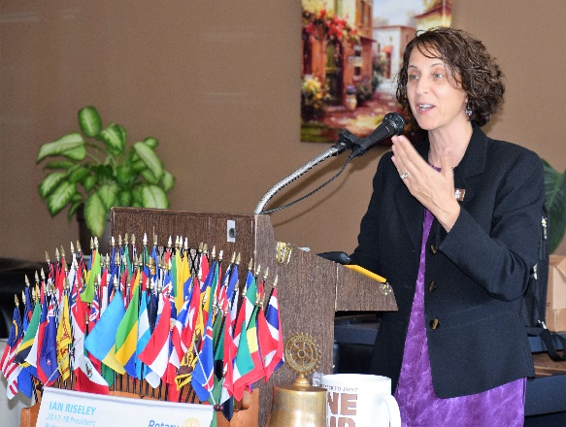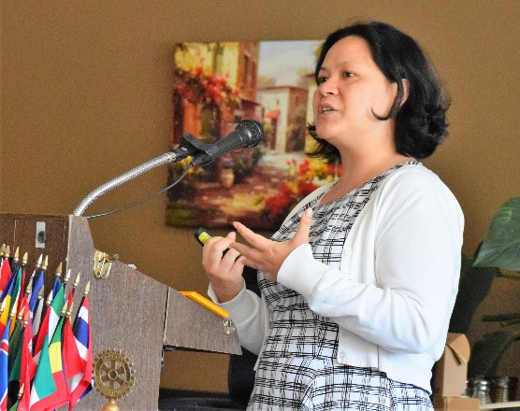

Sharon Trieu explained that even though the District has about 20 projects of various sizes and complexity, most of the projects can be characterized as small to medium sized. Since most school districts have construction projects during the summer vacation period, it causes a temporary shortage of contractors to compete these
Projects, which results in no bids on some projects. The largest capital projects receive the most interest from the available pool of contractors followed by medium and small projects. Since many of the neighboring districts are undertaking many major construction projects, there is a temporary shortage of qualified contractors. As the contractors are selected for the bigger projects, the remaining contractors start focusing on medium and small size projects. CVUSD is getting better response from the contractors and some of the projects have started moving forward. Some projects require temporary classrooms and other facilities at the start of the school year. The projects are being rescheduled to accommodate these changes and may result in increased cost than anticipated. Work is underway on some projects and others are being rescheduled with temporary housing facilities. For progress and schedule of these projects, more information is available on the CVSUD website at http://tinyurl.com/y8cmj3al.

The Rotary Foundation (TRF)
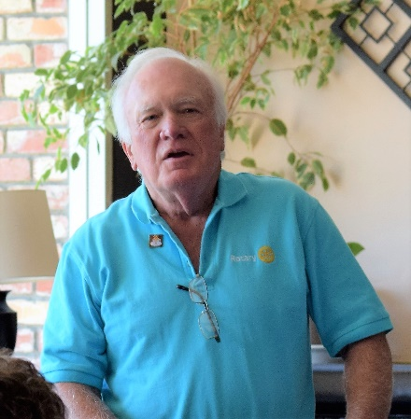
Dwight Perry presented two checks from Teri Railsback in memory of her father, Bob Waberski a deceased member of the Club. One check was for $1000 to TRF and the other was for $5000 to the Rotary Club of Castro Valley Endowment. We truly appreciate the donations in Bob’s honor.

For 100 years, The Rotary Foundation has been supporting Rotarians’ work to create sustainable solutions to our world’s most pressing needs. Give the gift of Rotary today and be a part of the positive change Rotarians are making in your community and around the world. Every gift makes a difference. To see the difference that your gift makes, click on http://tinyurl.com/yb7omlbv. Donations and pledge cards to be a Double Sustainer are still being accepted. See President Jim Negri for more information.

Honorary Member
President Jim Negri announced that based on the recommendation of Cliff Sherwood, the board has approved Linda Parker as an Honorary Member for her work over the years with the Rodeo Parade (e.g., staging all the entries and merging them into the parade from her location on Norbridge Avenue). Linda will be presented her certificate at a future lunch meeting.

Castro Valley High School Robotics Team
Rotarian Bill Nott, who is actively involved in robotic competitions across the United States presented Castro Valley High School student who are starting a Robotics Club at CVHS. Robotics Club President Sofia Revina described their efforts and asked for Club support (e.g., volunteer time, mentoring, supplies, and donations). She stressed that involvement in FIRST promotes Teamwork, Competition, Team Spirit, Alliances, and Game Strategies. Superintendent Parvin Ahmadi and Paula Haywood, mother of CVHS graduates Christine and Lindsey Matheney who participated in FIRST at CVHS, spoke to the value of the program.
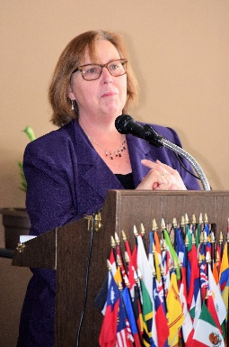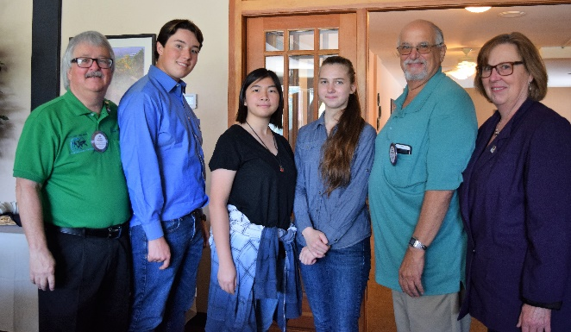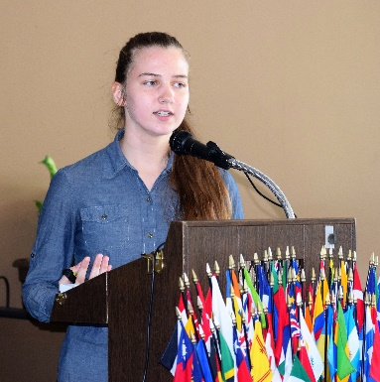
Pictured above (L-R): Paula Haywood; President Jim Negri, Cameron Ensel, Katrina Poon, Sofia Revina, Rotarian and FIRST Coordinator Bill Nott, Paula Hayward; and CVHS Robotic President Sofia Revina. For more information on how to support the Robotics Club, contact Bill Nott or Parvin Ahmadi

Celebration of Life for Leslie Rothwell
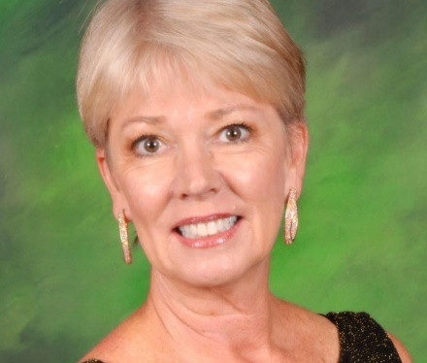
The Celebration of Life for long-time Rotarian and Castro Valley Unified School District administrator Leslie Rothwell will be held on Sunday, August 13th, at the Castro Valley Center for the Arts (CFA) at 2:00 p.m. In lieu of flowers, Leslie asked that donations be made to the Castro Valley Arts Foundation (CVAF) at P.O. Box 2777, Castro Valley, CA 94546.

There is an outstanding testimonial about the impact that Leslie had by CVUSD teacher Matt Johanson on the Castro Valley Matters website, http://castrovalleymatters.org/2017/06/20/leslie-rothwell-tribute/.

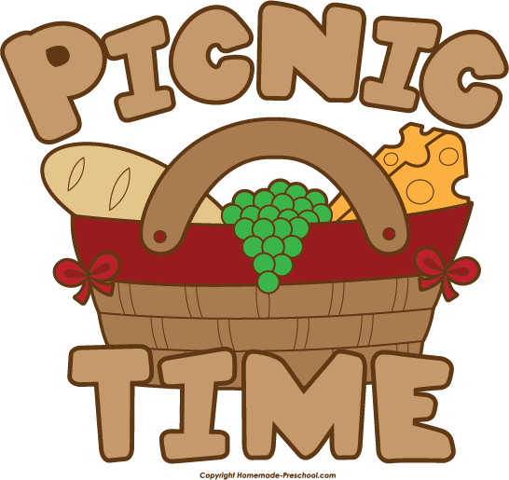

Club Picnic/BBQ
The Annual Club Picnic/BBQ will be held on August 15th at 5:00 p.m. at Lake Chabot Park. Please use the electronic invitation that was sent to you to RSVP. Cost is $35 per person, but the picnic is free for children.

Deadline to sign-up is August 12th. See Cliff or Jim for details.

UPDATE: First Object of Rotary
When DG Orrin Mahoney spoke to the Club on July 18th, he addressed the First Object of Rotary. He recently shared, “As some of you have heard by now, I have updated the First Object of Rotary, The Development of Acquaintance as an Opportunity for Service into Building Lifelong Friendships, while Making a Difference.

End Polio Now
Rotary is improving its online giving platform over several phases. The first phase, now complete, allows donors to make easy, efficient, and secure financial contributions at endpolio.org. Donors can also make contributions using tablets and smartphones. They will continue to sign in to My Rotary to track their cumulative giving. Watch for more enhancements that will appear on Rotary.org this year. All donations to The Foundation Rotary count towards a Paul Harris Fellow. See Dwight Perry for more information and to make a contribution to End Polio Now.

Backpack Project
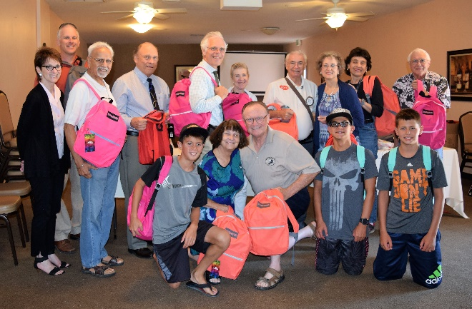

After the July 25th meeting under the leadership of Heidi Hausauer and Dan Willits, the Club prepared 96 backpacks full of school supplies for students in Castro Valley USD and Redwood Christian Schools. The backpacks have already been distributed to Redwood Christian students and the Club has received the following two thank you notes (names and grades deleted):

Dear Mr. Jim Negri,

I would like to thank the Rotary Club of Castro Valley for the thoughtful and generous gift of a backpack and school supplies. My son, …, a … Grader at Redwood Christian, thanks you as well. We're blessed to be part of a community in which service organizations such as yours have a valued impact on our youth.
Sincerely,
​Thankful RCS Parent

Dear Mr. Jim Negri,

Thank you to you and the Rotary Club for donating back packs and school supplies to Redwood Christian Schools.
My name is … and I will be in … grade this year. The back pack and school supplies will help my family and I very much. I promise I will get a lot of use out of this gift.

Thank you again.
*******************************************************************************************L

UPDATE: The Man in the Arena
When Jeff Kirschner, founder of Litterati, spoke to the Club on July 25th, he shared Theodore Roosevelt’s “Man in the Arena,” which many members request
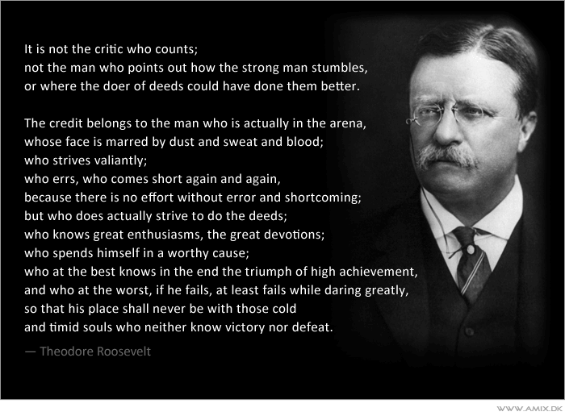

Upcoming Events
August 8 – Lunch meeting with Christoph Nauer on Success Breeds Success
August 15 – Dark at Lunch
August 15 – Club Picnic at 5:00 p.m. at Lake Chabot Park. Register by August 12th.
August 19 – District 5170 Membership Workshop at Castlewood Country Club in Pleasanton
August 26 – Lunch meeting with Kelley A. Wray on How to Manage Your I.P. Assets

MAKING A DIFFERENCE
STARTS IN CASTRO VALLEY

