Rotary Club of Castro Valley
Meeting Highlights – August 14, 2018

District Governor Tim Lundell
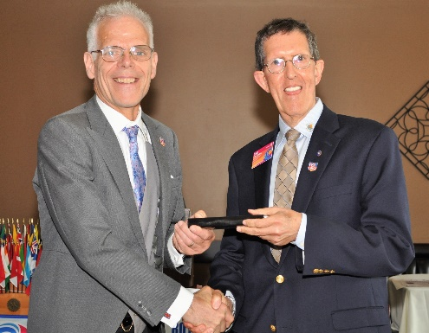
District Governor (DG) Tim Lundell addressed this year’s Rotary International theme, Be the Inspiration. DG Lundell said that he thought long and hard about how to implement this theme in District 5170 and has concluded that our biggest challenge is the dwindling membership in the Clubs throughout District 5170. One of the reasons for the decline of membership is the aging population; therefore, DG Lundell has decided to emphasize membership growth as the highest priority for District 5170.

DG Lundell stated that membership growth is Rotarian’s responsibility, not just the Board of Directors and Membership Committee. Rotarian Clubs are vibrant and active community organizations that should emphasize opportunities for training and leadership growth. District 5170 provides many outstanding learning opportunities as well as opportunities to develop leadership qualities that build future community and Rotary leaders.

As Rotarians, each of us needs share with new and prospective members these opportunities for Services Above Self and experienced Rotarians need to provide mentorship so that new Rotarians can learn and grow from these opportunities to serve. The experienced members of the Rotary Club of Castro Valley must inspire and encourage Learning, Leadership and Achievement.

Prior to the lunch meeting, DG Lundell met with the Board of Directors and interested Rotarians to share the goals of District 5170 and learn what the Rotary Club of Castro Valley has planned for the year. Every DG visits all 55 Rotary Clubs in District 5170 at once during the year. For more information regarding District 5170, click here.
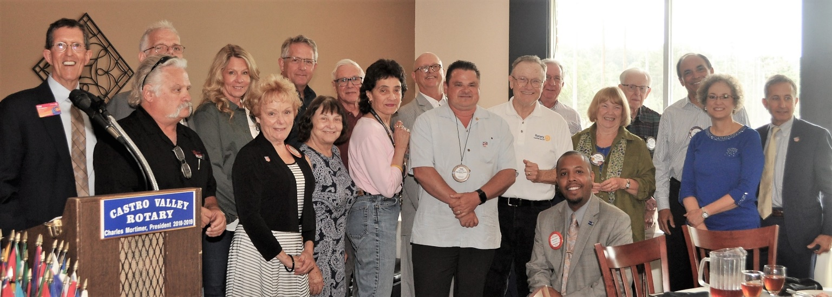
The Rotary Foundation (TRF) Double Sustainers
Every year during the District Governor’s visit, members of the Rotary Club of Castro Valley are asked to become Double Sustainers ($200/member) to The Rotary Foundation (TRF). The Club has committed to donating $10,000 to TRF in 2018-2019. DG Lundell presented every member who pledged to be a Double Sustainer with a TRF pin. It is never too late to make a donation. See Dwight Perry details. For more information about the work of TRF, click here.

Newest Member

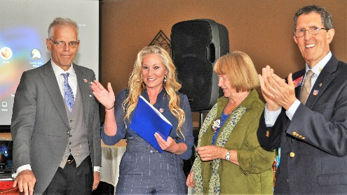
Vicki Alva was inducted and presented her Red Badge by DG Tim Lundell, President Charles Mortimer, and Membership Virginia Degner as the newest member of the Rotary Club of Castro Valley. Vicki is a Financial Planner who works for Prudential Advisors in San Ramon and lives in Hayward. Virginia Degner was her sponsor. Please personally welcome Vicki to the Rotary Club of Castro Valley.
Announcements:
- Heidi Hausauer announced that approximately 100 backpacks were assembled by volunteer Rotarians at her office on August 7th. The backpacks where distributed to needy students at Redwood Christian Schools and Castro Valley Unified School District Schools. Be sure to check out the story in the Castro Valley Forum. (Left photo)
- President Charles Mortimer updated the membership on the status of the Breathing for Life Project and shared the donations from the Castro Valley Sanitary District, which will be used to support the Children’s Christmas Party. Be sure to check out the story in the Castro Valley Forum.
- Cliff Sherwood announced the Club Picnic/BBQ at Randy Vanderbilt’s home. A BIG THANK YOU to Randy for hosting.
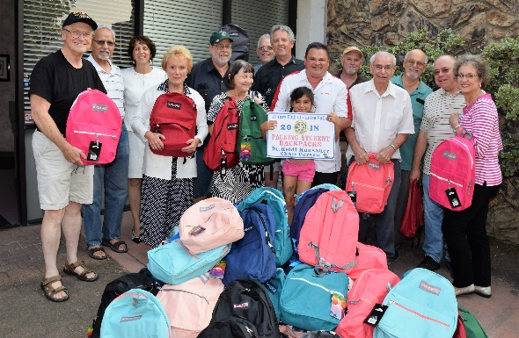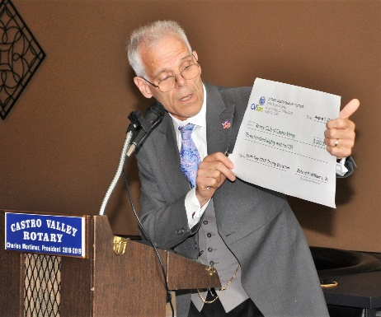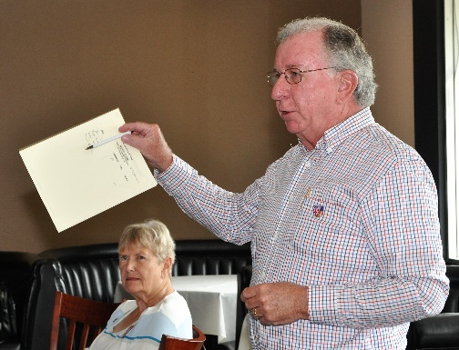
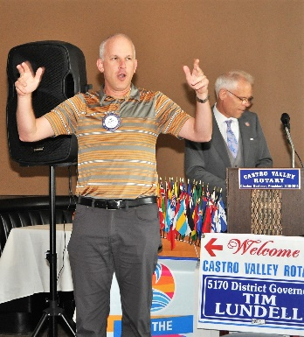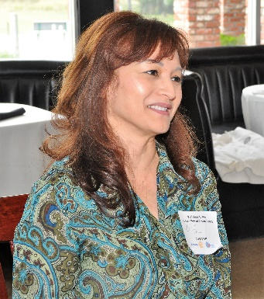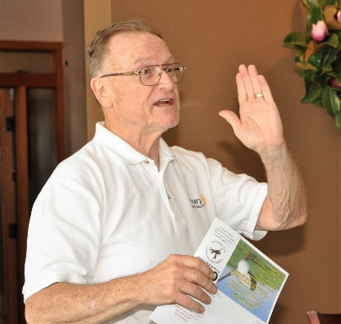
(Left to Right): Dan Willits leading the Hello Song. Former Castro Valley Rotarian Rita Sabin looking to rejoin the Club. Bruce Johnson promoting the Castro Valley Sports Foundation Golf Tournament.

Upcoming Speaker
August 28: Teddie and Keith Seibert, TwiningVine Estate Winery - Making Estate Wines in Castro Valley

Meeting Notes: Ajay Ahluwalia
Photos: Murline Monet
Editor: Jim Negri

