Summary of August 2nd Meeting
Prepared by Jim Negri

Welcome to Our Newest Rotarians
President Carol inducted two new members: Ajay Ahluwalia (Engineer – Retired) and Michaela Thompson (CPA). Tammy Landmesser (Corporate - Recycling) will be inducted next week. Please introduce yourself to our newest members.

Carol and Ceta have challenged each of us to bring in a new member this year. Consider inviting a potential member to a lunch to learn about our Club. Remember: A personal invitation is the best way to recruit a new member. See Ceta for recruiting/membership information.

Announcements
Board meeting is August 8 at 6:00 p.m. at the Chamber of Commerce Office. Everyone is invited to attend. Attending a board meeting is a requirement for a Red Badge member to earn a Blue Badge.

Club Picnic is August 16 at Lake Chabot. You should have received an invitation through ClubRunner. Please RSVP even if you signed up at the meeting so that we have enough food and drink for everyone.

Castro Valley Eden Area Chamber of Commerce is hosting a Mixer on August 18 at Redwood Canyon Golf Course.

Redwood Canyon Golf Course is hosting a free Movie Night with food and drink on August 27 at 5:00 p.m. A flier with details will be sent out later.

Mathilda is hosting an October Fest on October 9. Tickets sold out last year and are going fast. See Mathilda for tickets.

Mark your calendars for the Breathing for Living Gala on October 22 at Redwood Canyon Golf Course.

Speaker
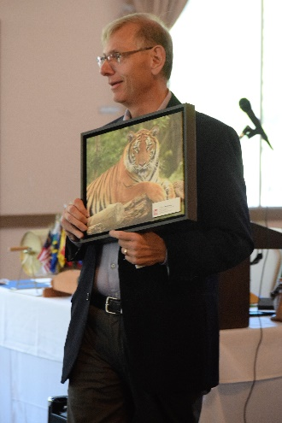
Len Wayne, District Manager for Mike’s Camera, was the engaging speaker for the day. His fast-paced and informative presentation covered how the photography business has changed, how businesses can use photography as a competitive advantage and what Mile’s Camera can do for you as an individual or business.

Founded in 1974, Mike’s Camera is a family-owned business based in Boulder, Colorado with five stores in California. Dublin is the nearest location. Mike’s Camera is a full service store, which means photographic equipment, supplies, printing and other services including education/classes and community service.

Len focused on what Mike’s Camera does well and what any successful business must do.

- Customer based
- Full service, one stop service
- Great service, but not necessarily the lowest price – high quality, personalized service is the key
He further described what Mike’s Camera does well.

- Serves photographers of all skills from amateur to professional.
  - Offers a free 30-minute consultation.
  - Will help you transfer photos from your phone to make quality prints.
- Stocks what people want to buy.
  - Help customers purchase the right camera.
  - The company is successful only if customers like what they purchase; therefore, there is no restocking fee on returned items.
- Offer high quality printing
  - Shared the wide range of surfaces (e.g., aluminum, acrylic, canvas, numerous paper textures) on which photos can be printed.
- Works with customers as individuals.
- Offer classes and education.
- Involved in the community.
- Fun in-store activities and support for community events (e.g., San Francisco and Sacramento Zoo).
- Production is centralized and done by experts in the field.

In terms of how photography and Mike’s Camera can help businesses, Len touch on

- Making presentations to business.
- Digital photography has made it easier and less costly to use photography in business.
- Utilizing photos in an office or business promotes the business by creating a real person for clients (e.g., owners having fun, customers with their projects, timeline of project development)
- Photos make the business and the people more real and connect to the customers.
- Photos can be used to create thank gifts for clients (e.g., photo homeowners in front of their new home, coffee mug with photo)
- Photo books that illustrate the work of a company from start to finish.
- Incorporating photos into announcement and event cards.
- Using drones to showcase homes for real estate agents as Charles demonstrated earlier in the year.

