Rotary Club of Castro Valley
Meeting Highlights- August 28, 2018

Teddy and Keith Seibert – TwiningVine Winery
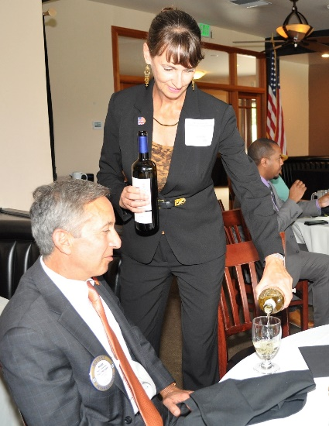
The husband and wife winemaking team of Teddy and Keith Seibert from TwiningVine Winery in Castro Valley shared their winemaking experience and samples of their wines to the delight of the members.
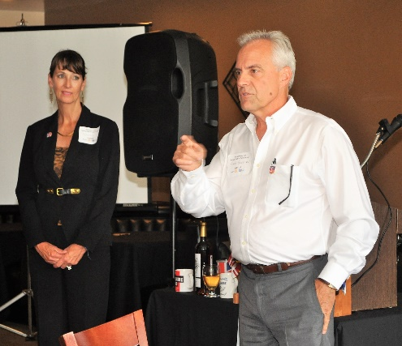
Teddy and Keith are long-time Bay Area residents who have worked as financial planners at USB. They both love rural living, which has become difficult due to the rapid urbanization of the Bay Area. In 1998, they purchased an old ranch among the rolling hills and oak forests of Cull Canyon in Castro Valley. Teddy and Keith worked to clear the ranch of old debris and started the winery with about 300 grape vines. They started making wine for their personal use as a hobby. Soon this hobby grew into a small business producing 1000 cases of wines a year. In 2003, they established the TwiningVine Winery and now produce Cabernet Franc, Cabernet Sauvignon, Chardonnay, Merlot, Sangiovese, Sauvignon Blanc, Syrah and Zinfandel from grapes grown at the winery estate.

The winery is open for tours and tastings on second and forth Saturdays of the month. The winery is available for intimate weddings or small parties. If you haven’t visited TwiningVine Winery, the drive out Cull Canyon Road is well worth it. More information about the winery is available here.

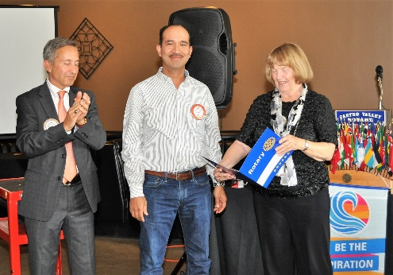
Newest Member: Javier Padilla

Javier Padilla is the President of the Oakland Pallet Company, Inc. was presented his Red Badge and Certificate of Membership by Membership Chair Virginia Degner, President Charles Mortimer, and Mark Poniatowski, his sponsor. Oakland Pallet Company, Inc. is located in San Leandro and has over 200 employees and multiple facilities throughout California. More information about the company is available here. Please introduce yourself to Javier at the next meeting and consider sponsoring a new member yourself.

Announcements:
- President Charles Mortimer and Carol Bigelow each pledged $1000 to expand the School Backpack Project.
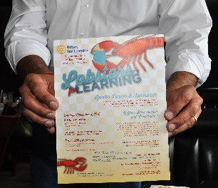
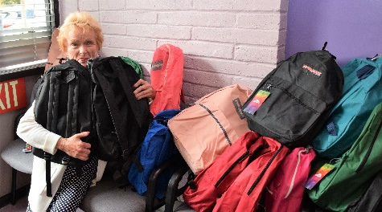
- President Charles Mortimer auctioned off two bottles of wine left over from the Club Picnic. John Aufdermauer and Bill Nott were winning bidders.
- San Leandro Rotary Club is holding a Lobster Feed fundraiser on November 5, 2018. Watch for further details or contact Aaron Lewis for additional information.

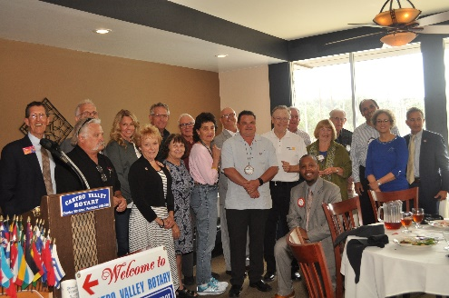
- The Rotary Foundation (TRF) Chair Dwight Perry reported that members of the Rotary Club of Castro Valley pledged $7,000 to The Rotary Foundation during the visit of the District Governor Tim Lundell on August 14. The target for the Club this year is $10,000, which the Club has met and exceeded in recent years. If you were not present on August 14 or have not responded to Dwight’s letter, it is not too late to make your 2018-2019 TRF pledge, which counts towards your Paul Harris Fellow. See Dwight for information on how to donate.
- John McPartland updated members on the progress BART is making. Currently, BART is operating 65 trains daily and has ordered new cars with revamped compartments, which will allow ridership to increase from I,000 passengers to 1,500 passengers per train. To meet this demand the new train compartments will have 3 doors each with fewer seats for sitting and more room for standing passengers.

Upcoming Speakers & Events
September 4 – Ginny Roth, Alzheimer’s Association of NorCal – Update on its work and activities
September 8-9 – Castro Valley Eden Area Chamber of Commerce Fall Festival
September 11 – Mary Jo Price, Douglas Morrison Theater – Update on the theater and upcoming productions
September 18 – Kathleen Scheidel, Attorney – Update on capital punishment in California
September 20 – Castro Valley Eden Area Chamber of Commerce Mixer at Pete’s Hardware/Vanderbilt Construction
September 26 – Rotary Club of Castro Valley Board of Directors Meeting – All members welcome
Don’t forget to RSVP every week for lunch. Consider bring a guest to share the Rotary experience.

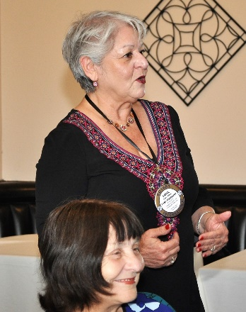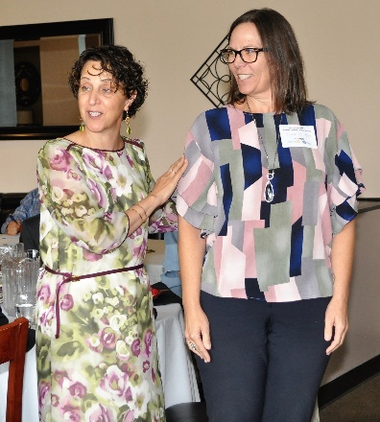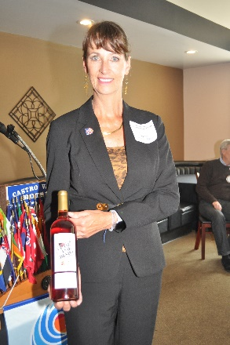
Left to Right: Past Past President Carol Wilke making an announcement. Superintendent Parvin Ahmadi introducing her guest, Aimee Cayere, Executive Assistant to the Superintendent. Teddy Seibert proudly displaying one of the TwiningVine Estate wines.

Meeting Highlights
Meeting Notes: Ajay Ahluwalia
Photos: Murline Monet
Editor: Jim Negri

