Rotary Club of Castro Valley
Meeting Highlights – August 7, 2018

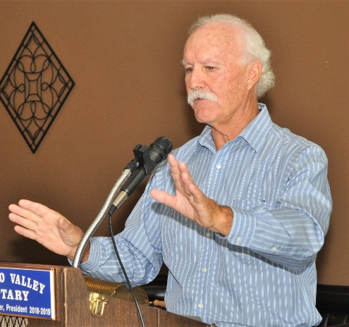
Dennis Waespi, Director – East Bay Regional Park District
Castro Valley resident Dennis Waespi represents Ward 3 on the East Bay Regional Park District (EBRPD) Board of Directors. Ward 3 includes Castro Valley, most of Hayward, Union City, and a portion of Fremont. Click here to see a map of Ward 3. The parks in Ward 3 include Anthony Chabot, Lake Chabot, Cull Canyon, Don Castro, Dry Creek/Pioneer, Garin, Hayward Shoreline, a portion of Pleasanton Ridge, Quarry Lakes, and Vargas Plateau.

The East Bay Regional Park District is the largest local park district in the United States and it manages:

- 121,397 acres;
- 73 regional parks, recreation areas, wilderness, shorelines, preserves and land bank areas;
- 31 regional interpark trails;
- 1,250 miles of trails within parklands;
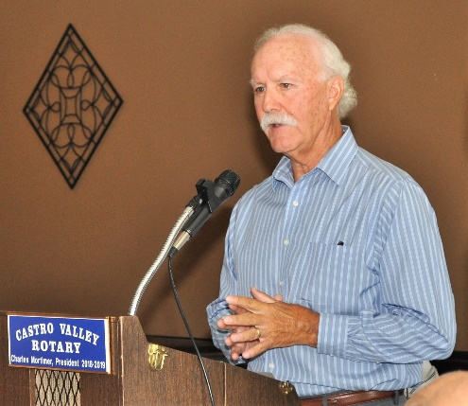
- 11 freshwater swimming areas, boating and/or stocked fishing lakes and lagoons and a disabled-accessible swimming pool;
- 40 fishing docks; 3 bay fishing piers;
- 235 family campsites; 42 youth camping areas;
- 2 golf courses;
- 2,082 family picnic tables;
- 1,707 reservable group picnic tables;
- 10 interpretive and education centers;
- 18 children's play areas; and
- Wedding, meeting and banquet facilities including Redwood Canyon where the Rotary Club of Castro Valley meets.

EBRPD acquires, manages and preserves the natural and cultural resources for all to enjoy now and into the future. The parklands help to ensure preservation of natural beauty that makes bay area such a desirable place to live. They provide habitat for wildlife, including many rare and endangered species. They enhance region’s quality of life resulting in tangible as well aesthetic values. The park district provides an extraordinary choice of educational and recreational facilities.

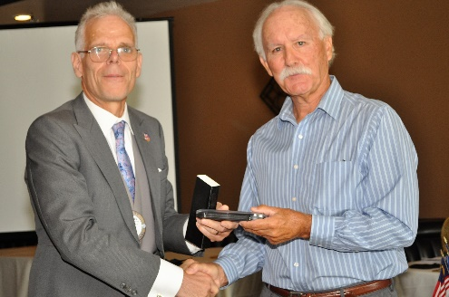
The Park District is responsible for maintaining the trails and open spaces including the maintenance of trees and cutting grass to maintain a safe environment in terms of fire protection. EBRPD maintains its own fire protection and fire safety and prevention departments who work in cooperation with other city, county and state fire prevention and Fire Safety departments. The district owns its own fire engines and has many trained fire fighters who are working in support of the current fire fighting efforts in the state.

The District also maintains and operates golf course including Redwood Canyon. The East Bay Municipal Utility District (EBMUD) owns the Redwood Canyon Golf Course and leases it to EBRPD, which in turn has leased the management and operation of the golf course to the present management who is responsible for the operation of the restaurant and banquet facility.

For more information about the wide range of parks, programs, and activities offered by the EBRPD, click here.

Newest Paul Harris Fellow – Bob Shayler
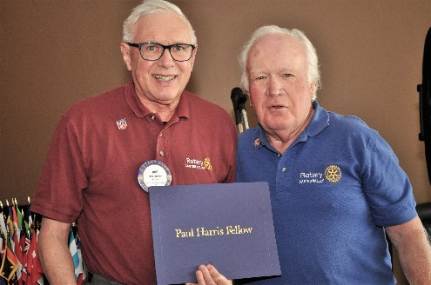
Dwight Perry, Club Chair for The Rotary Foundation (TRF), presented Bob Shayler with his Paul Harris Fellow pin and certificate for his cumulative donation of $1000 to TRF. Each $1000 donation earns a Rotarian a different Paul Harris pin. Since the Club was chartered in 1953, the Rotary Club of Castro Valley has donated approximately $850,000 to TRF. Currently, 30 Club members are Paul Harris Fellows and 22 of the 30 are multiple Paul Harris Fellow. To learn more about the history of the Paul Harris Fellow recognition, click here.
Visit by District Governor (DG) Tim Lundell
DG Tim Lundell visits the Club on August 14th. The DG will start the day with a meeting with the board at 10:30 a.m. at Redwood Canyon Golf Course followed by lunch when Tim will speak on Be the Inspiration, the 2018-2019 Rotary Theme. The board meeting is open to all members and attendance at a board meeting is a requirement to earn a Blue Badge.

District 5170 Membership Seminar
President Charles Mortimer distributed a flier for the District 5170 Interactive Seminar on Membership on August 25th at Cupertino Community Hall, 10350 Torre Ave., Cupertino, CA 95104 from 9:00 am to 12:30 pm.
Click here to see the flier. Attendance at a District event is a requirement to earn a Blue Badge. The Club pays the cost of the seminar. Contact President Charles ASAP, if you would like to attend.

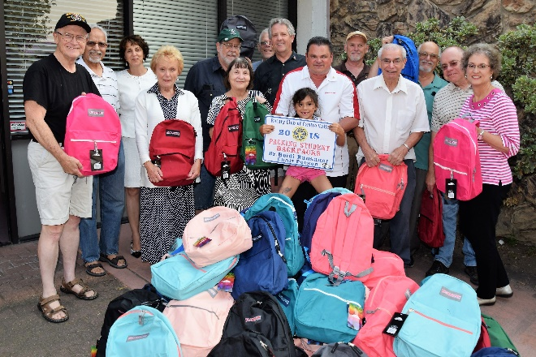
Student Backpack Project
On the evening of August 7th, 15 Rotarians gathered at the office of Dr. Heidi Hausauer, Chair of the Student Backpack Project, and stuffed 96 backpacks for students in the Castro Valley Unified School District and Redwood Christian Schools. Thank you to everyone who participated. The many hands made the work fun and go quickly.
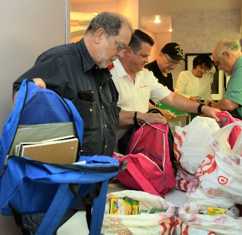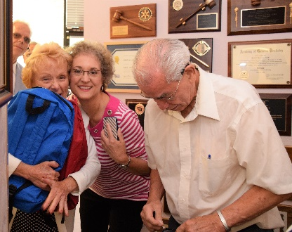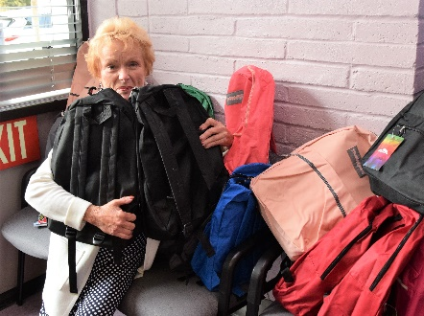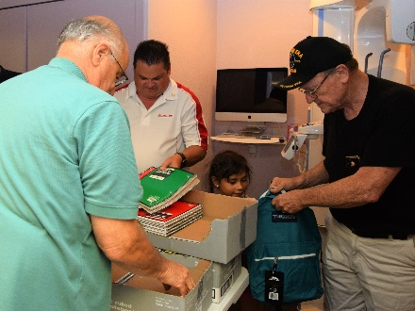

CVSan Donation
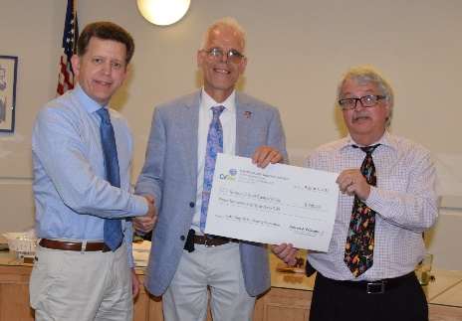
After stuffing backpacks, President Charles Mortimer and Past President Jim Negri headed over the CVSan board meeting where they received a donation of $380 from Board President Tim McGowan. The donation was generated by volunteers on the CVSan Earth Day Clean-up. Each volunteer could designate one of three community organizations to receive $5 for the individual’s volunteer efforts. The Club will use the donation to support the Children’s Christmas Party in December.

Upcoming Speakers and Events
- August 14 – Special Board Meeting with District Governor Tim Lundell at 10:30-12:00 – All board members are expected to attend, and all members are invited to attend. Attendance at a board meeting is a requirement to earn a Blue Badge.
- August 14 – Lunch with District Governor Tim Lundell – Be the Inspiration
  - Please consider making a Double Sustainer Pledge ($200) to The Rotary Foundation. Please refer to the letter that Dwight Perry mailed to you and discussed at recent lunch meetings.
- August 21 – Club Picnic at 5:30-8:30 p.m. Please refer to the email you received for details regarding location and cost.
- August 25 – District 5170 Inactive Membership Seminar. See details posted above.
- August 28 – Lunch with Teddie and Keith Seibert, owner of TwiningVine Estate Winery in Castro Valley.

Please remember to RSVP each week for lunch to ensure that there will be enough food for everyone.
Details regarding the speakers are available on the Club website.

