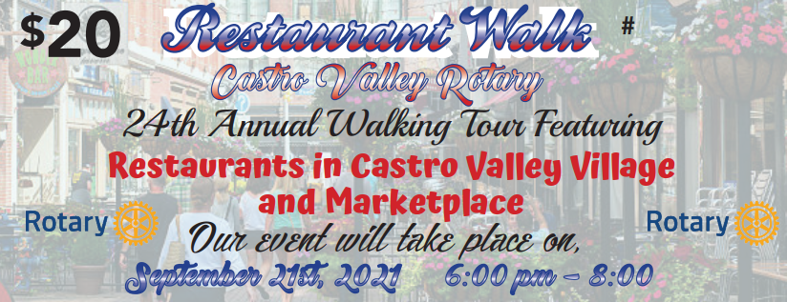
Purchase your ticket books
today! Just $20 gets you
samples from:
Foundations to your contributions also help to support the following Projects:
- Adopt a Family during the holidays
- Holiday Party for underprivileged
- Student Backpack program
- Thanksgiving Senior Luncheon
- Supporting sports, science etc. In the CV School Dist.
- iPads in senior living facilities
- Dinner for firefighters
- Support of Ruby’s Place and FESCO
- Oxygen generator plant in Ethiopia (saves the lives of 10 children a month)
- PolioPlus - To eliminate polio in the world
- Don Jose’s Restaurant
- Shari’s Pies
- Cannery Kitchen & Tap
- Cordial Cellar and Lounge
- Farmcurious
- Amphora Nueva
- Mr. Pickles
- MOD Pizza
- Aroma Cuisine of India
- Knudsen’s Ice Creamery
- Rigatoni’s
For tickets to Restaurant Walk 2021, please contact:
Aaron Lewis – Alsplace2013@gmail.com or 510-283-3760
Christian Carr – chris@yourlenderchris.com or 650-207-4364
- Portales Taqueria
- See’s Candies
- Vitality Bowls

