ClubRunner 101: How to Access Everything for Rotary Club of Castro Valley
Lesson #1

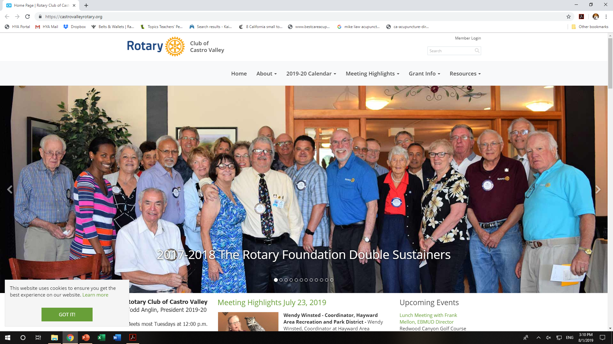

- Log into ClubRunner at www.castrovalley.org (A)

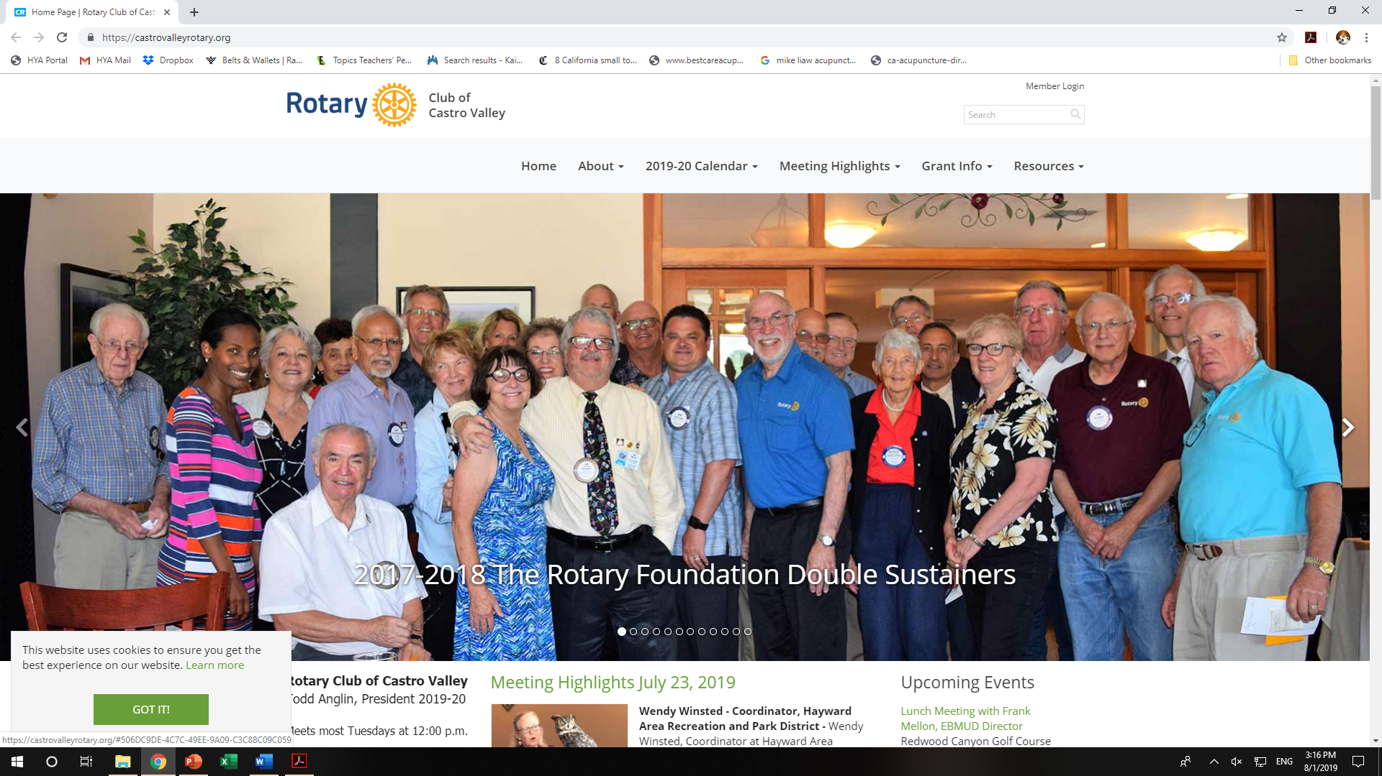
- Click on Member Login (B)
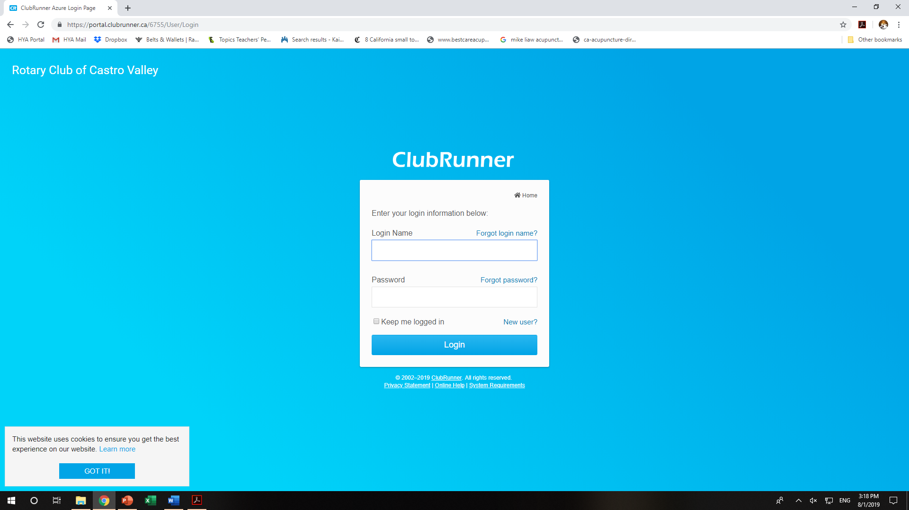
- Enter your Login Name (C) and Password (D) and proceed to Step 12.
- If you do not recall your Login Name, click Forgot login name? (E)
- If you do not recall your Password, click Forgot password? (F)
- Steps 4 and/or 5 will take you to this screen. (G)
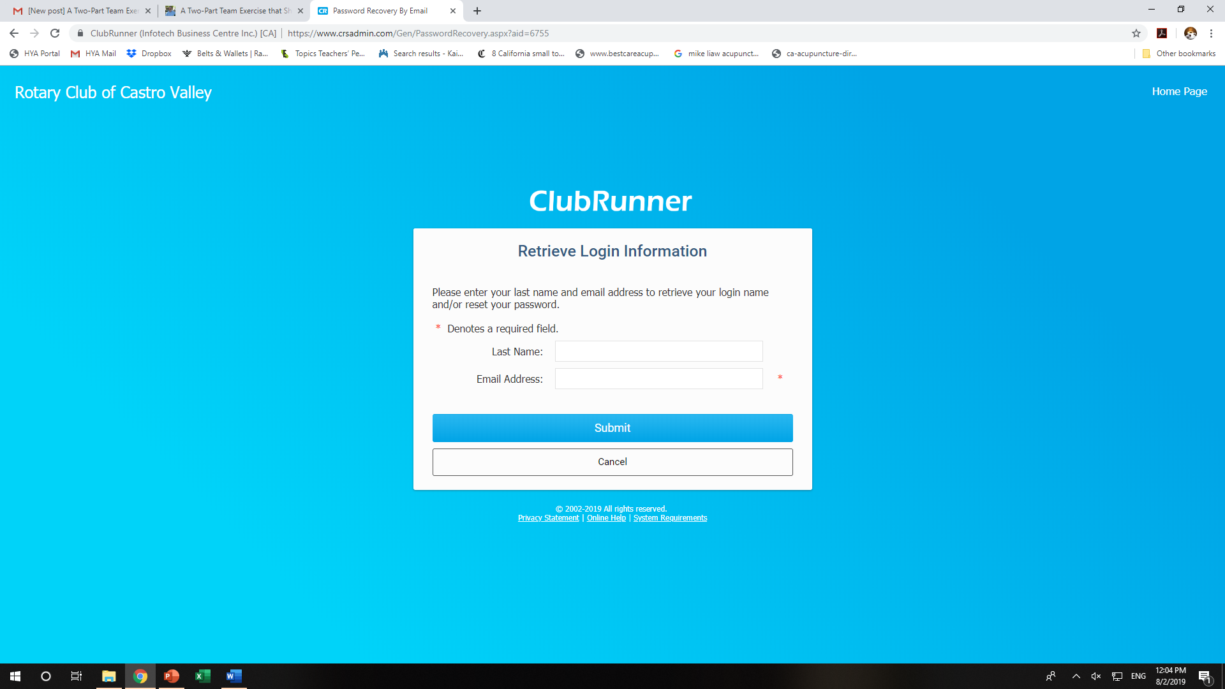
- Enter your Last Name (H) and Email Address (I) and you will see the following screen. Check you email for directions.
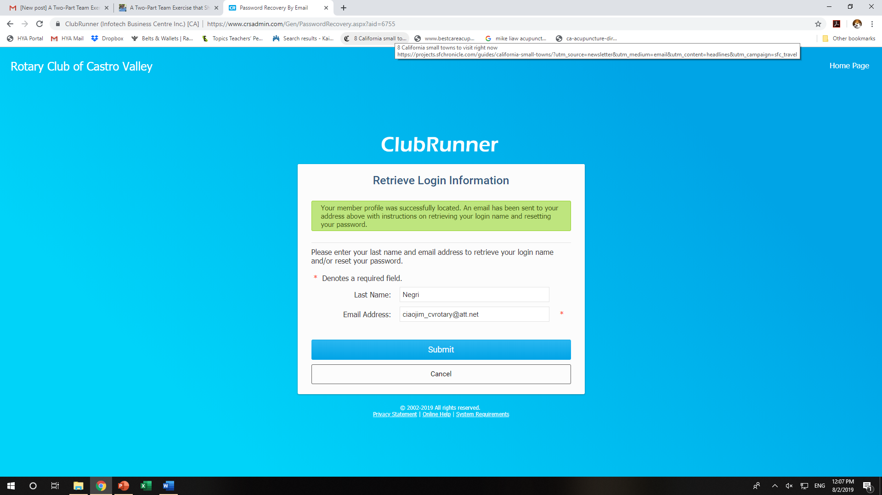
- When you open your email, you will receive this message. (J)
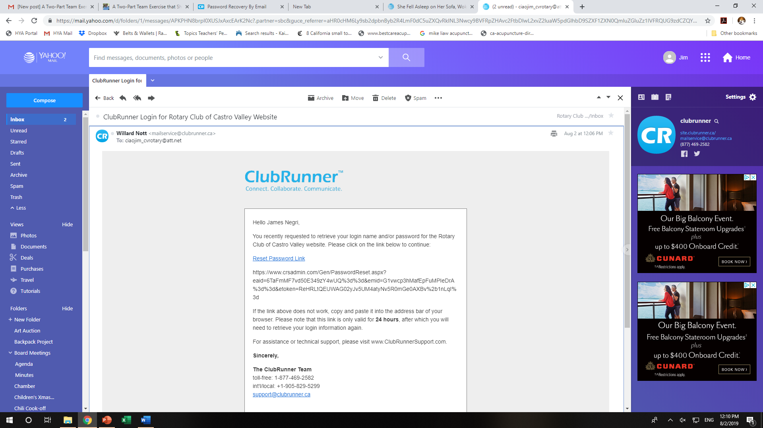
- Click on the Reset Password Link (K), which will take you to the following screen, enter the requested information, and submit.
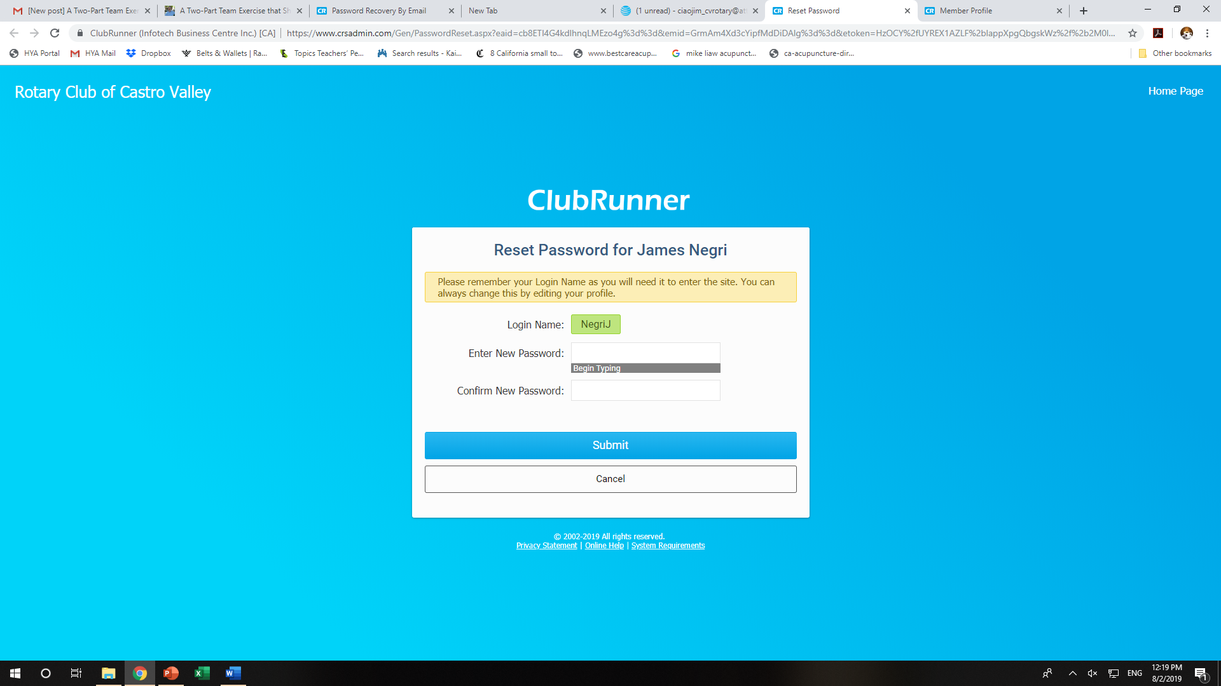
- When you submit the information, you will see this screen. (L)
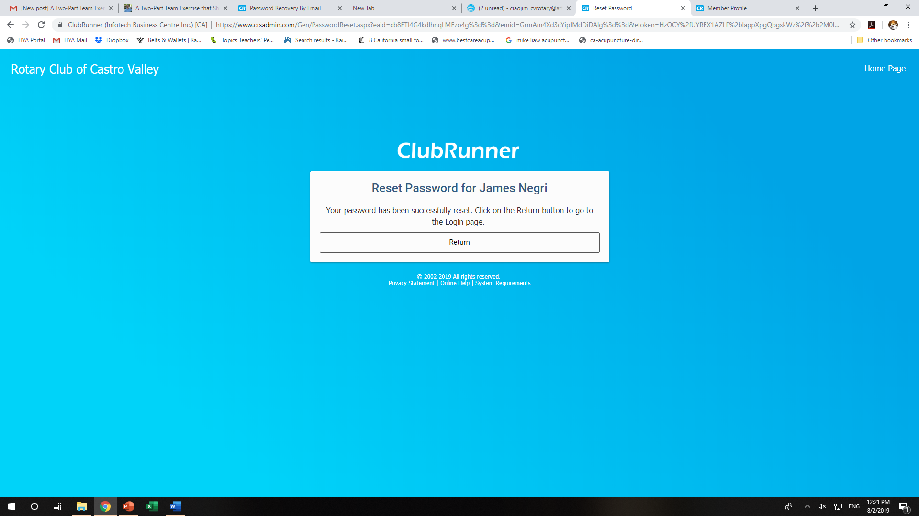
- Click return (M) and you will be taken to the ClubRunner login page (N – next screen shot). Enter your Login name (O) and Password (P).
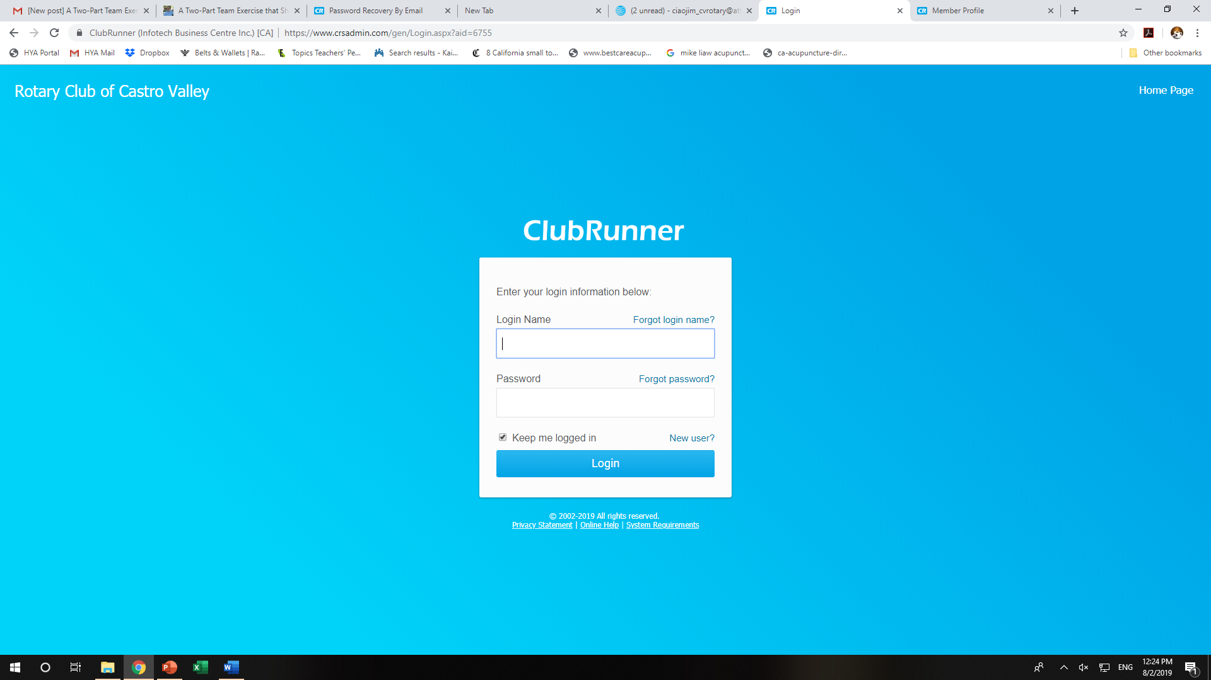
- Enter your Login Name (O) and Password (P) and you will be taken to the following page, which allows you to access all the member’s features for ClubRunner. Please note, some features have restricted access based on the role you have in the Club. If you have any questions about your access level, please contact Todd Anglin or Jim Negri for assistance. 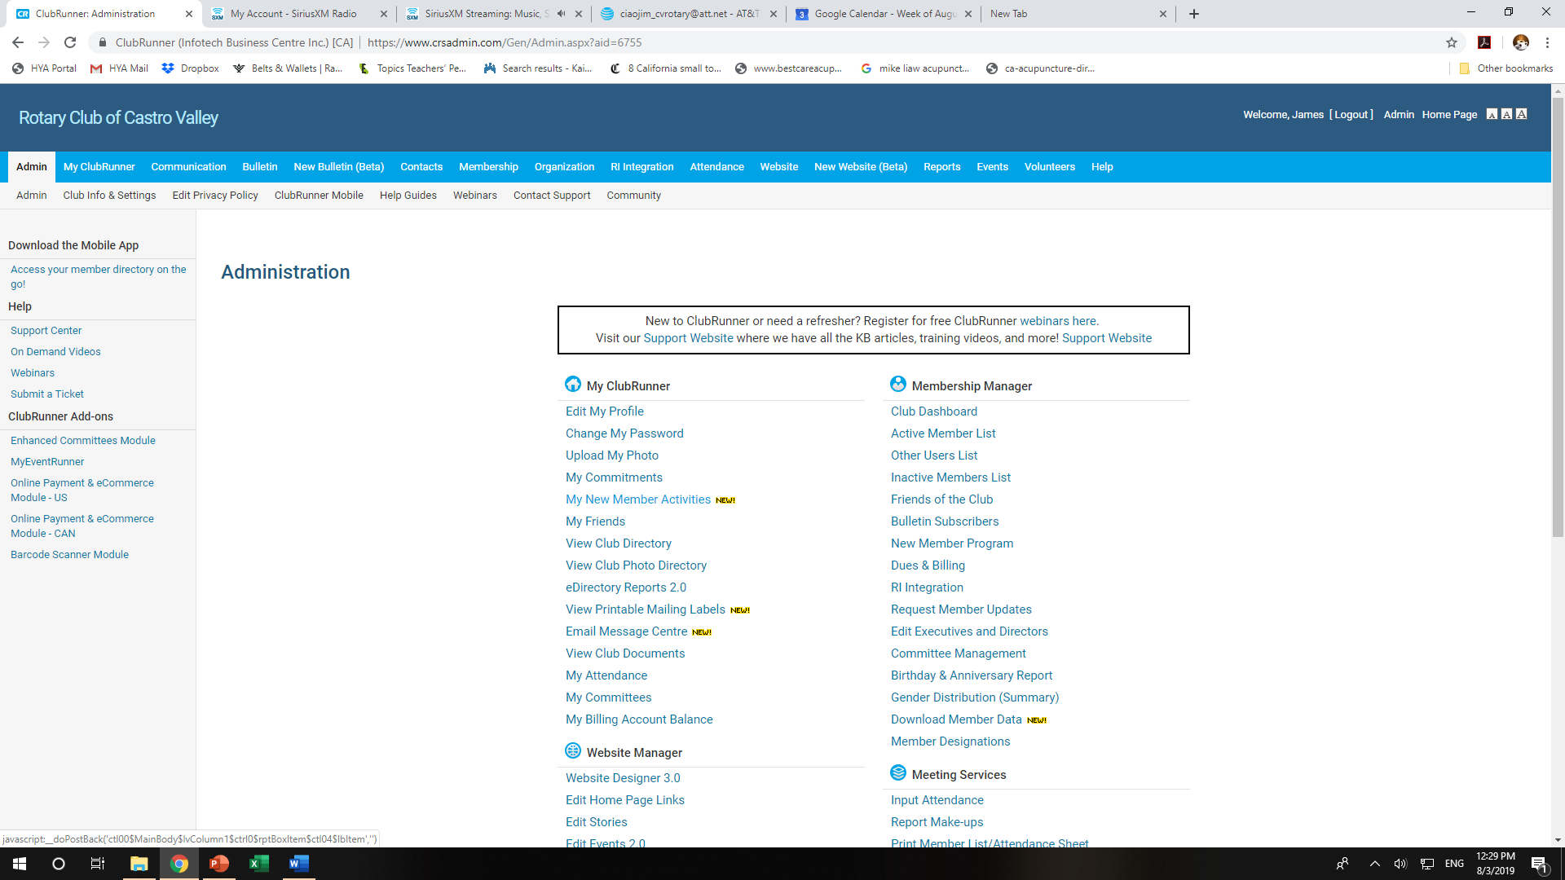
- This page is your access to all information in ClubRunner. ClubRunner 101: How to Access Everything for Rotary Club of Castro Valley Lesson #2 will demonstrate how to access the various components of ClubRunner.

