Rotary Club of Castro Valley
Meeting Highlights – December 19, 2017

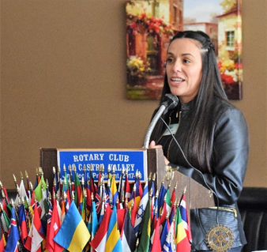
Emily Griego – President & CEO San Leandro Chamber of Commerce
Emily Griego, a native of New Mexico, shared what has been happening with the San Leandro Chamber of Commerce and what is in the works for the future, both the short and long term. She was accompanied by Chamber Marketing Manager Nicole Hankton. Emily and Nicole are two of the three Chamber employees, the other being Angela Villanueva-Olson, Operations Assistant. The San Leandro Chamber of Commerce is governed by an 18-member Board of Directors.

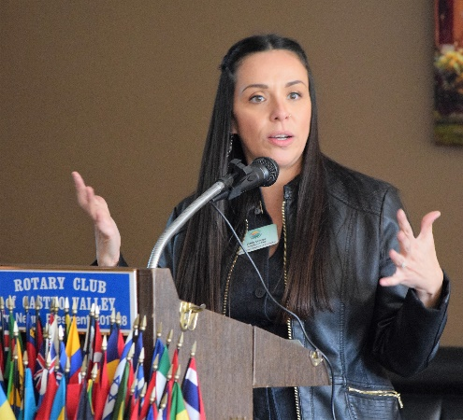
Emily did a great job sharing the Mission and Goals of the Chamber as well as explaining the Leaders Circle of Premiere Chamber Supporters, the many innovative and relevant programs offered by the Chamber (e.g., "San Leandro by Design," Career Pathways, "Ambassadors" Program, Leadership San Leandro, Public Policy Forum and Business Support, Networking Programs). She shared a list of the Top Twenty Employers in San Leandro and described how social media is an intricate piece of Chamber’s promotional efforts.

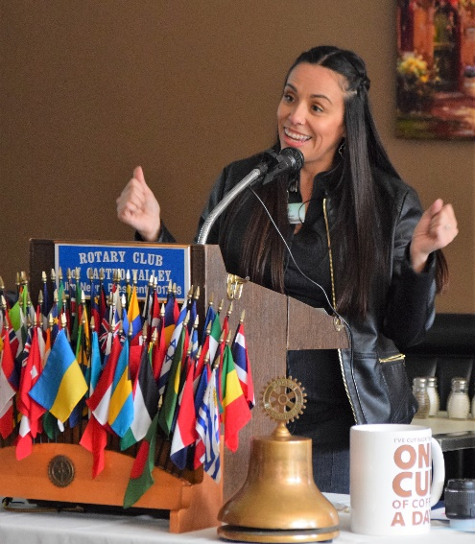
Development in San Leandro is booming with the construction of the San Leandro Tech Campus, the Marea Alta Phase II, Friant Furniture, Marina Gateway Industrial Center, San Leandro Business Center, SLTC, Creekside Plaza (4th Building), Galvan Apartments, 2001 Williams Street and four new restaurants (Shabu House, Moussaka Mediterranean Kitchen, Top Hatter's Kitchen and Bonchon Chicken).

In addition to the projects currently in production, several other projects are in the "pipeline" including Monarch Bay, Alvarado/Aladdin Project, Cannabis Manufacturing and Labs (San Leandro will have three cannabis retail outlets), Eden Housing, Broadmoor Village, Parrott Street & Washington Avenue, Sansome Pacific Project, Alvarado & Antonio Project and the Bayfair Transit Oriented Development! Many things are happening in San Leandro!

Thank you to Emily for making her PowerPoint presentation available here.

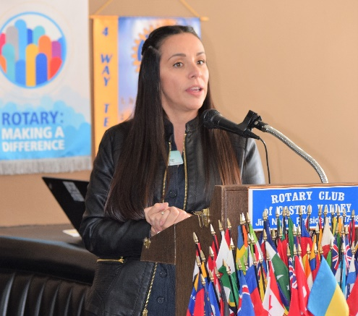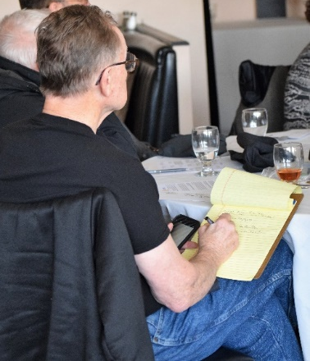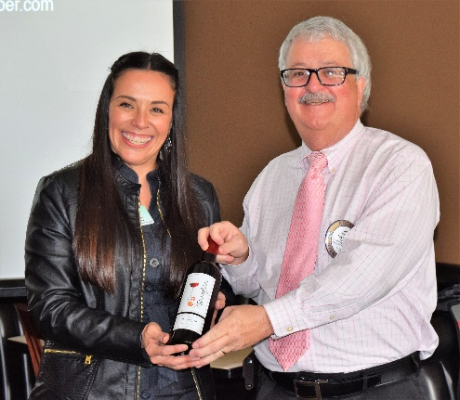
(Left to right): Emily Griego sharing the San Leandro Chamber of Commerce story; Bruce Johnson taking notes for Meeting Highlights; and President Jim Negri presenting Emily a bottle of wine from Castro Valley winery TwiningVine.
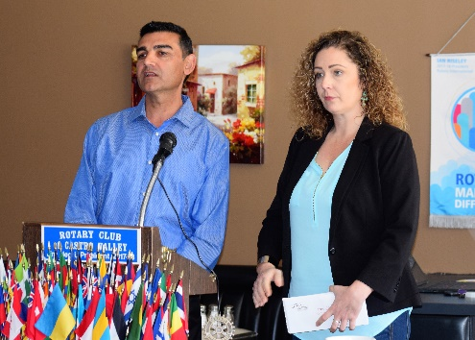
What's New in Castro Valley – JP’s Restaurant & Sports Lounge
Jessica Samler, Floor Manager, and Nazir Ahmadi, Partner, shared the long development, opening, and operation of JP's Restaurant & Sports Lounge (3600 Castro Valley Blvd., the former location of Dino's Restaurant, phone number 510.876.5151). JP’s has a sports bar has 12 big screen TV's, a dining area, and a banquet room that can serve up to 90 people. Breakfast, lunch, and dinner are served seven days a week (be sure to check for daily specials at www.dinejps.com) Jessica and Nazir presented Rotarians and guests with a $5 gift certificate to JP's that expires in 2018.

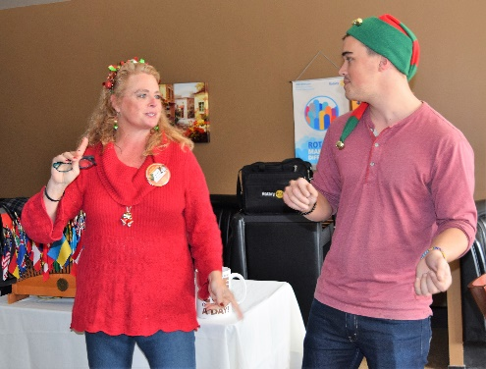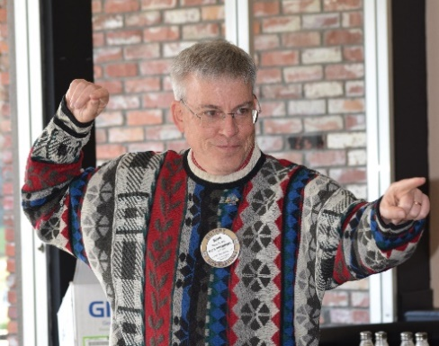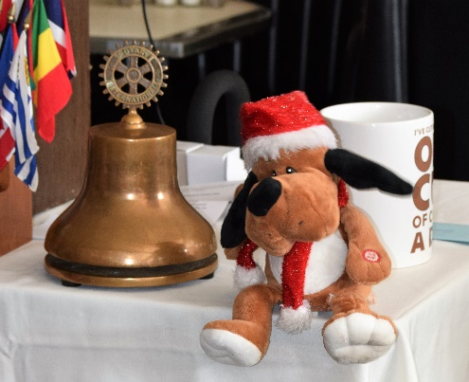
(Left to Right): Michaela Thompson and son William lead a holiday Song of the Day, Kern Lewis leads the Welcome Song,
and a special guest (thanks, Ceta) presents another holiday song.

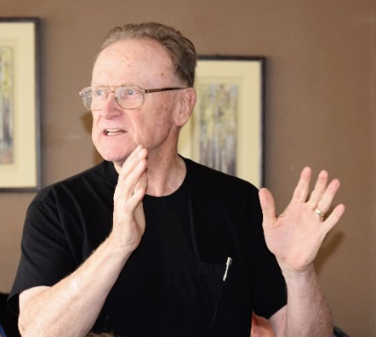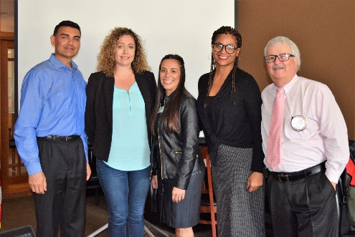
Bruce Johnson shares the joy that Rotary spread with the Children’s Christmas Party and thanked the CHP and others for their support of the Party. Speakers for the day (l-r): Nazir Ahmadi, Jessica Samler, Emily Griego, Nicole Hankton, and President Jim.

Christmas Tradition: Christmas Gift for Kim, Our Server
President Jim Negri passed his Coffee Cup to collect a Christmas gift for our weekly server, Kim. Jim thanked Kim for her great service every week over the past year and presented her with a cash gift on behalf of the Club and the members.

Upcoming Speakers
- January 9th - Sal Sbranti- President of Antioch Rotary Club
The Women Empowerment Project
- January 16th- Susie Passeggi, Director of CV Adult and Career Center
The New Medical Technology Program- Pathways to Success
- January 23rd- Parvin Ahmadi, Superintendent-Castro Valley USD
Bills Impacting Education

Upcoming Events
- January 11 – Texas Hold ‘em Poker, Chili Cook-off, and Parade Meeting
- January 16 – Paul Harris Fellows Recognitions at Lunch
- January 18 – Castro Valley Eden Area Chamber of Commerce Mixer
- January 27 – Castro Valley Eden Area Chamber of Commerce Eden Awards Dinner
- January 31 – Board of Directors Meeting

