Rotary Club of Castro Valley
Meeting Highlights - December 4, 2018

Zack Ebadi – Adopt-a-Family Program
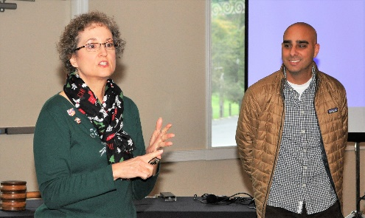
Zack Ebadi is the Hayward Area Recreation and Park District (H.A.R.D.) Volunteer Coordinator for its Adopt-a-Family Program. Under the leadership of Dr. Heidi Hausauer, the Rotary Club of Castro Valley has partnered with H.A.R.D. for a number of years on the Adopt-a-Family Program. Zack provided members and guests with a short update on the Adopt-a Family program. The Club always adopts at least one family to give gifts during the holiday season. This year, the club has adopted two families. Each family member will be presented with a jacket, shoes, and a complete outfit. Project Chair Dr. Heidi Hausauer, who handled the shopping duties, looks forward each year to this project and made full use of Black Friday sales for purchasing the gifts.

After his presentation, Zack joined the Club members for the annual wrapping of the gifts, which always brings out the unique talents of our Rotarians.
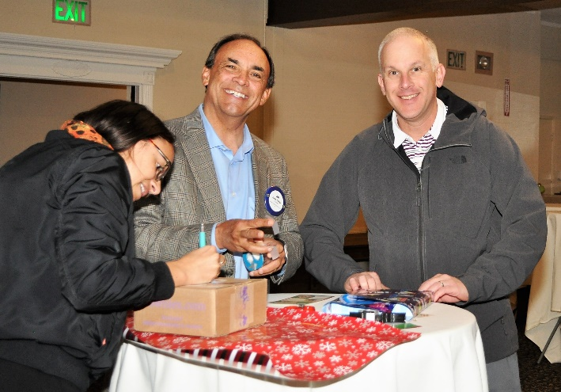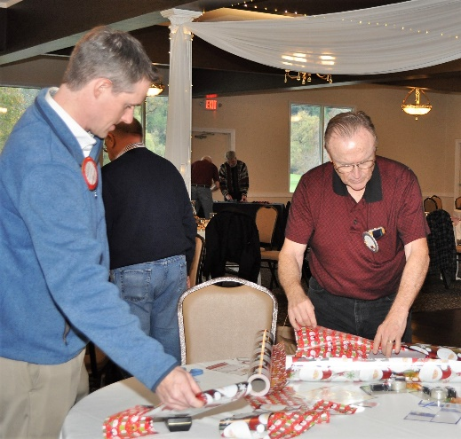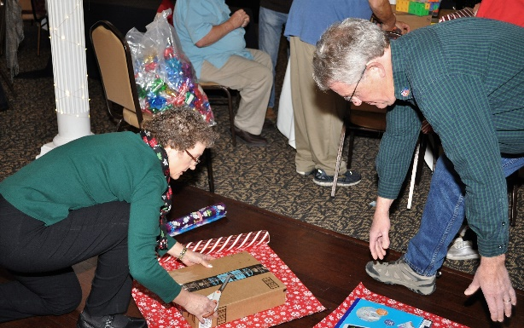

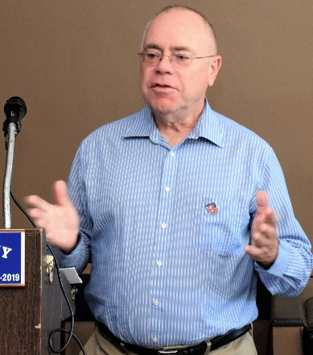
Announcements :
- President Charles Mortimer announced that since Past President Jim Negri is not present and has informed him that there are no other nominations received till now, the nomination process for President Elect 2019-2020. He then proposed that Gary Howard be approved as President Elect 2019-2020. The club members present unanimously approved the nomination by a voice vote. Congratulations to Gary.
- Carol Wikle and Dan Willits announced that the Rotary Club of Castro Valley Trust account is doing well, despite the fluctuating stock market and the portfolio is worth $208,000 at this time.

