Rotary Club of Castro Valley
Meeting Highlights of December 5, 2017

Nick Lavingia - Challenges Executing International Mega Energy Projects
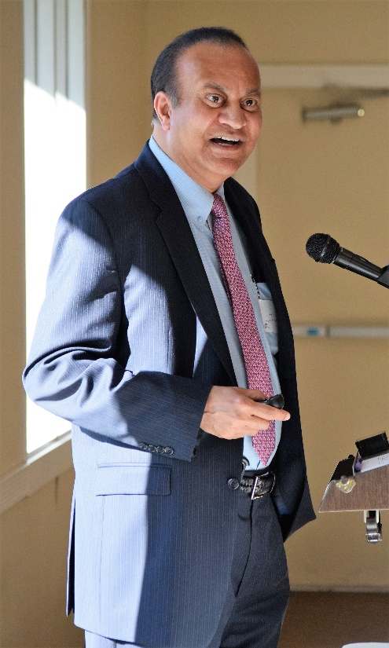
Nick Lavingia, who has over 40 years of Global Project Engineering, Management, Consulting and Training experience in the energy industry with Chevron, captivated the audience with stories and photos of his work on than 100 major capital projects worth well over $100 billion in more than 20 countries. During his presentation, Nick focused on the challenges of executing multi-billon projects that often take twenty years to bring online. Among the challenges that he described with specific personal examples were:
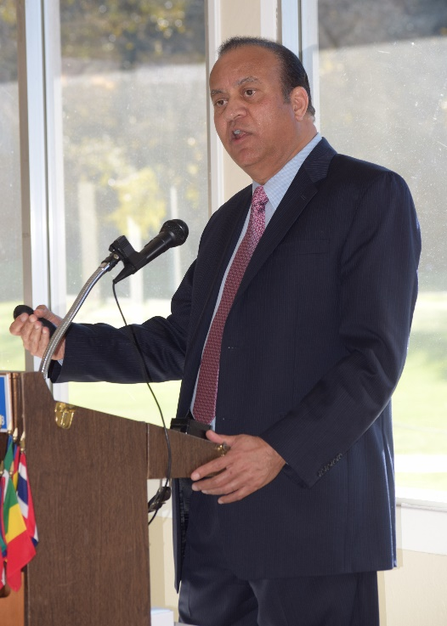
- Safety: Santa Barbara Channel & the North Sea with harrowing stories of accessing an oil platform and a platform designed to absorb a collision with an ice berg
- Technology: Deep Water, High Temperature/Pressure
- Politics: Nigeria
- Regulatory: Los Angeles Nox Project
- Culture: Middle East and Asia with stories of different business practices and procedures in contract negotiations
- Language: Argentina and Kazakhstan when one does not speak the language and must survive day-to-day as well as conduct business
- Weather: Canada and Middle East where one must survive in extreme freezing Artic cold and incredible desert heat

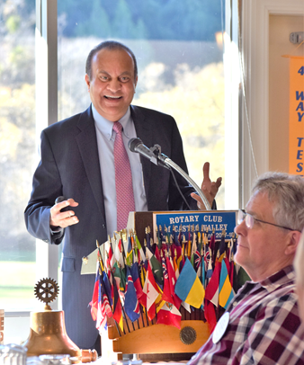
Based on his 40 years of experience, Nick concluded his presentation with a list attributes that a project manager must possess:

- Intelligence of Einstein
- Patience of Two Saints
- Integrity of a Supreme Court Justice
- Negotiating Skills of a Mongolian Horse Trader
- Savvy of James Bond
- Communication Skills of Tom Peters
- Planning Skills of General Schwarzkopf
- Personal Drive of Donald Trump
- Skin of an Armadillo
- Ego of Mother Teresa

He noted that we have yet to find a perfect match.

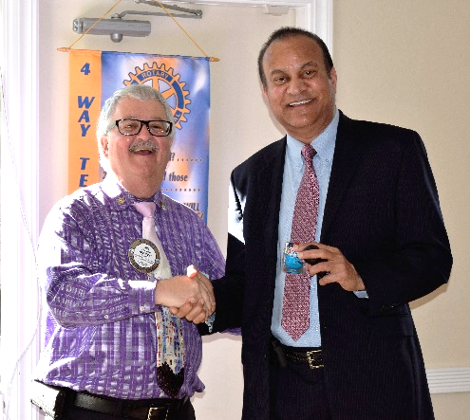

Nick’s stories and slide presentation painted the challenging picture of how a gallon of gas get from to the earth to our cars. Nick generously shared his slide presentation with the Club, which is available here as well as posted on the Club website, www.castrovalleyotary.org. Be sure to make time to see the incredible photos of where Nick has worked.
.

Dan Termini – What’s New in Castro Valley? Cyber Security
Dan Termini, owner of ‎Fast-teks On-Site Computer Services, who has spoken to the Club in the past on technology, presented a quick overview of cyber security as part of the What’s New in Castro Valley segment of the meeting. In his brief overview, Dan focused on the 12 Signs Your Identify Might Have Been Stolen and Identity Theft Tips, and provided handouts on each topic. The handouts are available here: 12 Signs and Tips.
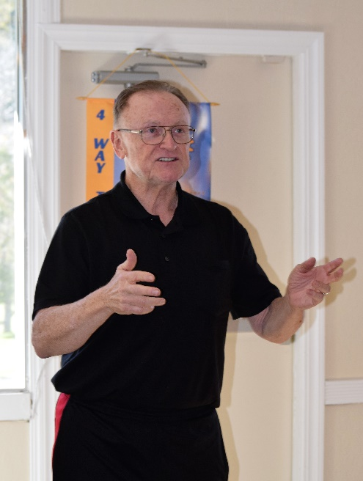
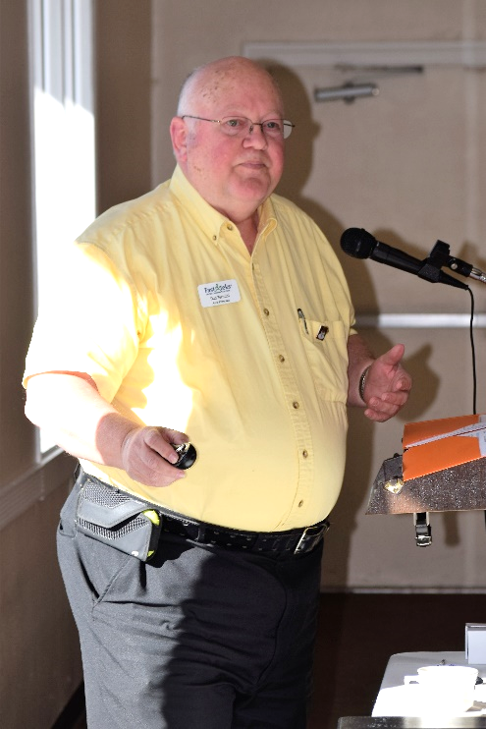
President Jim Negri thanked Dan for the valuable insights and tips as well as Gary Bosley for coordinating the What’s New in Castro Valley? segment, which the Club is tentatively scheduling for twice a month.

Bruce Johnson - Membership Moment
As part of Membership Moment (a one-minute sharing by a member about him/herself that Club members may not know), Bruce Johnson how and why he became a Rotarian. In his work as Superintendent of Redwood Christian Schools and his personal life, he had three appointments that all had to be scheduled around their Rotary Club meeting. This experience convinced Bruce that he needed to be part of the Rotary Club of Castro, which he has been an active member for the past 20 years!

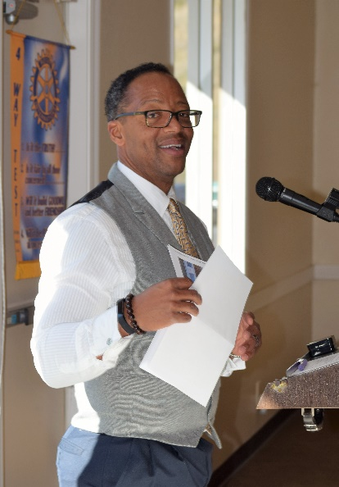
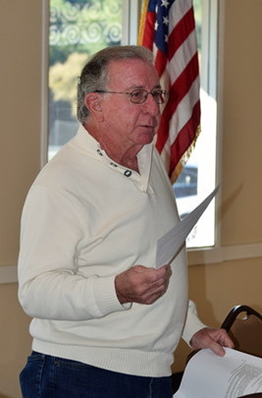
Cliff Sherwood (R) requesting Volunteeers for the Children’s Christmas Party on December 12th. Photos will follow in Special Edition of Meeting Highlights.

Roland Williams (L) providing an update on the opening of Redwood Road.

Speaker on December 19 – Emily Griego, CEO of the San Leandro Chamber of Commerce on What’s Happening in the San Leandro business community including the high speed internet.

Happy Holidays!

