Rotary Club of Castro Valley
Meeting Highlights for December 6, 2016

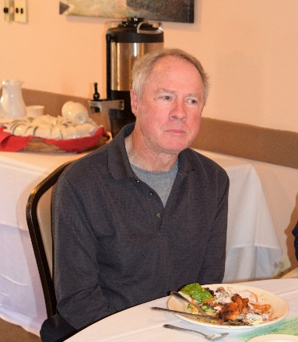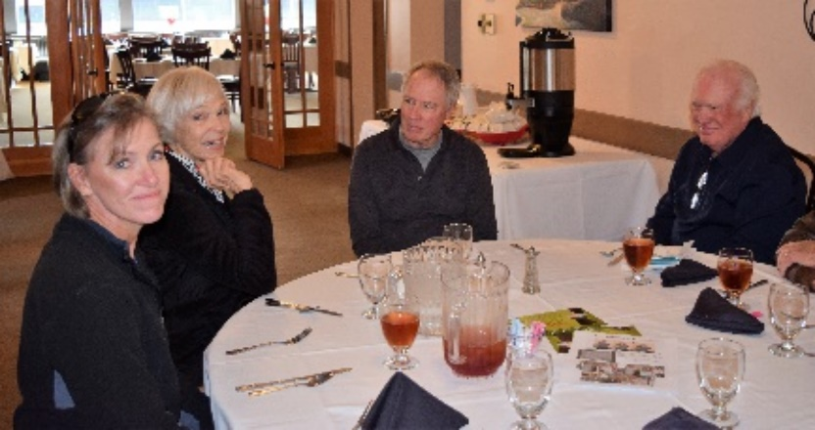
It was great to see Walt Schneider, who attended with his wife, Beth, and daughter, Bonnie. Walt and Beth will be moving to Texas soon near their daughter.
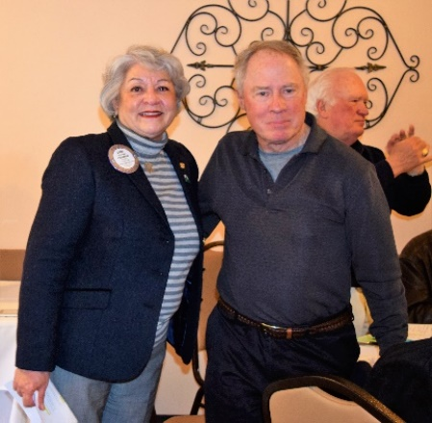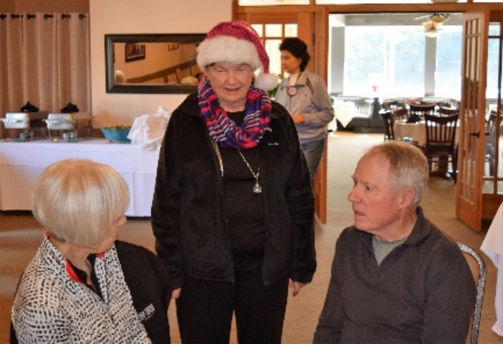
President Carol Wikle presented Walt Schneider with a Rotary Club of Castro Valley Lifetime Membership Certificate. Walt join the Rotary Club of Castro Valley in April 1987 and served as Club President in 1993-94. His sponsor was Rudy Johnson. Walt sponsored Todd Anglin as a member.
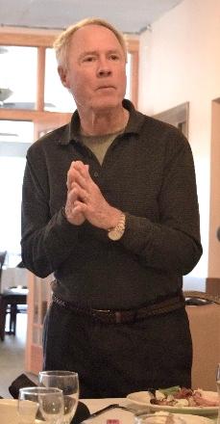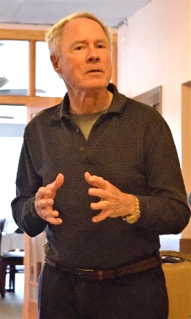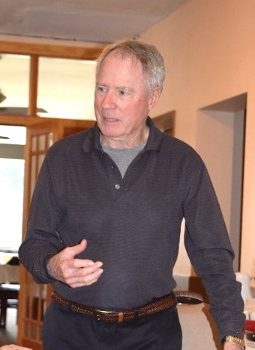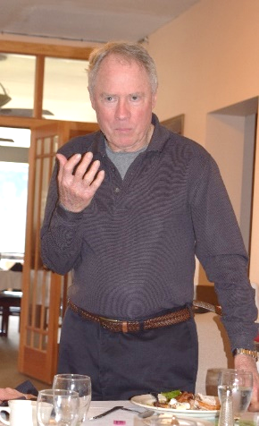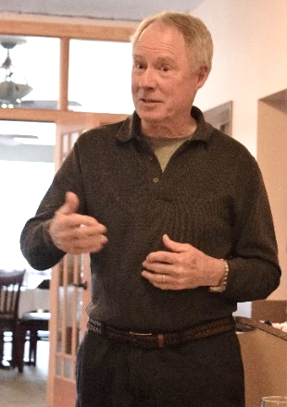
Walt shared thoughts about his move to Texas and time in the Rotary Club of Castro Valley.

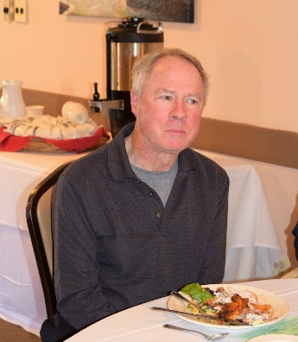
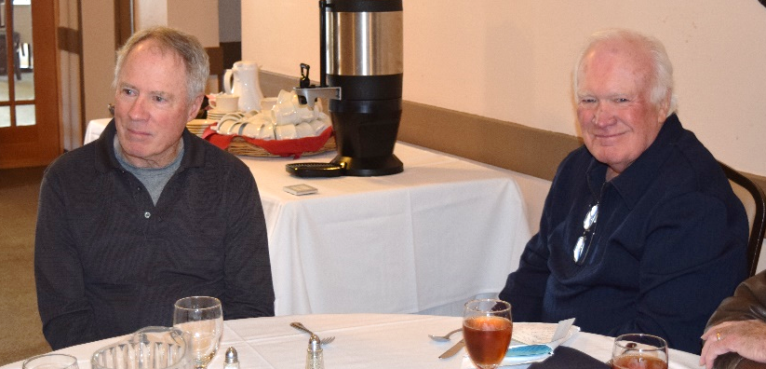
”

Walt is probably thinking, “How many times have I had chicken for lunch at Rotary?

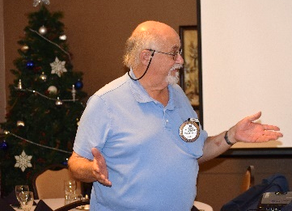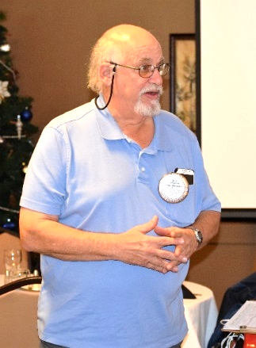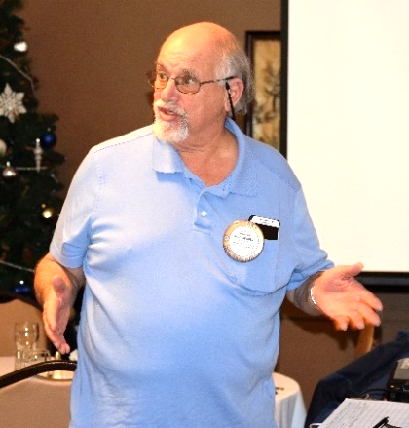
Bill Nott providing technical support and introducing the speaker.
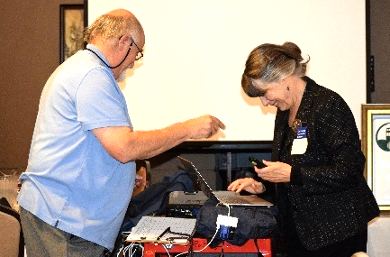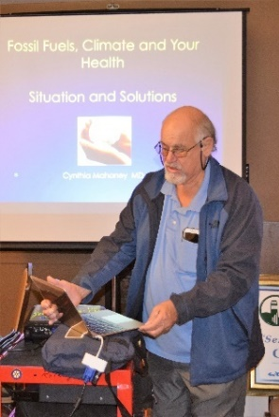

Speaker: Cynthia Mahoney, M.D. on Fossil Fuels, Climate, and Your Health: Situation and Solutions
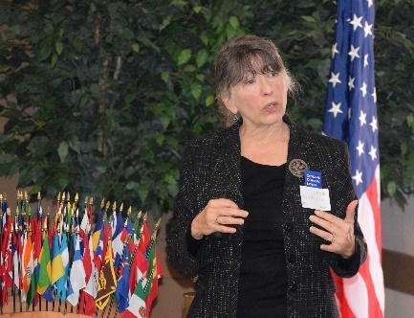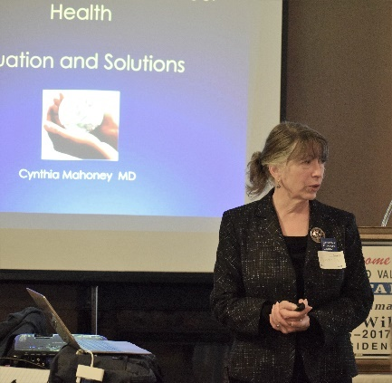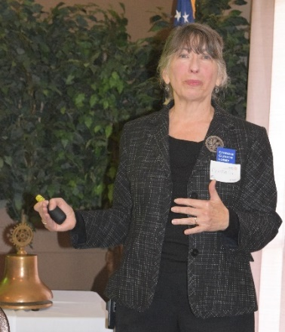
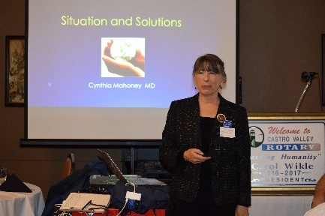
Dr. Cynthia Mahoney representing the Citizens’ Climate Lobby (www.citizensclimatelobby.org/) was our club. She started by stressing the increase in CO² since the Industrial Revolution with dramatic charts and discussed the impact on the climate and the health of individuals. She explained the impact of natural greenhouse gases, which have blanketed the world and increased temperatures by 1.4⁰F and are projected to continue rising in the future unless action is taken (prediction is an 8⁰F increase. Dr. Mahoney explained the interconnectedness for greenhouse gases, rising temperatures, melting ice caps, increased ocean temperatures, rising sea levels and more acidic oceans. These changes are causing changes to traditional weather patterns , which leads to more droughts, heat waves, and severe storms among the changes.

After reviewing the changes occurring, Dr. Mahoney pointed to a Center for Disease Control (CDC) report, The Impacts of Climate Changes on Human Health in the United States, that noted the increase in diseases (e.g., particles absorbed in the lungs and heart, which is like secondhand smoke) and deaths (e.g., heat related deaths) due to climate changes. One interesting statistic was that an individual has a 41% great risk of heart disease if he or she grew up next to a freeway.

After laying out the facts, Dr. Mahoney offer solutions including collecting a fee on pollution/greenhouse gases, revenue sharing back to states and local agency, and tariffs on foreign products. In recent surveys, 2/3’s of those surveyed indicated support for a carbon fee, which could be directed back to address health issues. Many of the proposals are outlines on the Citizens’ Climate Lobby website where you can sign up for more information and updates.
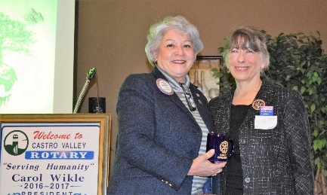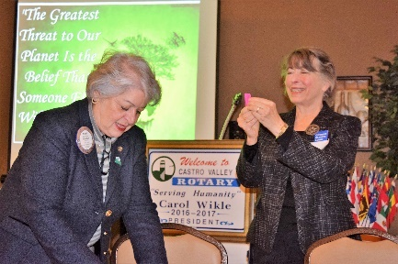
President Carol present Dr. Mahoney with her Rotary speaker’s mug.
Dr. Mahoney pulling the winning ticket, which Dwight Perry had, again.

Announcements
- Candi Clark and Roland Williams reviewed the Rotary International requirement that all Club members complete the online Youth Protection Training. Roland will be emailing members the link to the training. It is very important that every member completed the training ASAP. Please contact Roland if you have questions.
- President-Elect Jim reminded everyone about the Club Holiday Party on Saturday, December 10, at 6:00 p.m. If you haven’t paid, please bring a check or cash. Don’t forgot the always fun White Elephant gift exchange (maximum value $20).
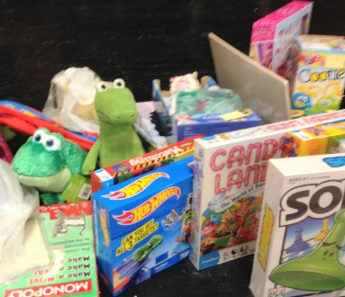
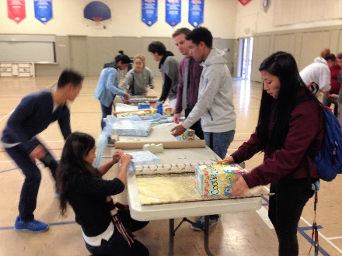
- The Children’s Christmas Party is Tuesday, December 13, at 4:00 p.m. in Room 10 at the Castro Valley Adult & Career Education campus. Mark Poniatowski is coordinating volunteers. We expect to assist 90-95 students. CHP has been collecting gifts for young students and Redwood Christian students and been wrapping the gifts. Older students will receive $25 gift cards. Mark collected over $400 in donations at the meeting to purchase additional gifts and gift cards as needed. It’s not too late to volunteer or donate.
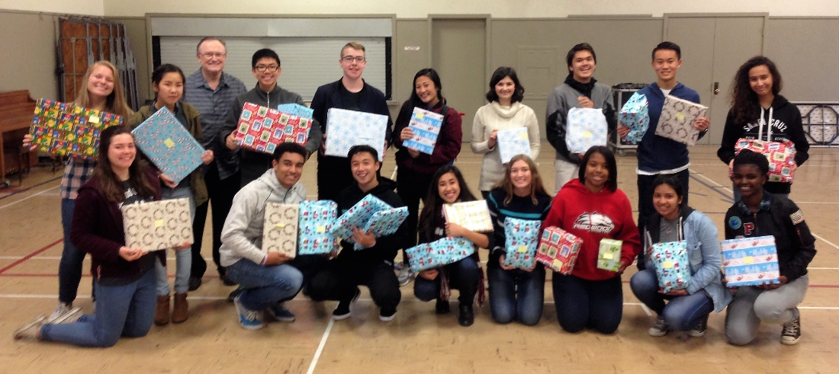
- The team helping Obse with the Breathing for Life grant is finishing the writing. It’s not too late to donate. Everyone needs that end-of-the-end tax deduction.
- There will be a Club Assembly on January 17 with reports on the Breathing for Life Project, Club activities for the year, upcoming activities, nominations and reports from committee chairs and officers.

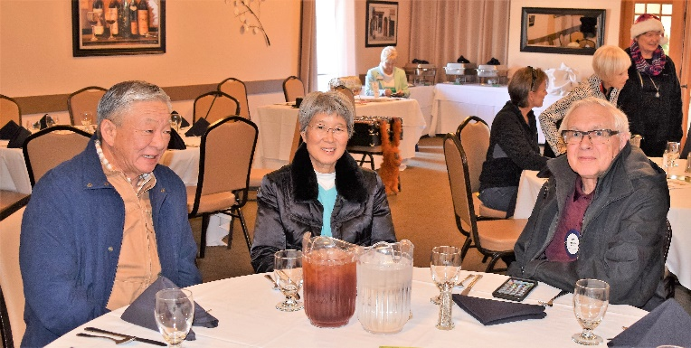

It was great to see Bob Shayler back at the Club for lunch. Bob is seated with Joyce the Clown who will be at the Children’s Christmas Party and her husband.

Upcoming Events
- December 12 – Board of Directors Meeting at the Chamber of Commerce Office at 6:00 p.m. All members are invited to attend and it is a requirement to earn a Blue Badge.
- December 13 – Lunch meeting with Zack Ebadi from H.A.R.D. Outreach and gift wrapping for the two families the Club is supporting with Christmas gifts. Thank you to Heidi for shopping.
- December 13 – Children’s Christmas Party at 4:00 p.m.
- December 14 – Rodeo Parade meeting – Chamber of Commerce at 12:00 p.m. Check with Bill Nott for details.
- December 14 – Breathing for Life meeting – Offices of Mark Poniatowski at 6:30 p.m. Check with Kern Lewis or Bill Nott for details.
- December 15 – Chili Cook-off meeting – Location TBD at 5:30 p.m. Check with Randy Vanderbilt for details.
- December 20 – Lunch meeting with Wendy Winsted from Sulphur Creek Nature Center, which is part of H.A.R.D.
- No lunch meeting on December 27 and January 3. Happy holidays!

