Rotary Club of Castro Valley
Meeting Highlights – February 12, 2019

JD Ducusin Wins Speech Contest
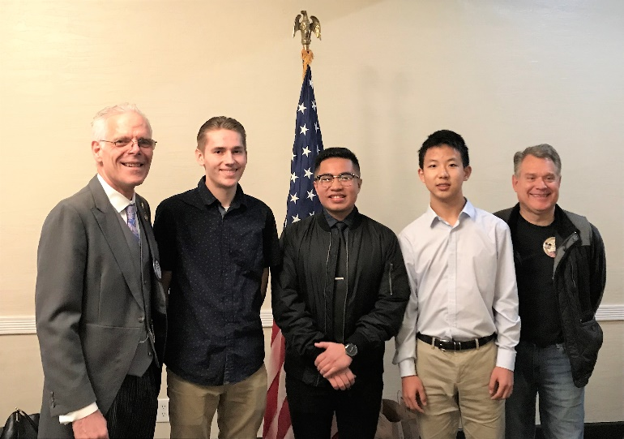
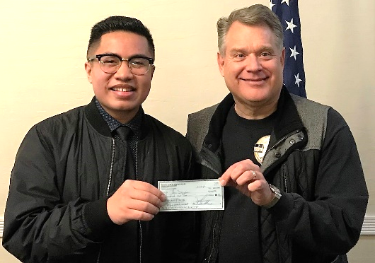
The 2019 Rotary Club of Castro Valley Speech Contest was held on February 12th during the Club’s weekly lunch meeting. The theme for the 2019 Richard D. King Annual Youth Speech Contest was “Be the Inspiration."

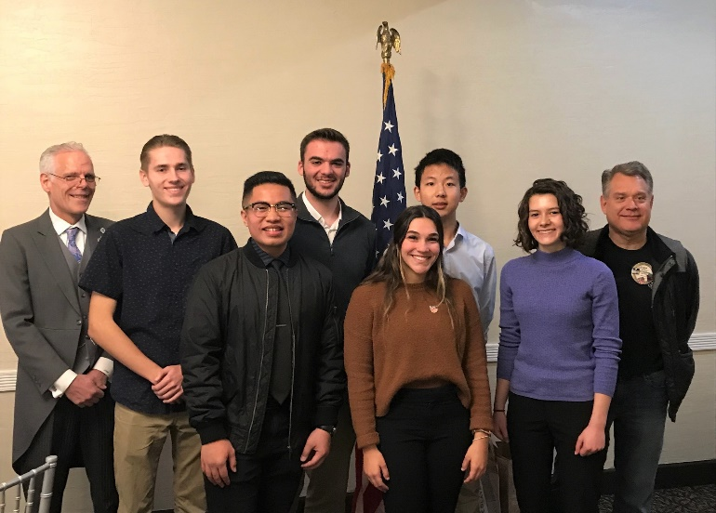
The winner was John-Daniel (JD) Ducusin, a senior at Redwood Christian High School (RCHS). Oliver Zhang, a sophomore at Castro Valley High School, finished second, and Jacob Shupp, a senior at RCHS, finished third. Other participants in the contest were RCHS seniors Isaac Hague, Emma Najarian, and Madison Shasky.
Pictured (left to right): Rotary Club of Castro Valley President Charles Mortimer, Jacob Shupp (third place), JD Ducusin (first place) and Oliver Zhang (second place), and Jeff Moore (Speech Contest Chair). Photo by Bruce D. Johnson
By winning the Club Speech Contest, JD advances to compete against students representing the Rotary Clubs in Rotary District 5170 Area 4, which include the Clubs in Castro Valley, Dublin, Hayward, Livermore (2) and Pleasanton (3). The Area 4 competition occurs on February 28th at Castlewood Country Club (707 Country Club Circle) at 5:30 p.m. The event is open to all Rotarians and their guest.
Pictured (left to right): Rotary Club of Castro Valley President Charles Mortimer, Jacob Shupp, JD Ducusin, Isaac Hague, Madison Shasky, Oliver Zhang, Emma Najarian, and Jeff Moore (Speech Contest Chair). Photo by Bruce D. Johnson

Announcements:
- A reminder that the memorial service for KJ Page’s husband, Thomas, is Wednesday, February 20th, at 3:00 p.m. at 1309 Allston Way, Berkeley. Parking is limited so please arrive early or consider carpooling. Contact cliff Sherwood if you have any questions.

Upcoming Events – Mark Your Calendar (Check ClubRunner for details)
- February 19 - Lunch Meeting with Castro Valley & Redwood Christian High School students who the Club sponsored to attend Camp RYLA this past summer
  - Come and hear from the dynamic future leaders that the Club is sponsoring
- February 20 - Chili Cook-off & Rodeo Parade Planning Meeting @ 6:00 p.m. at Direct Sales Floors
- February 21 - Castro Valley/Eden Area Chamber of Commerce Mixer @5:30-7:30 pm at Don Jose’s sponsored by the Rotary Club of Castro Valley
  - Wear your Rotary shirt
  - Looking for several donated door prizes – see Charles or Michaela
- February 26 - Lunch Meeting with Denyse McCowan, Program Director - Alameda County Ombudsman
- March 9 TEXAS HOLD’EM FUNDRAISER @ 5:00 p.m. at Our Lady of Grace Church – Stack Center
Registration closes February 28, 2019
Purchase tickets today.

