Rotary Club of Castro Valley
Meeting Highlights – February 13, 2018

Craig Semmelmeyer - Main Street Property Services, Developer of the Daughtrey’s Building
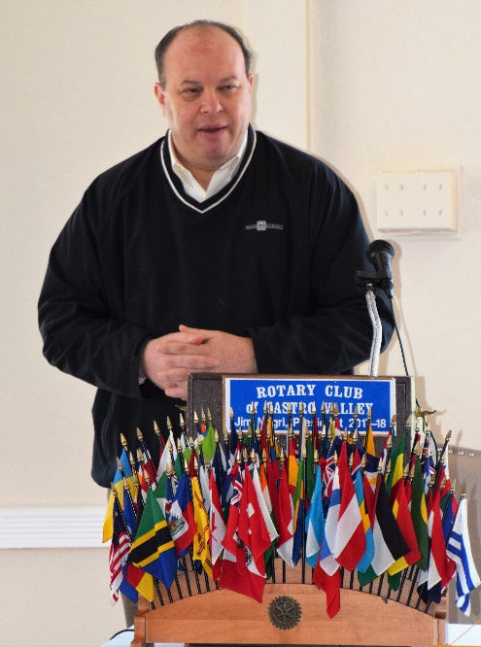
Craig started his presentation by noting that his father was a member of Rotary for 44 years and that he is considering joining the Club too.

The Daughtrey's Building has been vacant for more than a quarter of a century before Main Street Property Services became involved in the development of the site about two years ago when they partnered with an architect, a major fruit and vegetable merchant, and a restaurant company. Main Street held many community open forums to discuss and solicit public input on the alternatives for the development. The first phase consisted of developing a large parking lot that runs behind the building and adjoining businesses. After receiving the various approvals from government departments and advisory groups, the development work started in earnest. The project is being developed as an open market concept and will include two full-service restaurants, a coffee shop, a fresh vegetable and fruit market, a butcher shop including a fish and poultry market with a wine cellar and market in the basement. The market is expected to be open from 8:00 a.m. to 8:00 p.m. with the restaurants and coffee shop observing extended hours of operation. The whole design is based on an open-air market concept and preserving the original features and design of the building.

The opening ceremony and ribboning cutting ceremony is scheduled for February 20 with the entire project expected to be functional by fall this year. Watch for details.

Craft Talk: Bob Shayler
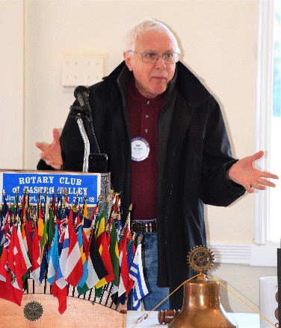
Continuing the series of Craft Talks, Bob shared that his father was in Air Force and because of constant moves, he attended 13 schools before graduating from high school. After completing his college studies, Bob became a physics teacher and taught at various schools in San Francisco, New York, and the Bay Area for 44 years. Later, he worked with the Alameda County in their Tech Development Department. During his days as teacher, he always believed in supplementing classroom education with field trips to various locations in the Bay Area and other parts of California. Bob was actively involved with an educational exchange program with Russia and took students there. In past meetings, Bob has shared his experiences as a Lyft driver.

If you are interested in presenting a Craft Talk, please contact President Jim Negri to schedule a time.

Announcements:
- Natalie Hung described Youth-to-Youth, a program that uses education, peer support, and fun activities to help young people stay drug free. It is a comprehensive peer involvement and drug prevention program where teens support one another in their decisions to be free of alcohol, tobacco, and other drugs. Youth shape the program and determine how they will be positive role model for their peers. The four strategies (Information / Education, Personal Growth, Environmental Change, and Drug Free Fun) are implemented through programs and education.

The Youth-to-Youth Middle School Conference will be held at Castro Valley High School on Saturday, March 24th, and is sponsored by the Rotary Clubs of Danville, San Ramon, and Castro Valley. The conference will need adult volunteers. Please contact Natalie Hung at cvyouth2youth@gmail.com for further information and volunteer opportunities. Watch for a special email with a link to volunteer on March 24th.

- Superintendent Parvin Ahmadi announced that Castro Valley Center for the Arts is presenting JANGLA, a family-oriented performance fusing contemporary ballet and baratnatyam dance on March 13th at 7:00 p.m. Tickets are $20. For further information please contact Parvin or go to the CFA website at http://www.cvcfa.com/.

- Jerome Blaha reviewed the details of the 2018 Castro Valley Derby that will held on February 15th as part of the Castro Valley/Eden Area Chamber of Commerce February Mixer at Faith Lutheran Church at 5:30-7:30 p.m. that the Rotary Club of Castro Valley is sponsoring. All members are encouraged to attend and participate in the Derby, Crazy Hat Contest, Celebrity Look-a-Like Contest and have a good time. Please remember to bring your spouse and guests. All Club members are requested to wear Rotary shirts and pins.

- Mark Poniatowski announced that TEXAS HOLD'EM FUNDRAISER of the Rotary Club of Castro Valley will be on Saturday March 10th at Stack Center at Our Lady of Grace Church on Somerset Avenue. Last date to purchase tickets is February 28th.

Upcoming Speakers and Events
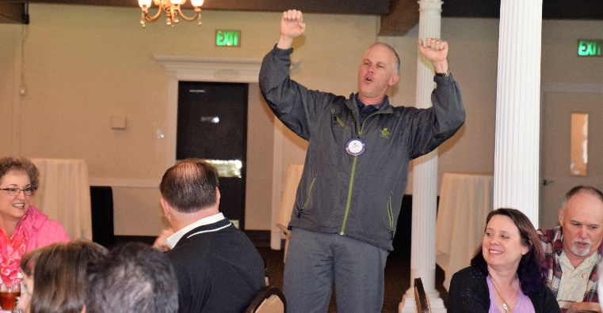
- February 20 – Lunch Program – Richard King Speech Contest with students from Castro Valley and Redwood Christian High Schools
- February 27 – Lunch Speaker – Paul Wildrick, Action Coach, speaking on What Businesses Do Right and What Businesses Need to Do Right
- February 28 – Board of Directors Meeting at 6:00 p.m. at the Chamber of Commerce Office
- March 6 – Lunch Program – Irish Dancing
- March 10 – Texas Hold ‘em Fundraiser

First Castro Valley First Derby
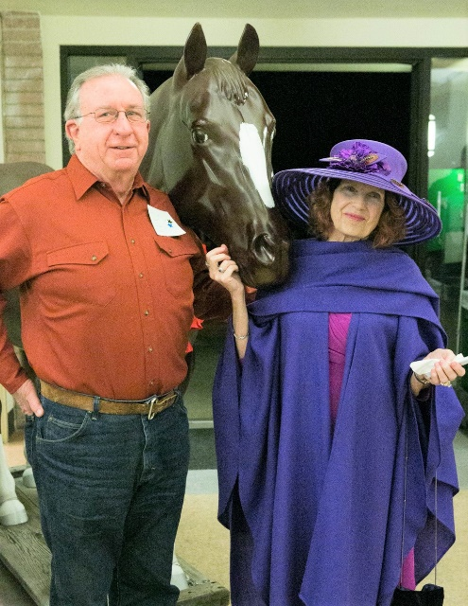
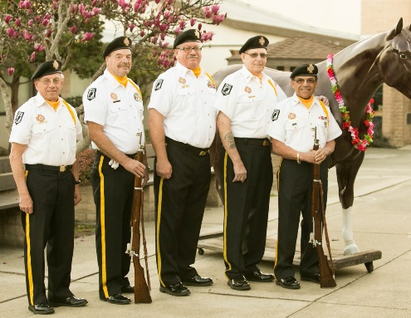
Thursday evening, February 15th, was exciting event for everyone present as the First Castro Valley Derby that was held as the Castro Valley/Eden Area Chamber February Mixer. The event was hosted by the Rotary Club of Castro Valley and was held at Faith Lutheran Church. The Rotary Club of Castro Valley President Jim Negri served as Master of Ceremonies, and Chamber Executive Director Ashley Strasburg and her staff greeted and encouraged all present to continue to be active within our community. Using display boards, President Jim shared the great that the Club is doing in the community

Program Chair Jerome Blaha, who organized and coordinated the entire event, ensured everyone had a great time with a Fancy Hat Contest in addition to the First Castro Valley Derby. The event was catered by Miraglia's Catering. The VFW (Veterans for Foreign Wars) presented to colors followed by Bruce Johnson leading the Pledge of Allegiance and Dan Willits leading those present in God Bless America. Thank you to Jerome for his efforts to make the event a rousing success!

The Fancy Hat Contest was won by Billie Sherwood with her fancy purple hat that perfectly matched the rest of her fancy derby outfit!

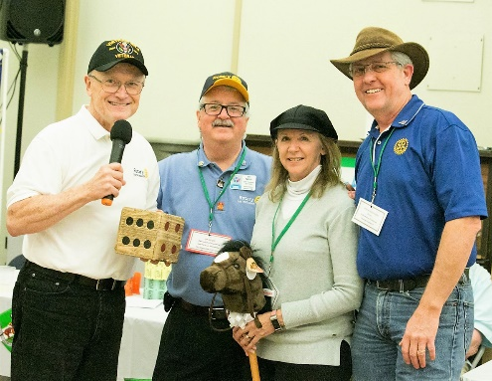
The Castro Valley Derby consisted of six horse "owners" selecting their jockeys to ride their stick horse as dice were rolled to move one space at a time to the finish line eleven spaces away! Owner John Aufdermauer with his Jockey Bobbie (also his Bride) won the First Castro Valley Derby and donated their winnings to the Castro Valley Endowment. Other husband and wife race participants included Owner Dan Willits/Jockey Kristy Willits and Owner Jeff Moore/Jockey Allison Moore. Other teams were Owner Randy Vanderbilt/Jockey Luc Dochterman; Owner Charles Mortimer/Jockey Melanie Blaha; and Owner Jim Negri/Jockey Sarah-Jean Thompson. Carol Wikle and Dawn Ortiz were the dice rollers and kept the event moving. Bruce Johnson was the announcer and called the race.

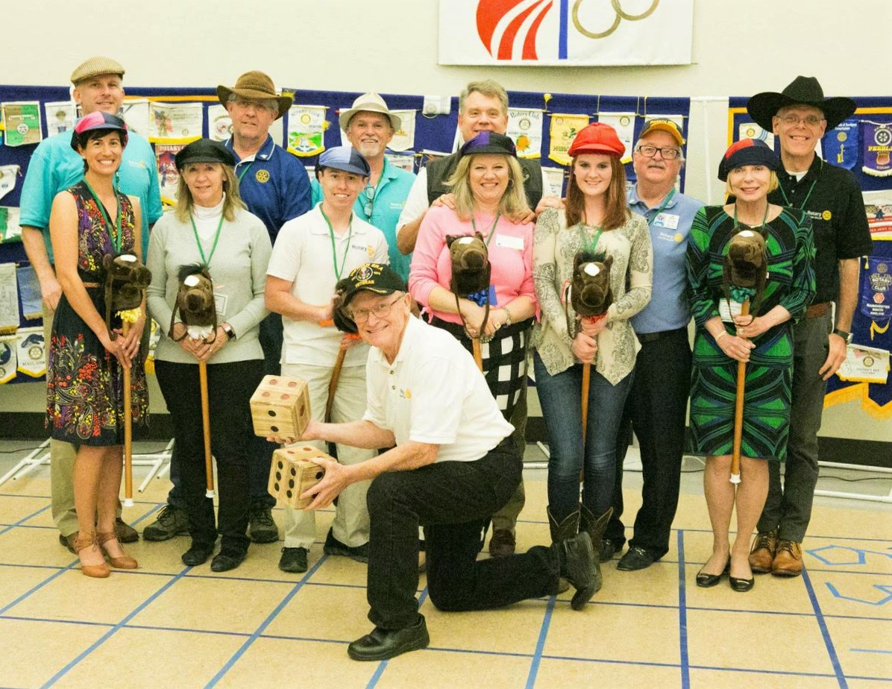

Story by Bruce Johnson
Photos by Kent Waith

Are you interested in Castro Valley Unified School District?

On March 27th, Castro Valley Unified School is offering you the opportunity to participate in Education Day on March 27 to learn about programs that prepare students for college and career. Yes, it is a Tuesday, but the program ends in plenty of time for you to grab a cup of coffee and still make to Rotary with time to spare.

Specific details and an invitation will be sent shortly.

