Rotary Club of Castro Valley
Meeting Highlights – February 19, 2019

Camp RYLA Students Share the Experience
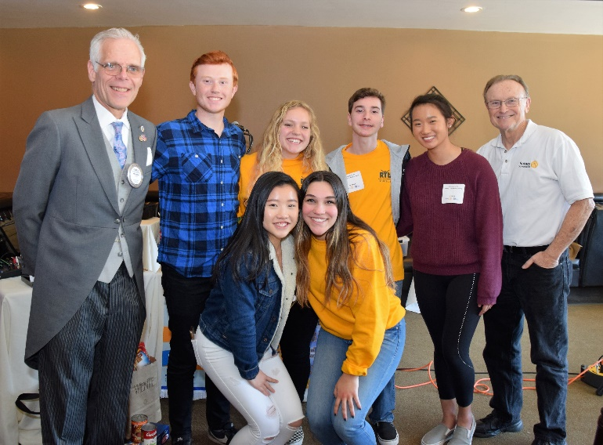
The lunch program showcased the leaders of the future when the Club hosted the six high school students from Castro Valley and Redwood Christian High Schools that the Club sponsored to attend the week-long, 2018 Camp RYLA (Rotary Youth Leadership Award) in Scotts Valley. The students/campers presented an outstanding program regarding how Camp RYLA was personally significant.
The students shared not only a typical day at RYLA, but the various life lessons that they learned as campers and how those experiences are helping them now as well as shaping their future. Camper Nick Bellison collected video and pictures from the campers and Rotarians Jim Negri and Bruce D. Johnson for a tremendous video presentation that shared the RYLA experience for Club members. The "payback" for the Rotary Club of Castro Valley and the community will be the tremendous impact that these students will have as future leaders.
Pictured left to right back row - CV Rotary President Charles Mortimer, RCHS Senior Joseph Carlton, RCHS Senior Vanessa Harris, CVHS Junior Nick Bellison, CVHS Senior Jada Liu, and Camp RYLA Program Chair Bruce D Johnson; front row - CVHS Junior Jessica You and RCHS Senior Madison Shasky.
The Rotary Club of Castro Valley is committed to training, supporting, and challenging leaders at all levels, especially high school students. Jim Negri, Past President of the Castro Valley Rotary, attends the end-of-camp BBQ each year with fellow Rotarian and RYLA Coordinator Bruce D. Johnson, and stated, “RYLA is an outstanding learning experiences for these students. It is truly amazing to watch 200 high school students come together for the week and bound while developing their leadership. I always return from RYLA knowing that the future is in good hands."
To learn more about Camp RYLA go to http://2019.ryla5170.com/. Members are invited to join Bruce and Jim for the Annual Camp RYLA BBQ on June 27, 2019, in Scotts Valley.
During the presentation, RYLA Camp Coordinator Bruce Johnson asked the students to respond to the following questions:

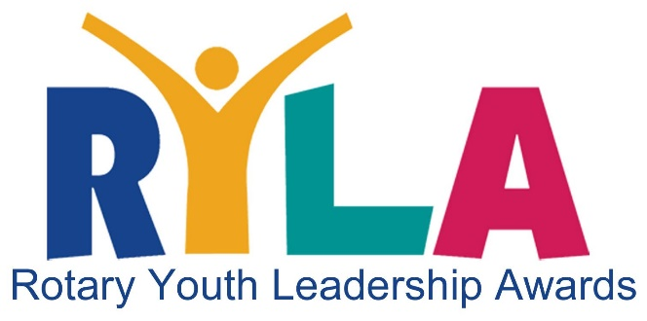
- What one word best describes your week at Camp RYLA?
- When you think back on your Camp RYLA experience, who do you remember that you did NOT know before going to Camp?
- What was your most memorable event from Camp RYLA?
- Camp RYLA is a leadership training camp. What leadership “tool” did you learn at camp?
- Describe a typical day at Camp RYLA.
- Share what it means to be part of a family.

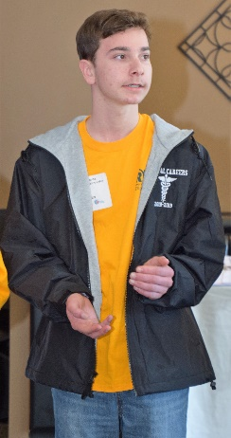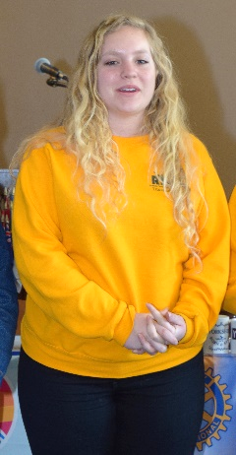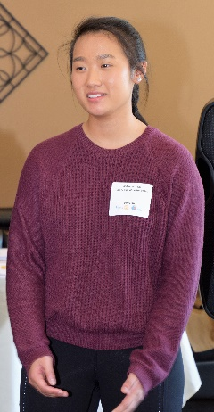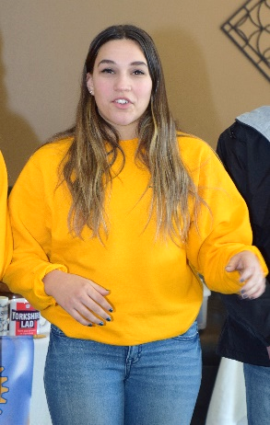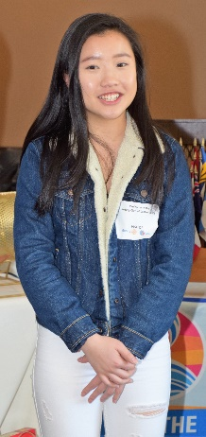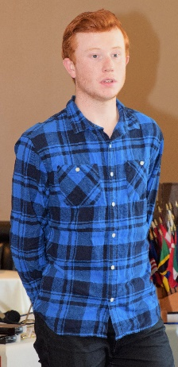
The Rotary Club of Castro Valley thanks the Camp RYLA campers for sharing their experiences with the Club and looks forward to great achievements from these students in the future. Pictures left to right: CVHS Junior Nick Bellison, RCHS Senior Vanessa Harris, CVHS Senior Jada Liu, RCHS Senior Madison Shasky, CVHS Junior Jessica You and RCHS Senior Joseph Carlton.
Scenes from the Meeting
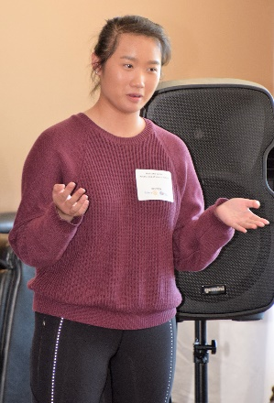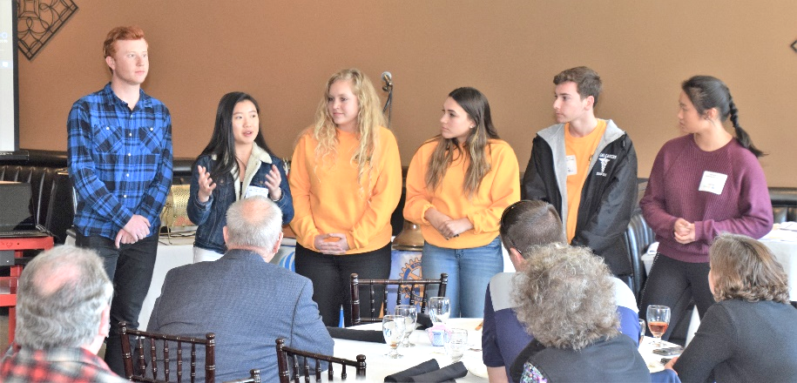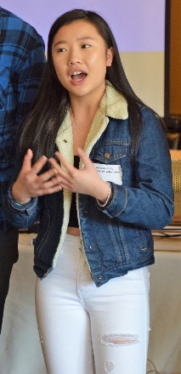
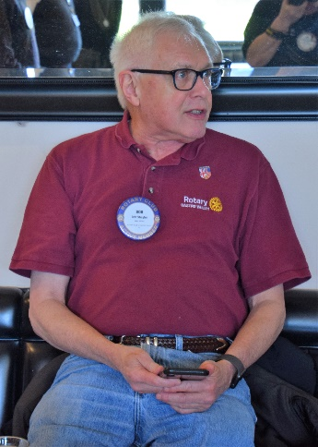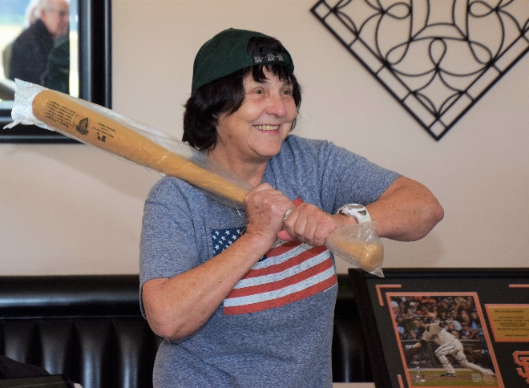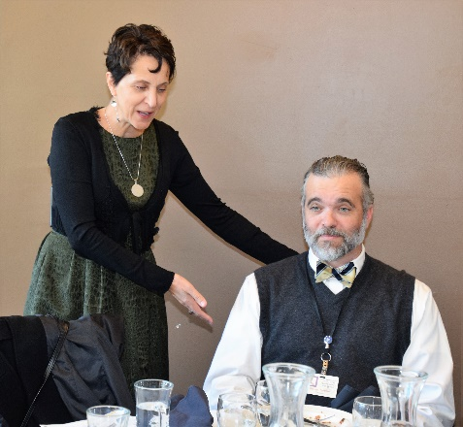
Left to right: Bob Shayler shares the “Thought for the Day”; in honor of spring training, Ceta Dochterman warms the Club up with Take Me Out to the Ball Game as the “Song for the Day”; and Parvin Ahmadi introduces her guest, Castro Valley High School Principal Blaine Torpey.
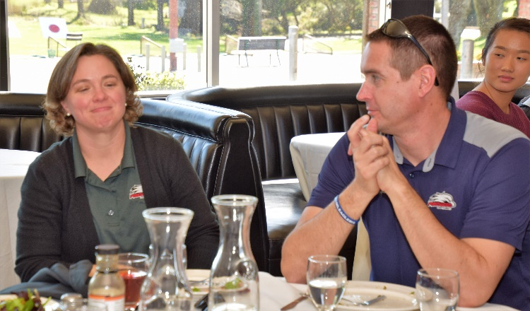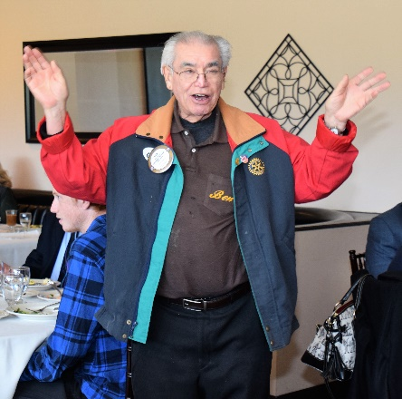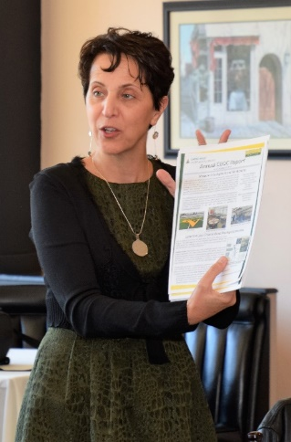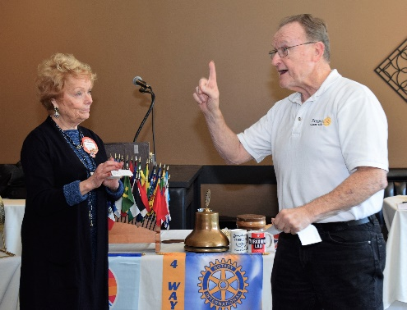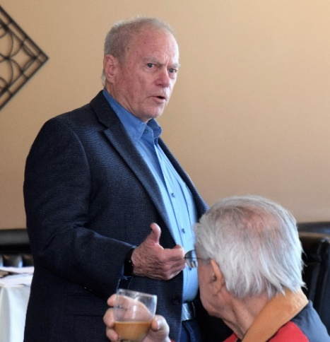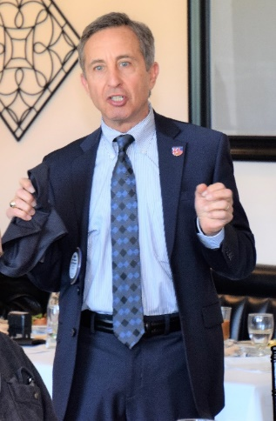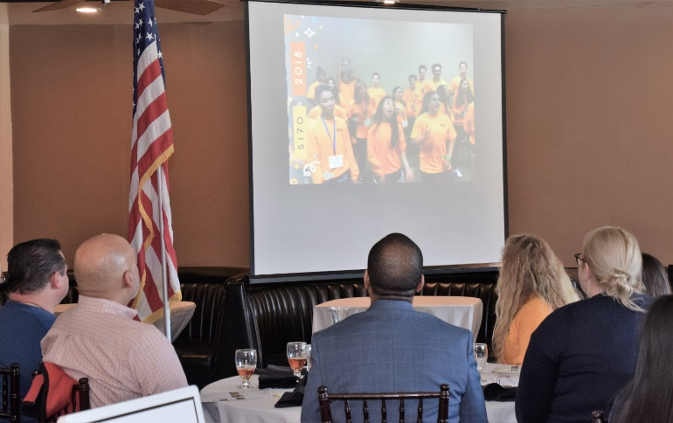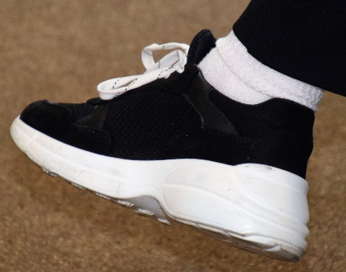
Left to right: Members watch the Camp RYLA video produced by Nick Bellison. CONTEST TIME: The first Rotarian, not wearing this shoe at the February 19th meeting, who submits the shoe wearer’s name to ciaojim_cvrotary@att.net will receive a special prize.

Announcement & Calendar Dates
- February 26 - Lunch Meeting with Denyse McCowan, Program Director - Alameda County Ombudsman
- February 26 – Texas Hold’em Planning Meeting
- February 27 – Board of Directors Meeting –
- March 5 - Lynda Foster with the California Earthquake Authority will discuss Protecting, Mitigating, and Recovery as well as retrofit programs for Californians after a major quake.
- March 12 - Feby Boediarto, East Bay Community Energy, will discuss the new power alternative for most of the county.

- March 9 TEXAS HOLD’EM FUNDRAISER @ 5:00 p.m. at Our Lady of Grace Church – Stack Center
Registration closes February 28, 2019
Purchase tickets today.

