Rotary Club of Castro Valley
Meeting Highlights – February 20 & 27, 2018

Paul Wildrick – Action Coach
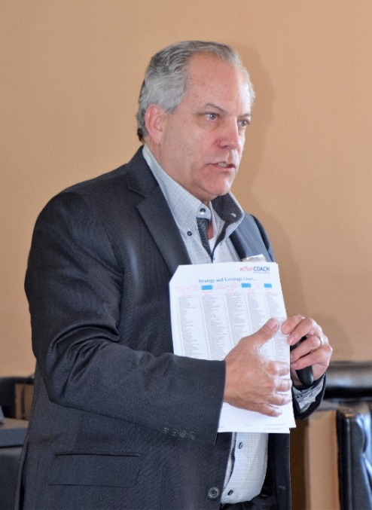
Paul Wildrick, Certified Business Coach of Proven Gain Business Coaching of Orinda California, was the featured speaker. He started his presentation by saying that he has started and owned several successful small businesses, and personally used the principles in growing these businesses many fold over the years. At present, he provides coaching for businesses of many sizes and types.

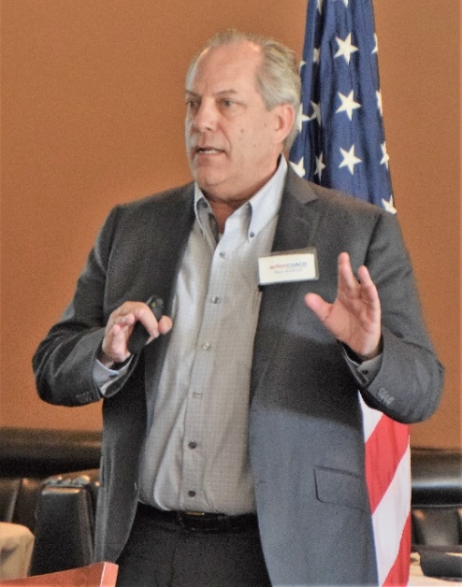
When a business hires Paul as a coach, his first advice to the owner of the business is to hire a business manager for running the day-to-day operations. Paul stated that the owner should spend the majority of his/her time in developing a strategy for growing the business using the "Five Ways to Growing the Business." Every businessperson has a dream of building a bigger or better business. Paul asks the businessperson to list where his business is today and where he/she wants to take it in five years. He then asks his clients where the business is today by asking the following questions:

- Where do you live?
- What is your current income?
- What type of car do you drive?
- What kind of vacations are you taking?
- Where do you want your life to be in five years?
- What are your immediate goals or desires five years from now?

To build a bigger or better business there are only five areas that the owner should be concerned with

1. Number of Leads - How many potential clients do you attract?
2. Conversion Rate - How many leads do you convert into clients?
3. Average $ Sale - How much do they spend each time they buy?
4. Number of Transactions - How many times a year do your clients buy?
5. What is the gross or net margin your business achieves?

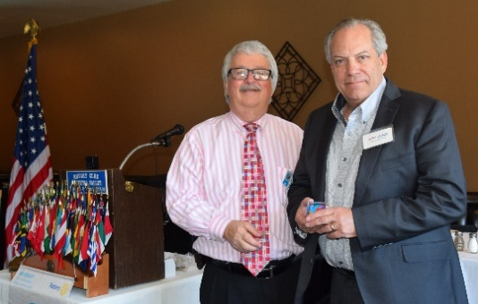
This simple but effective system of evaluating one’s business in terms of efficiency allows the businessperson to benchmark where they are right now and select strategies and tactics from the Action Coach, resources and strategies that have worked with thousands of businesses all over the world. Once the strategies have been selected, Paul works with the owner on implementing them, and then testing and measuring the results. The key objective is to reduce acquisition costs and increase lifetime values of A grade clients to one’s business. A copy of Paul’s handout is available here.
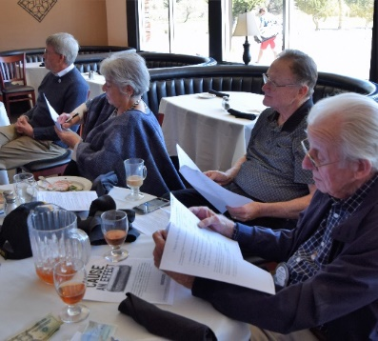
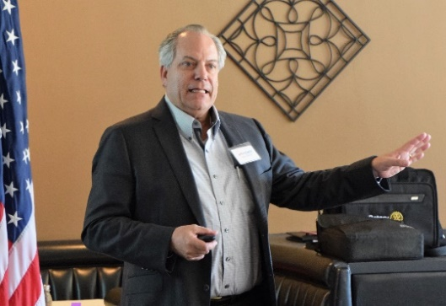

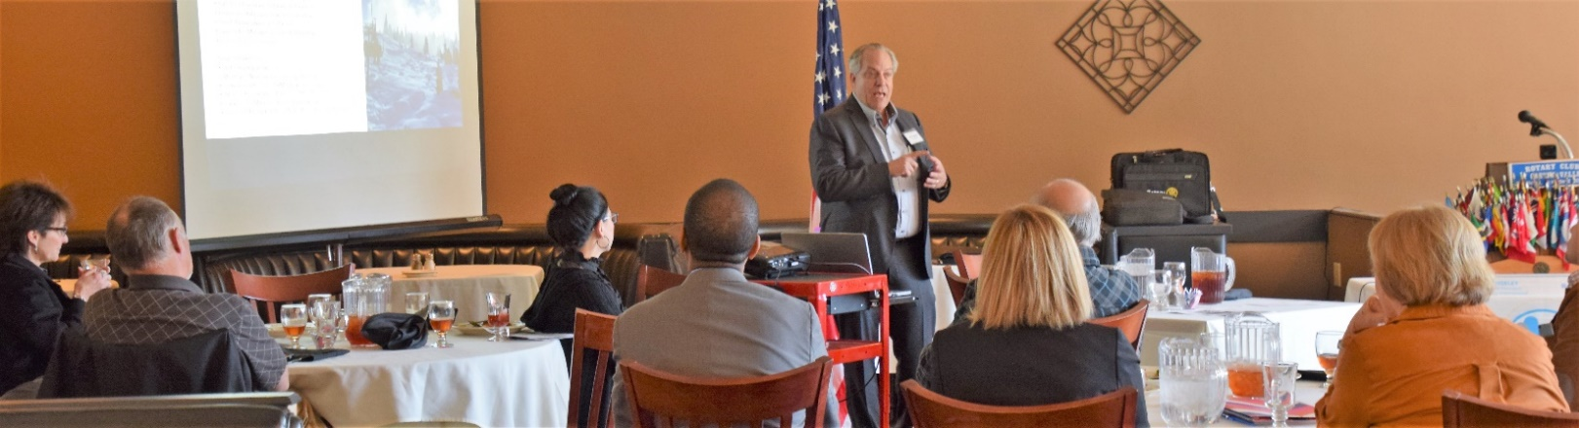

Gary Howard – Newest Member
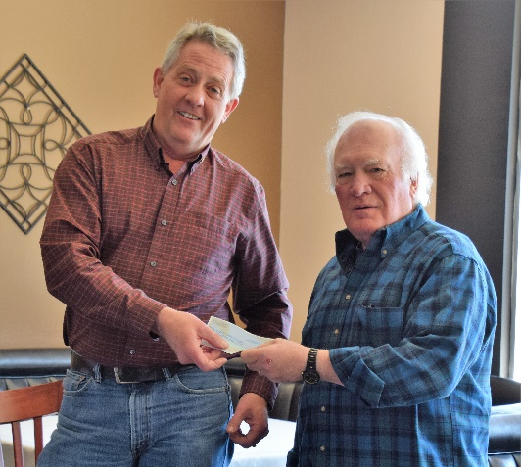
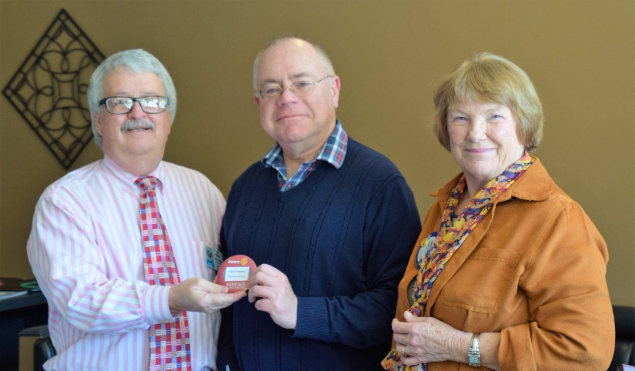
President Jim Negri and Membership Chair Virginia Degner presented Gary Howard with his Red Badge as the newest member of Rotary Club of Castro Valley. After the presentation, Gary shared with the Club a little of his background. Gary has recently retired as a science editor for Gladstone Institute in Mission Bay in San Francisco, but he will continue to do some work for Gladstone. Gary also serves as a board member for the Castro Valley Unified School District. President Jim encouraged members to get to know Gary because he has a very interesting history. Welcome, Gary!

Donation to the Rotary Club of Castro Valley Endowment
John Aufdermauer, owner of the winning horse in the first Castro Valley Derby, presented his winnings ($600) to Dwight Perry representing the Rotary Club of Castro Valley Endowment. Bobbie Aufdermauer, the winning jockey, matched the $600 through her work for a total donation to the Endowment of $1,200. The Endowment supports scholarships for graduating Castro Valley High School seniors.

District 5170 Richard D. King Youth Speech Contest
On February 20, the Club hosted the Annual District 5170 Richard D. King Youth Speech Contest. The theme this year was “Rotary: Making a Difference.” Each student speaker had to speak at least 4 minutes, but not long than 5 minutes, on the theme as well as address the Four Way Test in his/her speech. This year, all six contestants were students from Redwood Christian High School. The students' teacher is Mrs. Lisa Suth. Superintendent Al Hearne, Middle School and High School Principal Ben Warner, and Superintendent Emeritus Bruce D. Johnson were present to encourage the speakers.
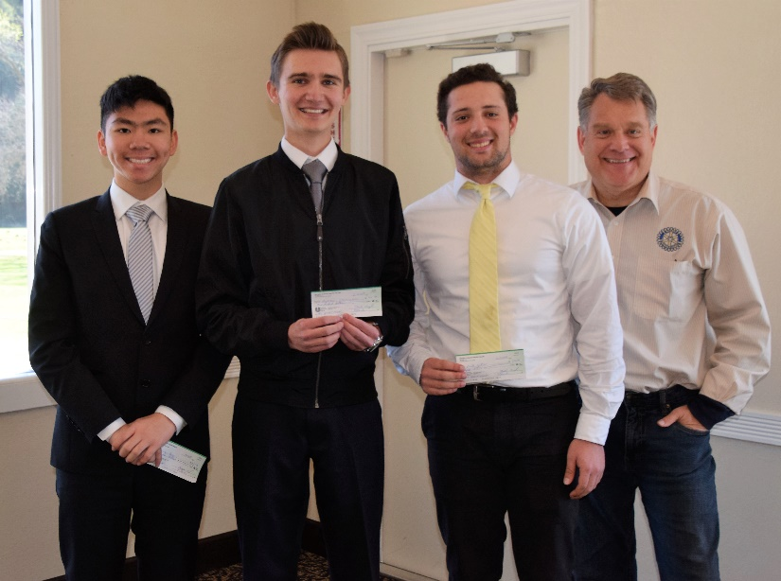
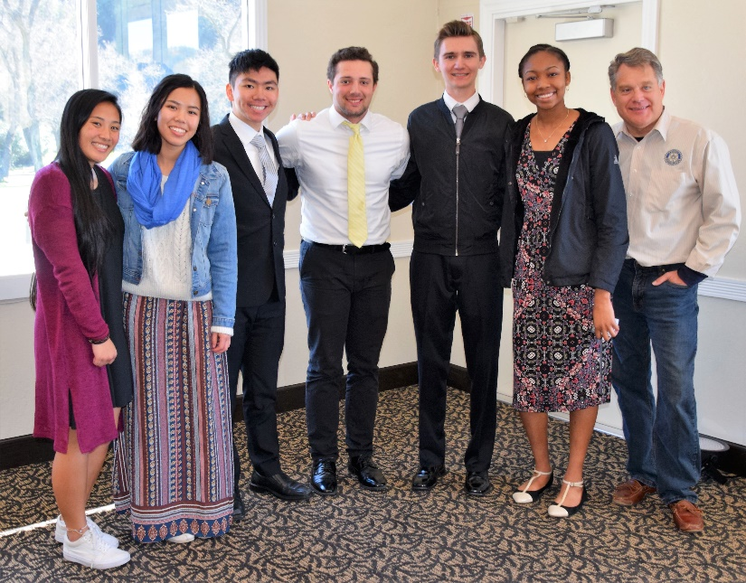

Left Photo: Speech Contest Participants (L-R): Katherine Geronimo, Kelly Tang, Ify Nwubebe, Lawton Young, Keith Collier, Andrew Stanciulescu, and Rotary Club Speech Contest Chair Jeff Moore.
Right Photo: Speech Contest Winners (L-R): Lawton Young (2nd place), Andrew Stanciulescu (1st place), Keith Collier (3rd place), Rotary Club Speech Contest Chair Jeff Moore.

MARCH LUNCH SPEAKERS

- March 6 - The History of Irish Dance in the Bay Area
Annie McBride, founder of the McBride Irish Dancers, will share about the history of Irish Dance in the Bay Area and the history of each dance with live performances of the dances. She is celebrating over 50 years of preserving and promoting Irish culture in the San Francisco Bay Area. She is credentialed to both train dancers of all levels and judge competitions.

- March 13 - Zero Waste Initiatives in Commercial Businesses
Jessica Nusse from CVSan will speak on "Zero Waste Initiatives in Commercial Businesses." This presentation will explore the Zero Waste goal in CVSan and what this goal really means, looking at business recycling and organics programs, the 4R Star Recognition Program, and ways CVSan supports increased recycling and organics with businesses through technical assistance and donations.

- March 20 - Financial Markets in 2018 & Tax Reform
Noah Rubin will be speaking on Financial Markets and the firm’s 2018 recommendations on global equities, interest rates and bonds as well as Tax Reform: Key Themes & Issues.

- March 27 - Post Polio Syndrome Start to Finish.
Al Padro will speak on "Post-Polio Syndrome Start to Finish." He suffered from polio and now has been hit with post-polio syndrome. Al will share his experience. Al works as a Marshal at Redwood Canyon and is a good friend of Dwight Perry.

OTHER MARCH EVENTS
March 8 – Planning meeting for Chili Cook-off and Rodeo Parade at 5:00 pm at Direct Sales Floors
March 10 – Texas Hold ‘em Fundraiser at 5:00 p.m. at Our Lady of Grace
March 15 - 2018 Taste of Castro Valley and Business Expo – Moose Lodge at 4:30-7:30 pm – Details here
March 27 - CVUSD Education Day at the CFA at 7:30 -9:30 am - Details here

