Rotary Club of Castro Valley
Meeting Highlights – February 28, 2017

Program Speaker:
Mona Palacios, Executive Officer Alameda County Local Agency Formation Commission
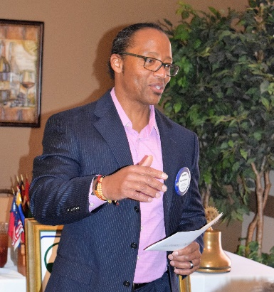
After an introduction by Monthly Speaker Chair Roland Williams (photo left), which noted that most people do not know about LAFCo even though LAFCo has been involved with Castro Valley incorporation efforts, Mona Palacios (photo below) described the role of the Alameda County Local Agency Formation Commission and provided information about LAFCos that included the following:

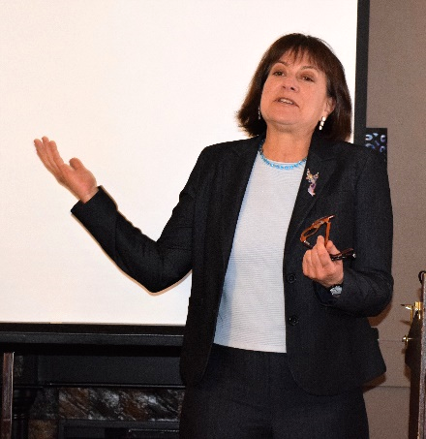
•They were created in the 1960’s by the State Legislature to address population growth because cities were expanding without any comprehensive plans about the growth, especially urban sprawl into agricultural land.
•There is one LAFCo in each county to promote local decision-making rather than Sacramento making decisions on local growth issues. The Alameda County LAFCo has a $700,000 budget, and uses outside consultants and legal counsel to conduct much of its work.
•LAFCo has jurisdiction over cities and special districts, but not school districts or the county, and the right to create or dissolve boundaries.
•Dublin is the newest city in Alameda County, but incorporation is now difficult now due to lack of revenue to support city services.
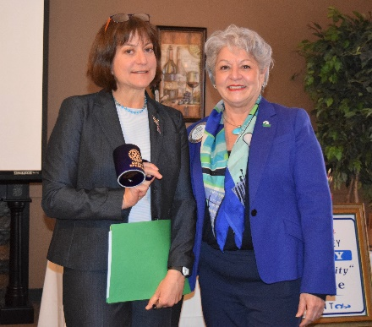
•LAFCo conducts special studies and is currently reviewing the status of the Eden Health District. Mona briefly discussed the situation with the Eden Health District. One issue is that legislation was introduce to disband the District without discussing it with LAFCo. Now that LAFCo has launched a study as required by law, the legislation is on hold pending the final report.
•LAFCO handled the boundary change (i.e., annexation of land) for CV San so that it could provide service in the Canyon lands.

Mona distributed a brochure, What is LAFCo? An Introduction to Local Agency Formations Commissions, which is available plus additional information at www.calafco.org. Information regarding the Alameda County LAFCo is available at http://www.co.alameda.ca.us/lafco/.

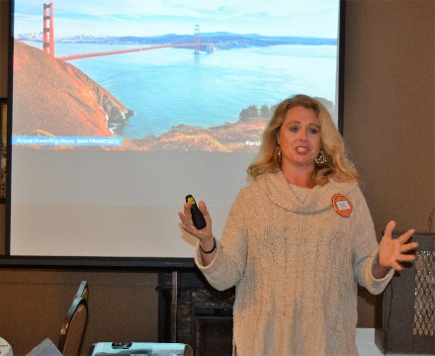
Craft Talk: Michaela Thompson
Red Badger Michaela Thompson, who had previously spoken to the Club about her personal background, delivered a craft talk today. She described a new business in which she is involved – membership travel (points based) – that offers very low travel prices due to bulk purchases on travel. Michaela showed several possible trips and options. The company has trips throughout the world and offers a 4 days/3 nights welcome trip. Michaela promises you a great experience. For more details, see Michaela before setting off on your vacation of a lifetime.

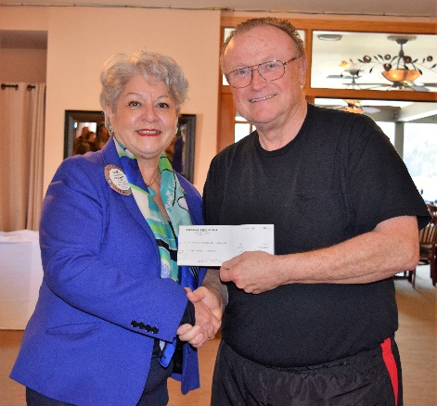
It was great to see Bruce Johnson return from his second knee replacement since August. He was accompanied by his wife, Linda. By all indications as well as Bruce’s own words, recovery is going great.

To mark his return, Bruce presented President Carol with a $2500 donation to the Breathing for Life (BFL)Project raised by Redwood Christian Chapel. BFL has now raised $359,655 for the oxygen generator in Nejo, Ethiopia. The team under the leadership of Obse Lubo is finalizing the grant application.

Announcements
►Ken O’Donnell reminded members that the Poker Tournament is Saturday, March 18, at the Castro Valley Masonic Center. The Poker Tournament is the Club’s largest fundraiser. The Club is still looking for poker players, sponsorships (contact Ken) and prize donations (contact Mark Poniatowski or Dawn Ortiz). It’s not too late to sign-up and demonstrate your poker talents.

►Youth to Youth for middle school students is scheduled for March 4 at Castro Valley High School. Volunteers are still needed to serve dinner at 5:00 p.m. in the CVHS Cafeteria. Call Jim Negri for details.

►Margie Ramos is collecting clothes for the homeless, especially t-shirts and coats. Bring your donations to any lunch meeting or contact Margie.

Service Above Self

