Rotary Club of Castro Valley
Meeting Highlights – February 5, 2019

Miriam Meadows, Castro Valley Unified School District Social Worker/Counselor
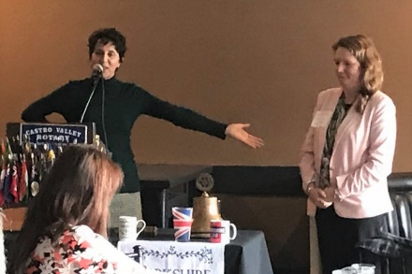
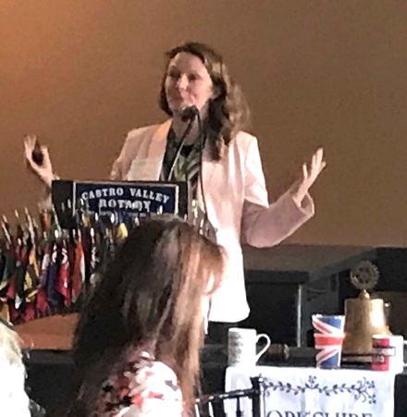
After an introduction by Castro Valley Rotarian Parvin Ahmadi, Superintendent of the Castro Valley USD, Miriam described the history and workings of the District’s Wellness Center located on the Castro Valley High School campus. The Wellness Center provides a multi-tier support system for all students at Castro Valley and Redwood High Schools. The Mission of the Wellness Center is to build, together with the CVUSD community, a web of adults, peers, spaces and experiences that make it safe for everyone to grow their best selves.

Finding space to house the Wellness Center was a necessary first step. Recently, a permanent independent structure was created at Castro Valley High School for the Wellness Center. Efforts are current underway to create similar Wellness Centers at the Canyon and Creekside Middle Schools. Students are referred to the Wellness Center for support by administrators, counselors, teachers, and others. Current programs available in the Wellness Center include

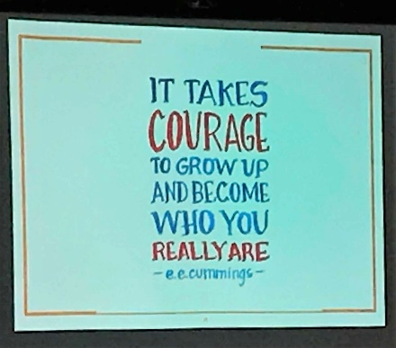
Drop In Lunch Circles

Restorative Justice Circles

1:1 Counseling for Social-Emotional Needs

Brief Intervention (BI) for Substance Use & Abuse

Resources for Students, Parents and Staff

Spring Support Groups:

Managing Stress & Anxiety

Cognitive Behavioral Interventions for Trauma in Schools (CBITS)

Young Men's Group

Young Women's Group

Grief Group

African-American Student Drop-in Group

Wellness Workshops

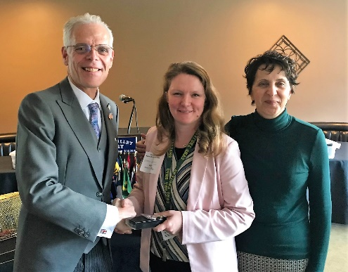
The Wellness Center is part of the District’s approach of educating the whole child to ensure the success of all students. The Board Policy on Student Wellness is available here.

The Wellness Center is looking for the following donations: cell phone charging cords; rocking chairs, fidget toys and snacks among other things.

Click here for more information regarding Castro Valley USD.

Announcements:
- A condolence card was signed for KJ Page’s husband, Thomas, who passed away suddenly. Members also contributed donations to charity. There will be a remembrance service for Thomas on February 20th at 3:00 p.m. 1309 Allston Way, Berkeley. Parking is limited so please arrive early or consider carpooling. Contact cliff Sherwood if you have any questions.

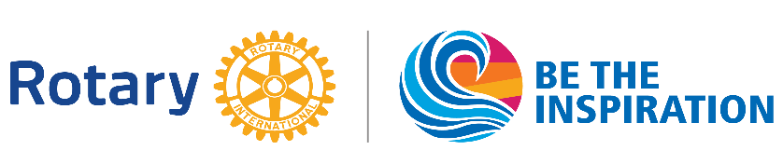
Upcoming Events – Mark Your Calendar (Check ClubRunner for details)
- February 12 - Annual Richard D. King Student Speech Contest at the Lunch Meeting
- February 19 - Lunch Meeting with Castro Valley & Redwood Christian High School students who the Club sponsored to attend Camp RYLA this past summer
  - Come and hear from the dynamic future leaders that the Club is sponsoring
- February 20 - Chili Cook-off & Rodeo Parade Planning Meeting @ 5:30 pm at Direct Sales Floors
- February 21 - Castro Valley/Eden Area Chamber of Commerce Mixer @5:30-7:30 pm at Don Jose’s sponsored by the Rotary Club of Castro Valley
  - Wear your Rotary shirt
  - Looking for several donated door prizes – see Charles or Michaela
- February 26 - Lunch Meeting with Denyse McCowan, Program Director - Alameda County Ombudsman
- March 9 TEXAS HOLD’EM FUNDRAISER @ 5:00 p.m. at Our Lady of Grace Church – Stack Center

Scenes from the Meeting
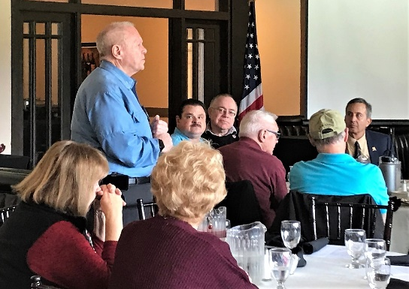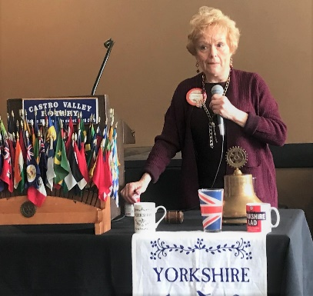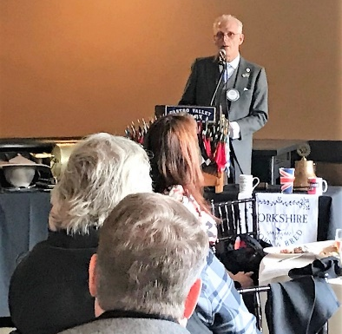

Rotarians in Action
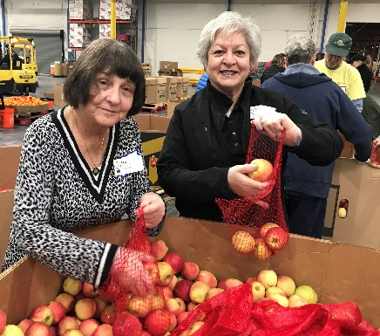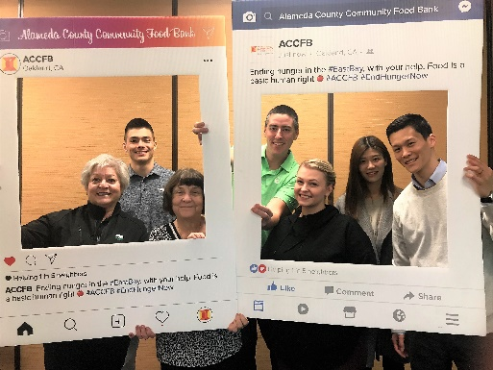

(Top): Something about Bill Nott putting his money where his mouth is to support Ruby’s Place.
(Bottom): Ceta, Carol and Mirador Capital Partner Team volunteering (Service Above Self) at the Alameda County Food Bank., which can always use volunteers.

