Rotary Club of Castro Valley
Meeting Highlights – February 6, 2018

Susan Ewing Haley & The Castro Valley Nike Missile Site
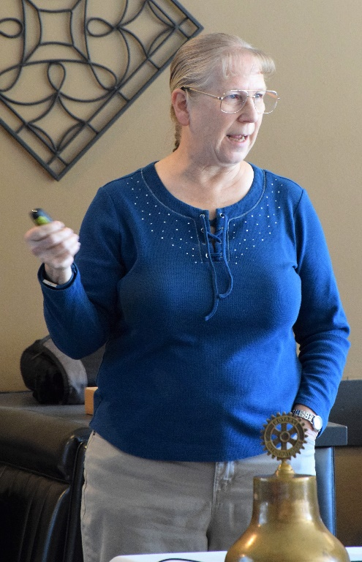
Susan Ewing Haley, Supervisor Curator for the National Park Service, Golden Gate National Recreation Area (GGNRA), Parks Archives & Record Center presented an outstanding program on the Nike Missile SF-31 Launch Battery Site located above Lake Chabot. In sharing numerous slides about SF-31 Lake Chabot Nike Missile Site, Susan showed slides of Nike Missile SF-88 located in the Marin Headlands. SF-31 now houses the offices and maintenance facilities for the East Bay Regional Park District, but it is not open to the public. SF-88 is open to the public on a limited basis.

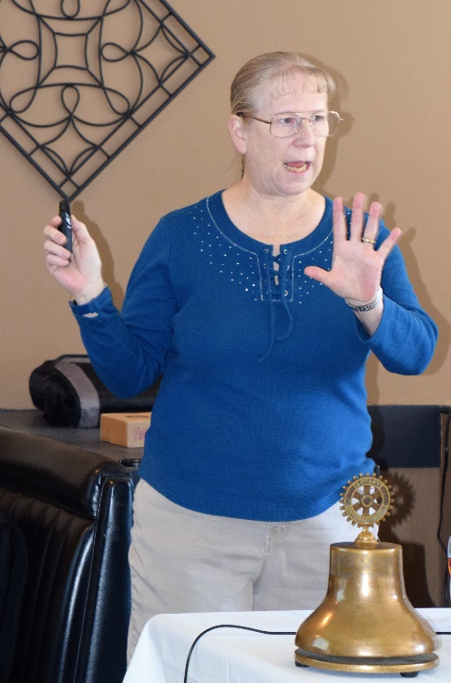
SF-31 was established in 1955 and consisted of Missile Storage Area, Missile Transportation Equipment, Missile Deployment Area, Living Quarters for the Missile Deployment Personnel and Administration Offices. In addition, it included the area for guards and sentries Living Quarters and Access Control Area. The entire had both outer and inner security fencing with sentry guard dogs. Most of Missile Storage and Handling Areas were underground. The missiles were stored underground and moved around on rails using missile transporters on rails. The underground areas were enclosed in gated bunkers with elevator access. The areas and buildings now visible from outside included Sentry Stations, Residential Quarters, and Administrative areas.

In 1958-59 the site was upgraded to accept the larger, more powerful Hercules missiles, which replaced the Nike missiles. Since the Hercules missiles were larger, the site stored few missiles. There were never any missiles fired from SF-31. The site was deactivated in March 1974 with all the missiles and usable equipment removed and the fence surrounding the area was removed. The site was handed over to Park Service.

For more information regarding SF-31, click here.

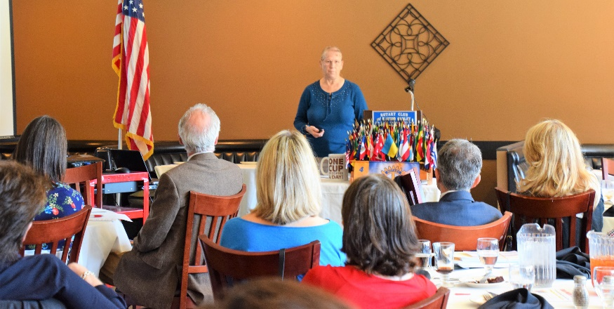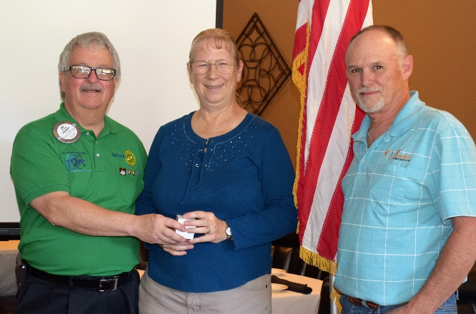

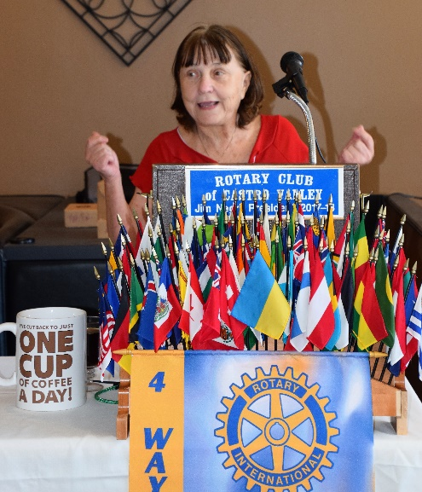
Membership Moment – Ceta Dochterman
Continuing the series of Membership Moments coordinated by Virginia Degner, Ceta shared her activities and interests beyond Rotary (her son, humanitarian work, and social activities). She also described her journey to Rotary and Service Above Self. Ceta’s brother, Cliff Dochterman who is a member of the Rotary Club of Moraga, is a Past Rotary International President. Ceta will be happy to share more of her story, if you ask her – politely, of course.
What’s New in Castro Valley
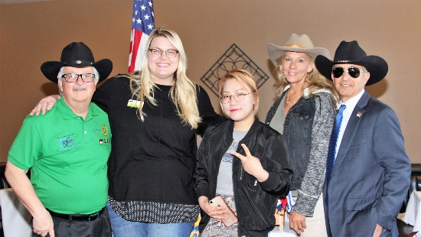
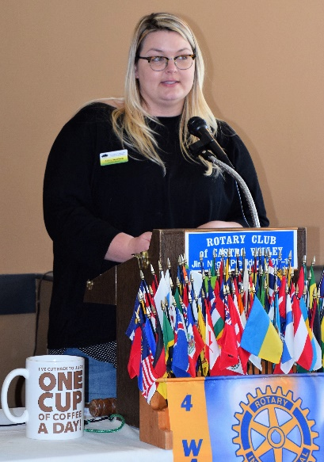
Ashly Strasburg, CEO of the Castro Valley/Eden Area Chamber of Commerce provided a quick update on Chamber activities and events including the Eden Awards where Heidi Hausauer will be honored as Volunteer of the Year and the Chamber Mixer on February 15th that the Rotary Club of Castro Valley is hosting with the 2018 Castro Valley Derby. Ashley announced the new Board of Directors who were sworn in on January 25th and highlight the many Chamber events and activities (Fall Festival, food trucks, business seminars/workshops, Taste of Castro Valley). Ashley introduced Chamber’s intern, Sean Lee, who is a Korean student and staffer, Allie Field.

Chamber Mixer
Jerome Blaha and his daughter, Jennifer, promoted the Chamber Mixer on February 15 at Faith Lutheran Church at 5:30-7:30 p.m. Please wear your Rotary shirt and pins, and a crazy hat – not that Rotarians are crazy. Be sure to invite your spouse/significant other and friends to this fund event.
Texas Hold ‘em Fundraiser
Mark Poniatowski reminded everyone to being selling tickets, recruiting sponsors and donating prizes. Mark and Michaela Thompson are also coordinating members to visit other Rotary Clubs in the area as well as Castro Valley business to distribute fliers and sell tickets. Do you think you can trust any of the players at this table? Remember the Four Way Test.

Upcoming Speakers & Events
- February 13 – Lunch Speaker - Craig Semmelmeyer, Developer - Main Street Property Services, speaking on the development of the Daughtrey's Building
- February 15 – Castro Valley/Eden Area Chamber of Commerce Mixer at Faith Lutheran Church at 5:30-7:30 p.m.
- February 20 – Lunch Program – Richard King Speech Contest with students from Castro Valley and Redwood Christian High Schools
- February 27 – Lunch Speaker – Paul Wildrick, Action Coach, speaking on What Businesses Do Right and What Businesses Need to Do Right

