Rotary Club of Castro Valley
Minutes Highlights for January 10 and January 17, 2017

January 10, 2017

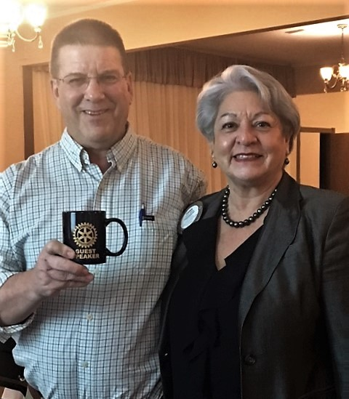
Speaker - Rich Schneck, College and Career Specialist, Castro Valley Unified School District
Mr. Schneck outlined the amazing programs for students in the Castro Valley USD that get them involved and excited about the education and skills needed for contemporary careers in the job market. Castro Valley High School offer the following Career Pathways:

- HABIT: Health & Biotechnology
- ICT: Information & Communication Technology
- PLTW: Project Lead the Way Engineering
- DADA: Drama, Art and Design Academy

For more information regarding these programs as well as others, click here. (http://www.cv.k12.ca.us/cvhs/academics/college-career-pathways/college-career-pathways-page)

Announcements from President Carol and Other Rotarians
- The Breathing for Life (BFL) project goals is now $355K to ensure sustainability once the oxygen generator is installed at Nejo Hospital. The Club is nearing the goal. If you have not contributed to BFL, now is the time to do so. Also, spread the message about this living saving projects to family, friends, and colleagues. Donations of any size are welcome.
- Rotary International (RI) and District 5170 requires all Club members to complete the online Youth Protection Certification Services exam so that Cub members can work with youth (e.g. Christmas Party, Interact, Rodeo Party, Chili Cook-off, Club Picnic and any event where youth are present). The training takes 20-30 minutes at the most and is a requirement for all Blue Badgers. Several Club members (President, Youth Services Chair, Youth Protection Officer, Interact Chair) must complete higher levels of certification and a Department of Justice (DOJ) fingerprint clearance. Rotary is taking these steps to ensure the safety of all students who interact with Rotary and Rotarians in any way. Youth Protection Officer will resend the link to the online certification course. Please complete the course ASAP.
- The Castro Valley Eden Area Chamber of Commerce is holding its Second Annual Eden Awards Dinner, which honors local heroes, on January 28th at Redwood Canyon Golf Course at 6:00 p.m. Information and tickets are available on the Chamber website at http://www.edenareachamber.com/. The Rotary Club of Castro Valley is one of the sponsors of the event.
- C&T Recycling sent note of appreciation for our $30 contribution.
- Dwight Perry announced that the Rotary Dragon won at the Rose Parade, which was a collaboration of six (6) Rotary Districts, including District 5170. Dwight asked members to donate $3-5 to support the effort.
- Mark your Calendar: The Poker Tournament is scheduled for March 18th at 6:00 p.m. at the Masonic Lodge. This event is the first Club fundraiser of the year. We need players and sponsors to make it successful, which will allow the Club to continue doing its good works.

January 17, 2017

A Club Assembly was held on January 17th where board members and committee chairs provided status reports on activities that have occurred this year and that are planned for the remainder of the year. Board members and committee chairs are posted on the Club website.

The recognition of Paul Harris recipients was the highlight of the meeting. President Carol recognized the following members with Paul Harris pins for their donations to The Rotary Foundation.

- Heidi Hausauer PHF+3
- James Philips PHF+3
- Leslie Rothwell PHF+3
- Robert Crossett PHF+5
- Bruce Johnson PHF+6

The “+” means additional donations beyond the first Paul Harris donations. Congratulations to everyone. Remember, it is never too late to donate to The Rotary Foundation. See Dwight Perry or Dan Willits for information
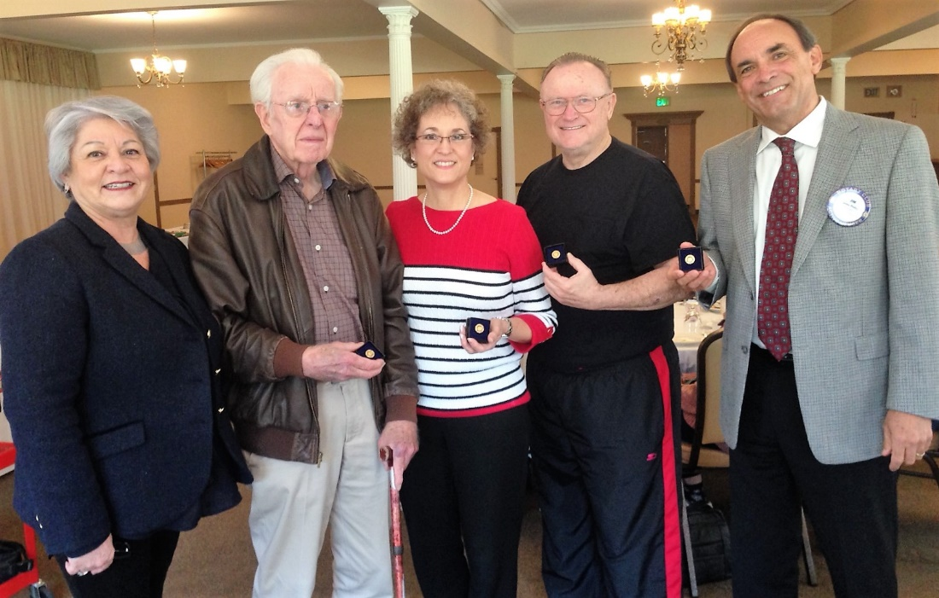
L-R: President Carol Wikle, Bob Crossett, Heidi Hausauer, Bruce Johnson and Jim Philips. Photo by Gary Bosley
President Carol reported that that Breathing for Life (BFL) Project Committee (Obse Lubo, Kern Lewis, Bill Nott, Cliff Sherwood, Dwight Perry, Carol Wikle and Jim Negri plus several District 5170 members including a Past District Governor) has been meeting regularly to ready the grant for submission. BFL has secured new commitments from the Rotary Club of Budapest City and Rotary District 5450 in Colorado for donations of $3000 and a District Designated Funds (DDF) of $1000. It’s not too late to donate to this life saving project. Please share information regarding BFL with family, friends and colleagues, and encourage them to donate.

Future Meetings:
- January 24 - Marian Meadows and Rinda Bartley from Castro Valley USD regarding social and emotional support for students. Please RSVP on ClubRunner.
- January 26 - Chili Cook-off (5:00 p.m.) and Parade (5:45 p.m.) at Direct Sales Floors. All members welcome to join either or both committees.

