Rotary Club of Castro Valley
Meeting Highlights – January 15, 2019

Derrick Hall - Solar Energy Systems
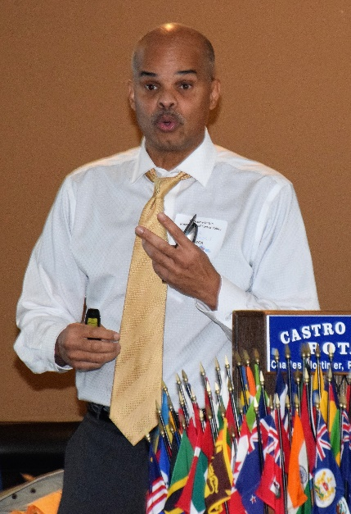
Membership Chair Virginia Degner introduced Derrick Hall from Solar Energy Systems whom reviewed solar energy options for Club members and guests. Derrick started by explaining how greenhouse gases trap heat and are making the planet warmer. This warming trend has been recognized by the both the State of California and the U.S. Government. As a result of this trend, they have been developing means of reducing the impact of greenhouse gases.
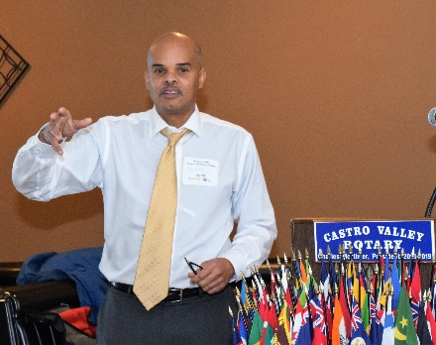
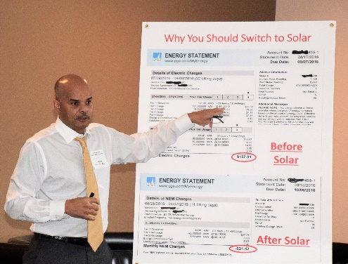
For many years, both the state and federal governments have offered incentives to homeowners to switch to solar energy for home use and many homeowners have taken advantage of these incentives. In recent years, these incentives have been disappearing. The State of California will stop giving tax breaks to homeowners starting in 2019. The federal government is still offering 30% tax credits for switching to solar energy. The recent availability of cheaper and more efficient solar panels coupled with the 30% federal tax incentive for year 2018 still makes switching to solar energy an attractive alternative at least for now. California has mandated that starting in 2020 all newly built homes onwards must be equipped with solar panels. Derrick showed slides illustrating different types of solar roof panels.

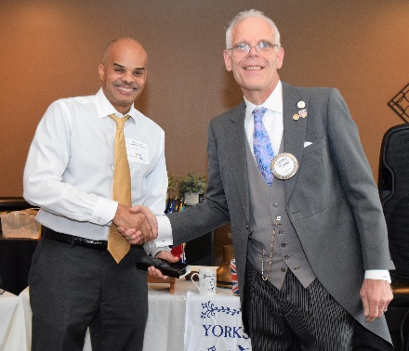
PG&E is still committed to buying the excess electric power generated by homes up to a specified level (power generated by solar minus power consumed by the generator equals net metering by the PG&E), which means that the net cost of using electricity by the homeowner can be reduced to almost zero. The homeowner is only liable for all the taxes and fees only. Derrick points out that the sale price of a home can be increased by 2-6% with the installation of solar panels. Since the cost of electricity provided by PG&E is expected to increase at a 6.7% in the future, switching to solar energy is still an attractive option for home owners in California. Derrick demonstrated several cost savings scenarios to drive home this cost saving point. Solar Energy Systems recently installed a solar energy system for Virginia so talk to her for a first-hand account.

Texas Hold’em Announcements
- Mark Poniatowski reminded members to sell their tickets for the Texas Hold’em Fundraiser.
- Michaela Thompson reminded members to turn in the money when they sell tickets.
- Kern Lewis distribute fliers and sponsorship letters, which have been emailed to all members.
- Jim Negri reminded members of the need for major prizes (a value greater than $300) for the top 10 finishers.
- Next meeting is February 6th at 5:30 pm at the Mark Poniatowski’s office.

Scenes from the Meeting and Other Announcement
- Todd Anglin announced that the next planning meeting for the Chili Cook-off (5:30-6:00 p.m.) and Rodeo Parade (6:00-6:30 p.m.) will on January 31st at Direct Sales Floors. The complete list of meeting dates is posted on ClubRunner. Both events (May 10th for the Chili Cook-off and May 11th for the Rodeo Parade) are All Hands-on Deck Events for all Club members. There are plenty of opportunities to volunteer in the Service Above Self spirit. See Todd Anglin (Rodeo Parade) and Randy Vanderbilt (Chili Cook-off) to volunteer.

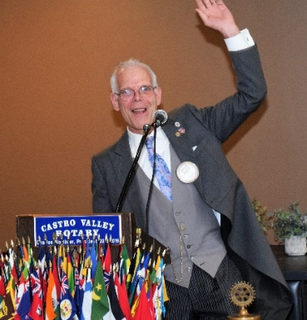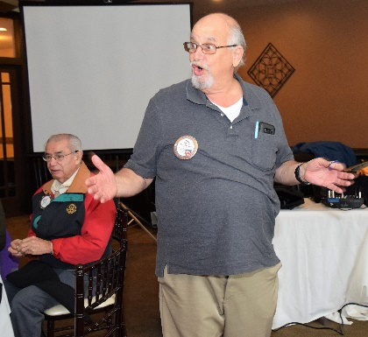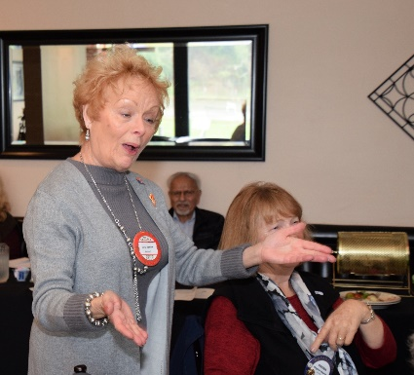

(Left to Right): The Club welcomed President Charles back from his recent trip to England. Bill Nott seemed surprised to lead the Four Way Test and had some difficulty reading the small font on the coin as Ben Gurule observed with interest. Carol Bigelow in her role as Greeter welcome guests and visitors.

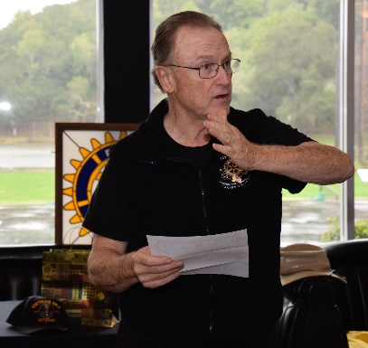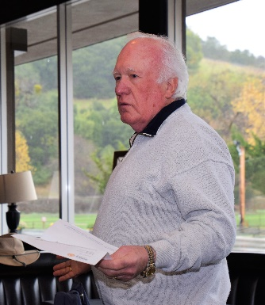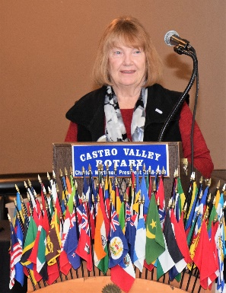

(Left to Right): Bruce Johnson shares a thank you letter from Ruby’s Place to the Club for hosting the Children’s Christmas party and other donations. Foundation Chair Dwight Perry shares a letter from the Rotary Club of Paradise thanking the Club for over $7,000 in donations for the victims on the Camp Fire. Virginia Degner introduces the Speaker for the Day.

Thoughts and Scenes from the Meeting of January 8th – Happy New Year
- Past President Jim Negri, chairing the meeting for President Charles, welcomed the members to 2019 with the following thoughts for the New Year:

New Year’s resolution: To tolerate fools more gladly, provided this does not encourage them to take up more of my time. ~James Agate~
The road ahead is not some predetermined path that I am forced to trod, but it is a rich byway that I can help create.
~Craig D. Lounsbrough~
Let our New Year’s resolution be this: We will be there for one another as fellow members of humanity,
in the finest sense of the word.
~Goran Persson~
- Jim stressed that the last two quotes speak directly to the heart of being a Rotarian and the concept of Service Above Self.
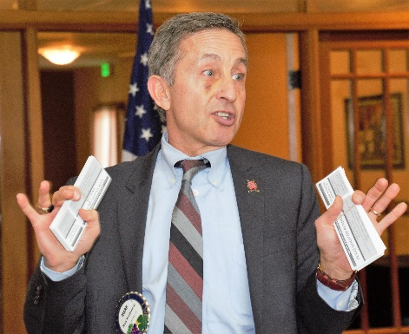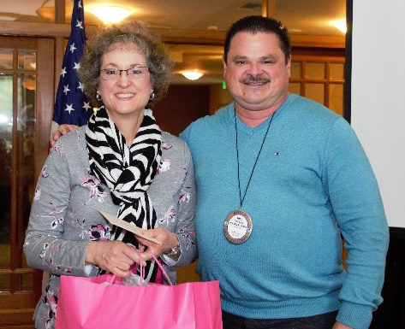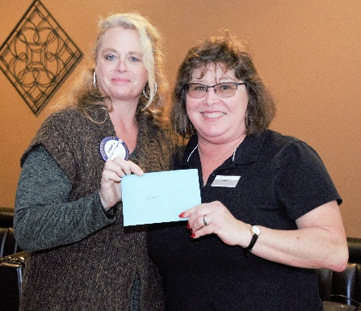

(Left to Right): Texas Hold’em Chair Mark Poniatowski reminds everyone to sell tickets for the Texas Hold’em Fundraiser, the Club’s largest fundraiser and explains the reality of his Presidential Theme, The Puck Stops Here. President-Elect and Holiday Party Chair Todd Anglin thanks party host Dr. Heidi and presents her with a small token of the Club’s appreciation. Treasurer Michaela Thompson presents hostess Kim with a $500 check as a belated Christmas presents for her outstanding service throughout the year.

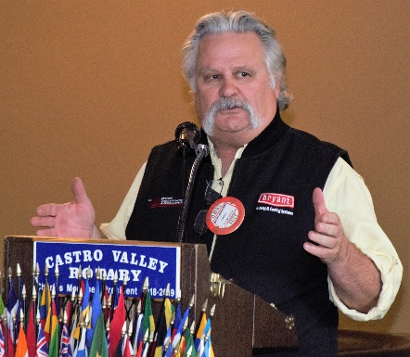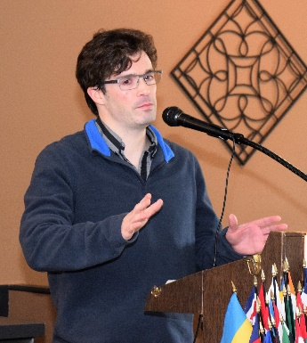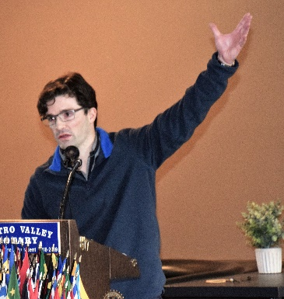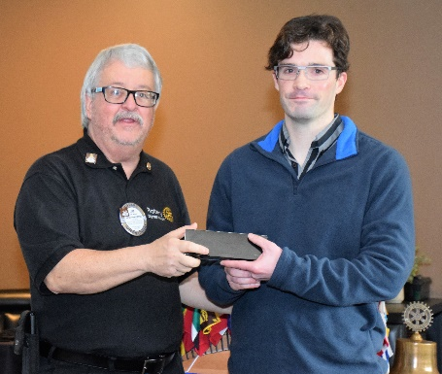

(Left to Right): Monthly Speaker Chair Brian Morrison introduces the speaker, his son Brandon Morrison, who spoke about his educational experiences where those experiences have led him in his research efforts during with space and other others. While the presentation was technical, Brandon engaged the members throughout his presentation with the range of his research. Past President Jim Negri presents Brandon with a thank you gift as he heads back to his studies in in Edinburgh.

