Rotary Club of Castro Valley
Meeting Highlights for January 16, 2018

Susie Passeggi & Kerry Principato – New Medical Technology Programs at CVACE
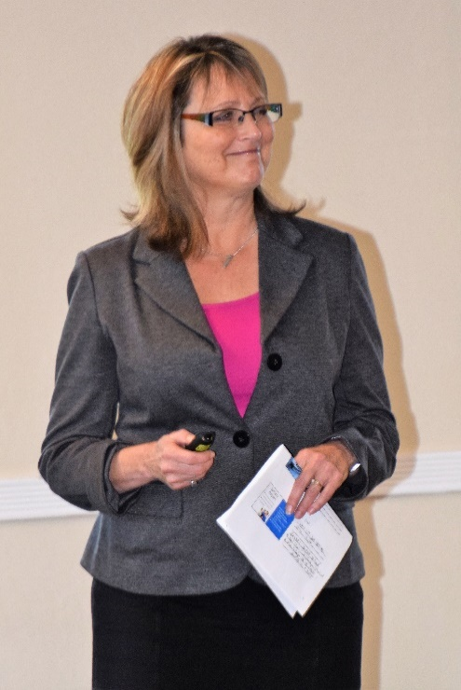
Castro Valley Adult & Career Education (CVACE) Director Susie Passeggi and Director of Career & Technical Education (CTE) Programs Kerry Principato shared the variety of Medical Technology programs offered by CVACE as well as the range of other, high interest programs. The CVACE Medical Academy includes multiple Certificate Programs and Courses

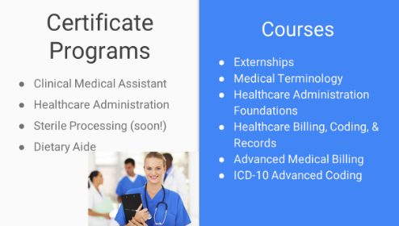
Participants who complete these programs have excellent rates of success: 99% pass the certification exam; 86% are employed or are continuing their education, and 83% who completed their externship are employed. Susie Passeggi attributes the success to
- Quality Teachers
- High Expectations and Program Rigor
- Intensive Hands on Skills Training
- Soft Skills
- Mock Clinics
- Academic Counseling
      - Career Fairs
      - Externships
Susie Passseggi
The high-quality instructors and externships provided by the many partners in the Medical Academy are very important to the success of the program and the students.

Susie and Kerry shared information about the other Career Education courses with include
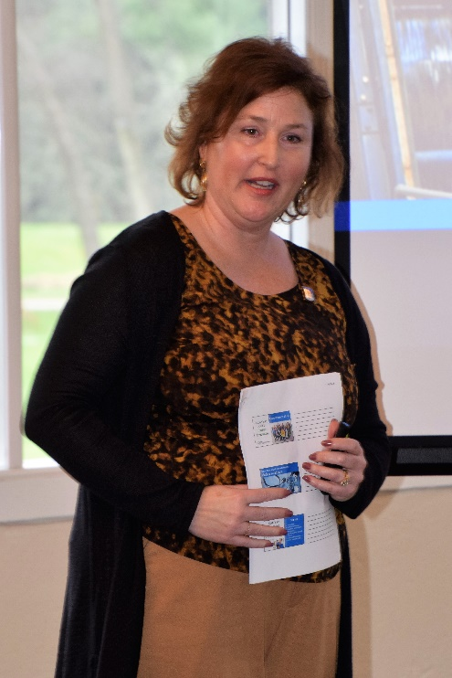
- Excel 2013, Part I & II
- Microsoft Office Essentials
- Windows 10 Essentials
- Keyboarding
- Become a Notary Public
- Make Extra Money as a Loan Signing Agent
- ServSafe Food Safety Manager Certificate

CVACE offers a range of Online Certificate Courses that includes
- Data Analysis
- Accounting & Finance for Non-Financial Managers
- Entrepreneurship Certificate
- Customer Service
- Workplace Communication
- Non-Profit Administration
- Web Design
- Word Press
Kerry Principato

Susie and Kerry shared several student video testimonials that detailed the impact that CVACE had on their careers. Jim Negri mentioned that despite the state budget cuts to Adult and Career Education over the years, the Castro Valley School Board has supported, maintained, and expanded the program so that the community can truly experience Lifelong Learning. The CVACE presentation is available here.
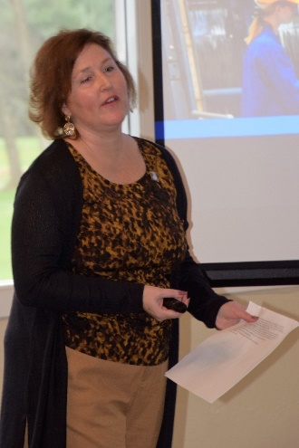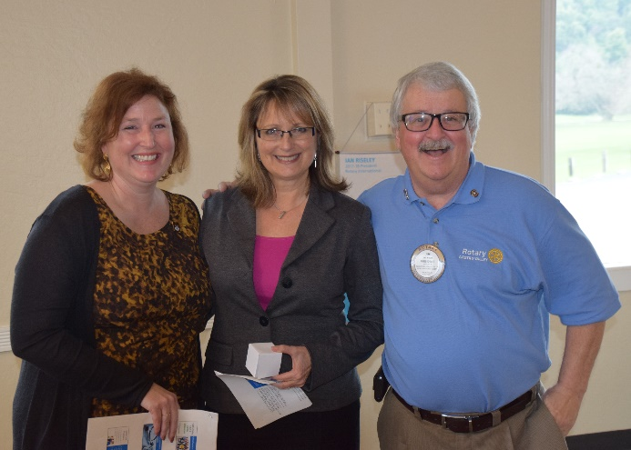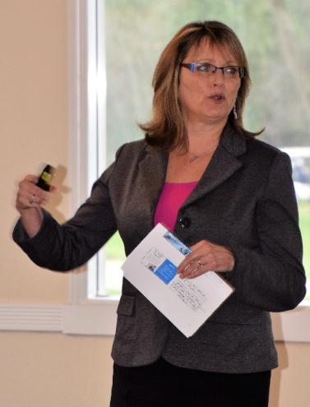

Paul Harris Fellows
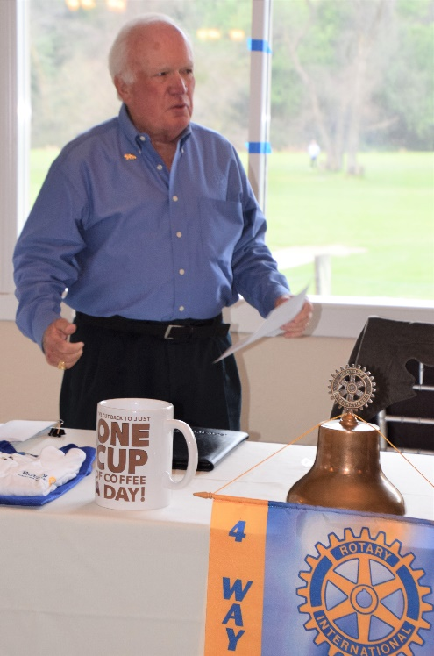
Ten members of the Rotary Club of Castro Valley received recognition for their contributions to Rotary International, enabling Rotarians to carry on a worldwide program of educational and humanitarian programs. The Paul Harris Fellowship was named after the founder of Rotary International. The initial Paul Harris Fellowship indicates $1,000 being donated The Rotary Foundation (TRF) in the name of an individual. With each additional $1,000 donated, the Rotarian receives a higher recognition with a Paul Harris pin with a stone representing each increase. Receiving their initial Paul Harris recognition were Charles Mortimer and Dan Willits as well as the children of Rotarian Mark Poniatowski, Daniel and Lisa Poniatowski. Other Rotarians recognized, and their contribution level were Virginia Degner and Ray Wallace (1 stone), Tony Morsilli and Jim Negri (2), John Aufdermauer and Carol Wikle (3), Jeff Moore (4), and KJ Page (7 stones).

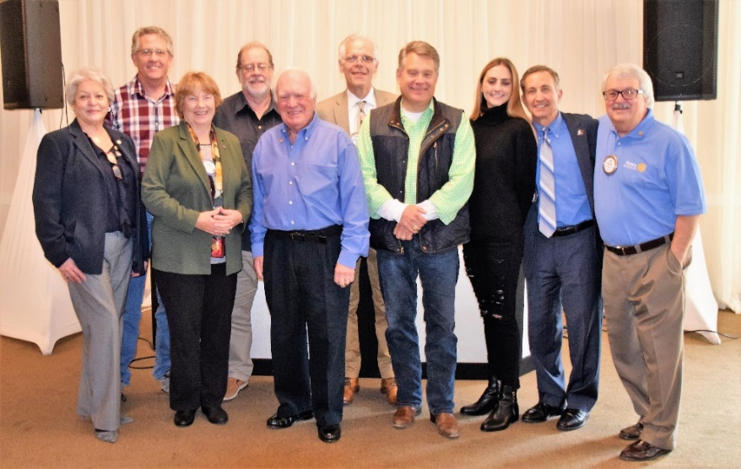
Today, Rotary International raises more than $100,000,000 per year and about 80% of those funds come from individuals being named Paul Harris Fellows. There are more than 1,000,000 Paul Harris Fellows and multi-Fellows in the world. Programs financed by The Rotary Foundation include: vaccinating children against polio and other diseases; adults and child alike can learn to read; women being awarded micro loans and receiving vocational training that enable them to support themselves and their families in a healthy and dignified way; teachers and students have access to toilet facilities and clean drinking water; research scholars being funded to study ways to prevent child mortality; and professional from around the world convening to discuss strategies for resolving conflict and fostering peace. This is Rotary Making A Difference.
Pictured (l to r): Carol Wikle, John Aufdermauer, Virginia Degner, Ray Wallace, CV Rotary Fund Chair Dwight Perry, Charles Mortimer, Jeff Moore, Lisa Poniatowski, sponsor Mark Poniatowski, President Jim Negri

Texas Hold ‘em Tournament
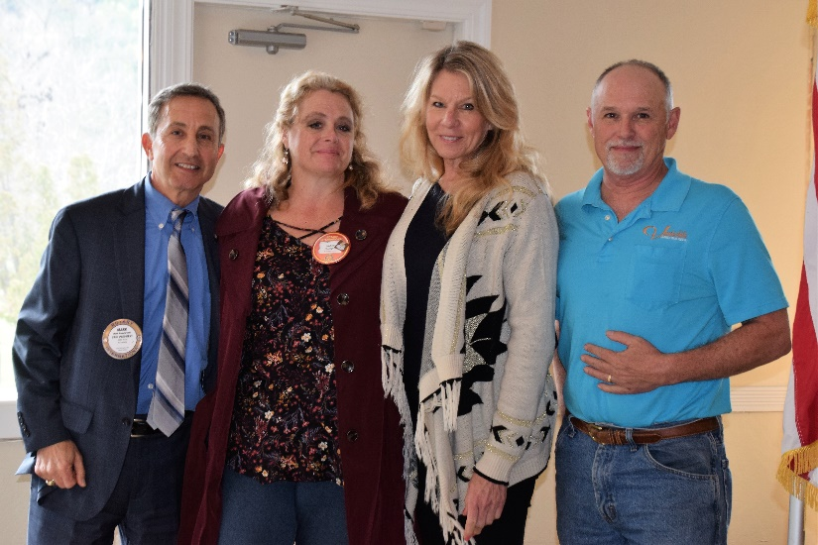
The Rotary Club of Castro Valley is sponsoring a Texas Hold ‘em Tournament on March 10th at Our Lady of Grace Church in Castro Valley. In addition to poker and dinner, there will be music and other activities for the non-poker player. Buy-in is $200 with re-buys allowed.

This event is the major fundraiser of the year for the Club. The committee of Mark Poniatowski, Michaela Thompson, Dawn Ortiz, and Randy Vanderbilt provided a brief overview of the event and will provide all the information that you need to know at the meeting on January 23rd.

Upcoming Speakers and Events
- January 23 – Lunch Speaker – Parvin Ahmadi, Superintendent of Castro Valley Unified School District, speaking on New Bills Impacting Education
- January 30 – Lunch Speaker TBD
- January 31 – Board of Directors Meeting at 6:00 p.m. at the Castro Valley Unified School District Board Room (4400 Alma Avenue) – All members are invited to attend
- February 6 – Lunch Speaker – Susan Ewing Haley, Curator of the Golden Gate National Recreation Area, speaking on the history of the GGNRA
- February 8 – Planning Meeting for Chili Cook-out and Rodeo Parade at Direct Sales Floors at 5:00-6:30 pm
- February 13 – Lunch Speaker - Craig Semmelmeyer, Developer - Main Street Property Services, speaking on the development of the Daughtrey's Building
- February 20 – Lunch Program – Richard King Speech Contest with students from Castro Valley and Redwood Christian High Schools

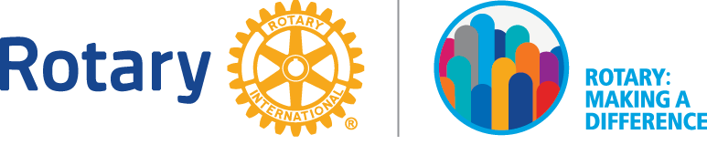

Making A Difference Starts in Castro Valley

