Rotary Club of Castro Valley
Meeting Highlights - January 22, 2019

Susan McCue and Kristin Perrault - Alameda County Economic and Civic Development Department
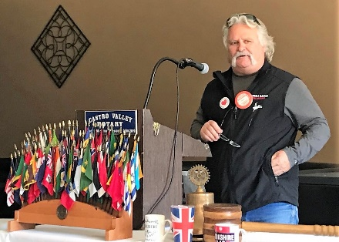
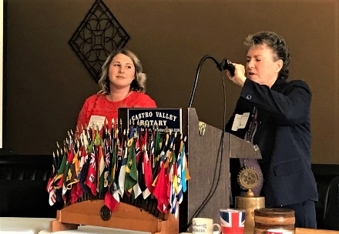
After an introduction by January Speaker Chair Brian Morrison, the Club welcomed back Susan McCue, Economic Development Manager, and Kristin Perrault, Economic Development Specialist, from the Alameda County Economic and Civic Development Department for an update on Alameda County activities, especially those activities that impact Castro Valley. The role of the Economic and Civic Development Department is to promote economic development and public/private investment in the unincorporated communities of Alameda County, including the Eden Area communities of Ashland, Castro Valley, Cherryland, Fairview, and San Lorenzo. The Economic and Civic Development Department works to
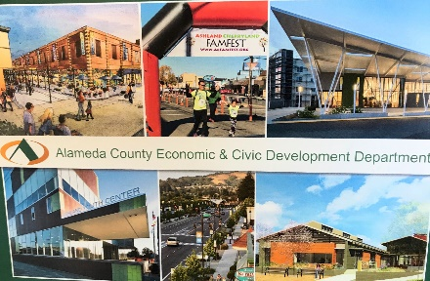
- Attract new businesses;
- Help businesses expand;
- Offer small business workshops;
- Offer the award-winning Food Training Academy;
- Provide technical assistance;
- Offer one-on-one business counseling;
- Attract new investment;
- Find the perfect location for businesses;
- Provide marketing opportunities at signature events; and,
- Be a liaison for property owners and real estate development project
Susan and Kristin described some the Castro Valley projects in which the Economic and Civic Development Department have been involved. These projects include
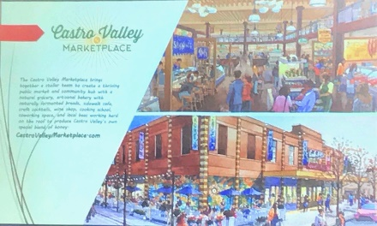
- Castro Valley Library;
- Castro Valley Streetscape;
- Castro Valley shared parking; and,
- Castro Valley Marketplace.

Other information that they provided included
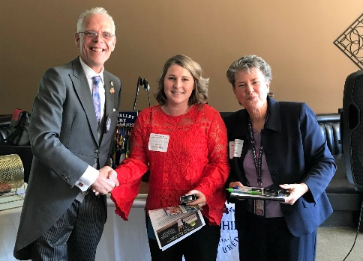
- A new food department store is expected to open by this summer;
- A new façade is planned for the Castro Valley Marketplace this year at a cost of $200,000;
- A Food Business Training Workshop in 2019 that will consist of seven, two-hour sessions;
- Economic Development Forum Seminars in 2019; and,
  - Signature community events including a 5K Run and store-front Holiday Decoration Contest.

Upcoming Events – Mark Your Calendar (Check ClubRunner for details)

January 29 | Lunch Meeting with Ashley Strasburg, Executive Director, Castro Valley/Eden Area Chamber of Commerce
January 31 | Chili Cook-off & Rodeo Parade Planning Meeting @ 5:30 pm at Direct Sales Floors
February 5 | Lunch meeting with Marian Meadows
February 6 | Texas Hold’em Planning Meeting @ 5:30 pm at Law Offices of Mark Poniatowski
February 12 | Annual Richard D. King Student Speech Contest at the Lunch Meeting
February 19 | Lunch Meeting with Castro Valley & Redwood Christian High School students who attended Camp RYLA
February 20 | Chili Cook-off & Rodeo Parade Planning Meeting @ 5:30 pm at Direct Sales Floors
February 26 | Lunch Meeting with Denyse McCowan, Program Director - Alameda County Ombudsman
March 9 | TEXAS HOLD’EM FUNDRAISER @ 5:00 p.m. at Our Lady of Grace Church – Stack Center

Meeting Notes – Ajay Ahluwalia
Photos – Bruce Johnson
Editor – Jim Negri

