Rotary Club of Castro Valley
Meeting Highlights – January 23, 2018

Parvin Ahmadi – Superintendent of the Castro Valley Unified School District – New Bills Impacting Education
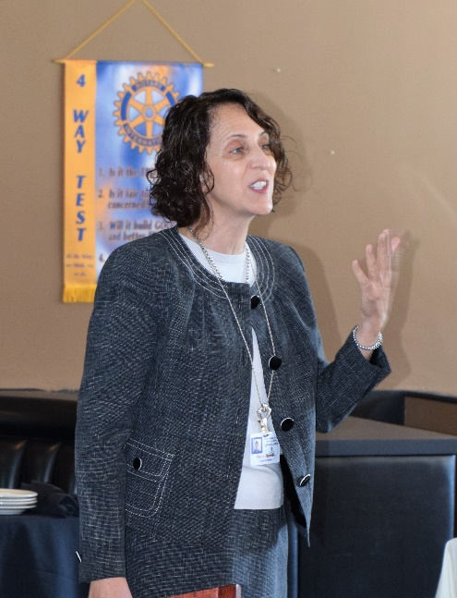
Parvin Ahmadi, Superintendent of Schools and Castro Valley Rotarian, spoke on the new bills impacting education and the impact of the Governor’s Proposed Budget.

The new legislation impacts education in four board areas:
- Board Ethics and Accountability
- Labor, Employment and Personnel Legislation
- Business, Finance and Construction Legislation
- Student Legislation

Examples of bill regarding Board Ethics and Accountability include
- Providing a Student Board Member a preferential vote, which CVUSD already does; and
- Requiring communication sent via personal devices and accounts subject to the California Public Records Act (CPRA). This law was based on a Supreme Court decision, which ruled that any communication related to the district by a board member is now subject to the CPRA.

Examples of bills regarding Labor Employment and Personnel Cases include
- Providing unions access to new employees’ orientations;
- Prohibiting actions to discourage union membership; and
- A Court of Appeals’ decision in Janus v. AFSCME regarding mandatory union dues.

An example of bills regarding Business, Finance and Construction include
- Requiring school district to test water systems for lead, which CVUSD already voluntarily does.

There were many bills regarding Students and Special Education that included
- Allowing district now share information on student homelessness to provide services. CVUSD has many homeless students;
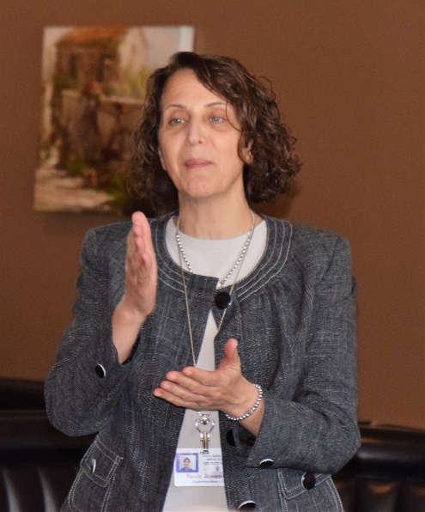
- Requiring sex education instruction to include education regarding sexual abuse and human trafficking;
- Requiring districts to inform students of means of correction before imposing a suspension on the student;
- Prohibiting districts from collecting information or documentation on a student’s citizenship;
- Prohibiting firearm possession in school zones. The superintendent previously had the authority to grant the right to possession a firearm at school.
- Prohibiting districts and schools to deny meals to students with unpaid meal fees; and
- Changing the Ed Code and eliminating the suspension of K-3 students for defiance.

Parvin was unable to demonstrate the California School Dashboard, which provides performance data for every district and school in California. Click here to see the performance data of schools in the Castro Valley USD.
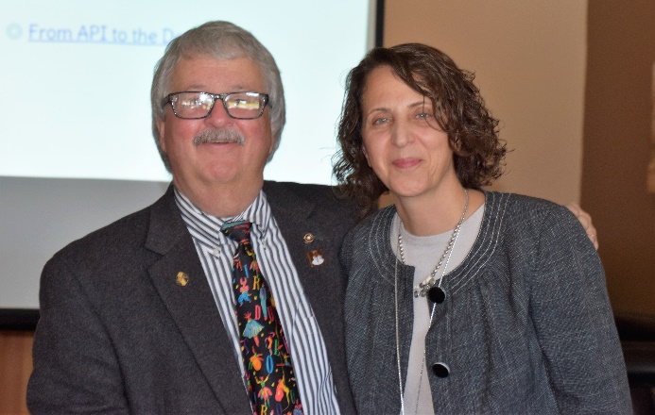

More Paul Harris Fellows Awarded
The Rotary Foundation (TRF) Chair Dwight Perry presented Dan Willits with his first Paul Harris Fellow and Randy Vanderbilt with s two stone Paul Harris Pin. Additionally, Jerome Blaha, and Jim Negri were recognized for contributing $1000 in a single year. It is never too late to donate to TRF and any donation makes a difference in Rotary’s work.
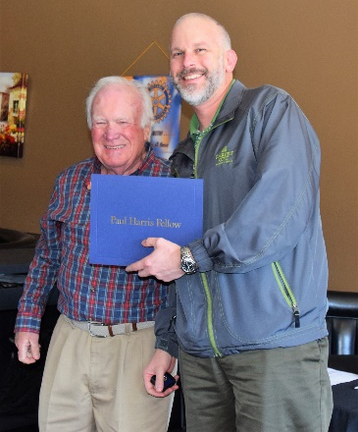
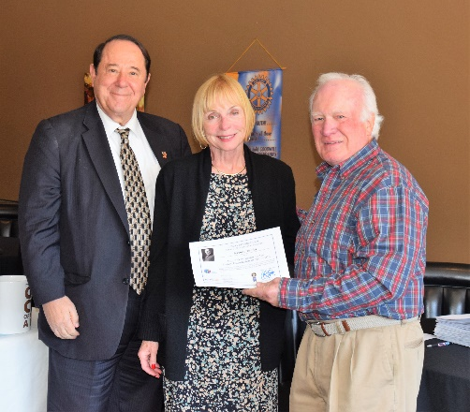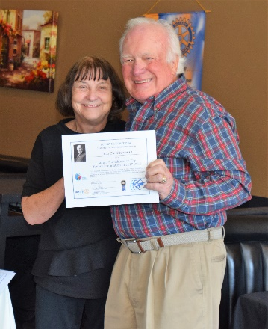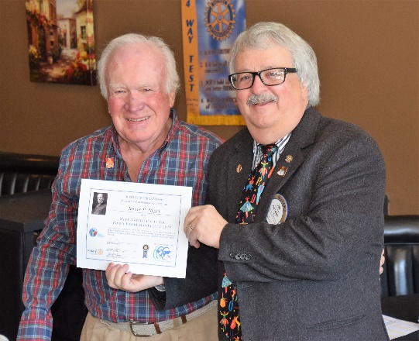

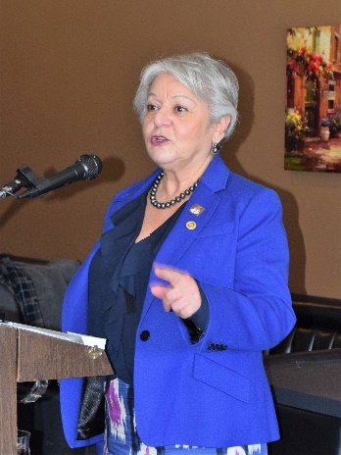

Todd Anglin Elected
Past President Carol Wikle announced that the Nominating Committee had nominated Todd Anglin, current Club Treasurer, as the 2018-2019 President-Elect, which means he will be the 2019-2020 President. After closing nominations, Todd was elected unanimously by a voice vote of the members. Congratulations to Todd.

Texas Hold ‘em Tournament Fundraiser
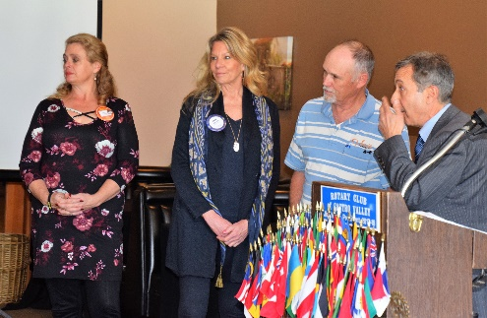
The Texas Hold ‘em Tournament Fundraiser Committee of Mark Poniatowski, Randy Vanderbilt, Dawn Ortiz, and Michaela Thompson reviewed the event, which will be held on March 10th at Our Lady of Grace Church starting at 5:00 p.m. Besides the location change, the dinner is being upgraded and there is a dinner only option for non-players as well as music.

All members were given a packet of fliers, tickets, and talking points. The Tournament is the Club’s largest fundraiser in terms of dollars. All members are asked to support the event by selling tickets, getting table sponsors, and obtaining prizes for the top 10 players. For more information, see any member of the committee.

Upcoming Speakers and Events
- January 30 – Lunch Speaker - Andy Lopusnak, Mike’s Cameras on What Was Hot and Was Not During Christmas Sales & Using Photography in Your Business
- January 30 – What’s New in Castro Valley – Laura McMichael-Cady, Eden Village Housing
- January 31 – Board of Directors Meeting at 6:00 p.m. at the Castro Valley Unified School District Board Room (4400 Alma Avenue) – All members are invited to attend
- February 6 – Lunch Speaker – Susan Ewing Haley, Curator of the Golden Gate National Recreation Area, speaking on the history of the GGNRA
- February 6 – What’s New in Castro Valley – Ashley Strausburg, CEO of the Castro Valley/Eden Area Chamber of Commerce
- February 8 – Planning Meeting for Chili Cook-out and Rodeo Parade at Direct Sales Floors at 5:00-6:30 pm
- February 10 – Eden Awards at Redwood Canyon Golf Course – Heidi Hausauer is being honored as the Volunteer of the Year
- February 13 – Lunch Speaker - Craig Semmelmeyer, Developer - Main Street Property Services, speaking on the development of the Daughtrey's Building
- February 20 – Lunch Program – Richard King Speech Contest with students from Castro Valley and Redwood Christian High Schools
- February 27 – Lunch Speaker – Paul Wildrick, Action Coach, speaking on What Businesses Do Right and What Businesses Need to Do Right

Making A Difference Starts in Castro Valley

