Rotary Club of Castro Valley
Meeting Highlights – January 24, 2017

Paul Harris Presentation to Leslie Rothwell
President Carol Wikle presented Leslie Rothwell with her Paul Harris +3 pin, which represents three contributions of $1000 to The Rotary Foundation over the years. Congratulations to Leslie for her genorisity.

While Rotary annually conducts a Double Sustainer Campaign ($200 donation to the Foundation), members may contribute to The Rotary Foundation in any amount at any time during the year and contributions accumulate until the $1000 level is reached. To learn more about The Rotary Foundation, go to https://www.rotary.org/en/about-rotary/rotary-foundation or contact Dwight Perry or Dan Willits.

Multi-Tiered Systems of Support (MTSS) for Students’ Social-Emotional Needs in CVUSD Schools
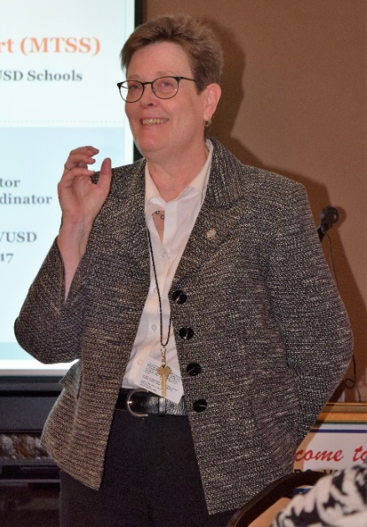
Rinda Bartley, Student Services Director, and Marian Meadows, Behavioral Health Coordinator, presented an overview of the multi-tiered systems of support for students’ social-emotional needs in the schools. MTSS is defined as: The framework of MTSS is a “way of doing business” which utilizes high quality evidence-based instruction, intervention, and assessment practices to ensure that every student receives the appropriate level of support to be successful in the academic, behavioral and social realms. MTSS is based on the following tenets:

- High-quality, differentiated classroom instruction;
- Systemic and sustainable change & improvement;
- Integrated data system; and
- Positive behavioral instruction & support (PBIS).

The MTSS approach been developed over several years through the following steps:
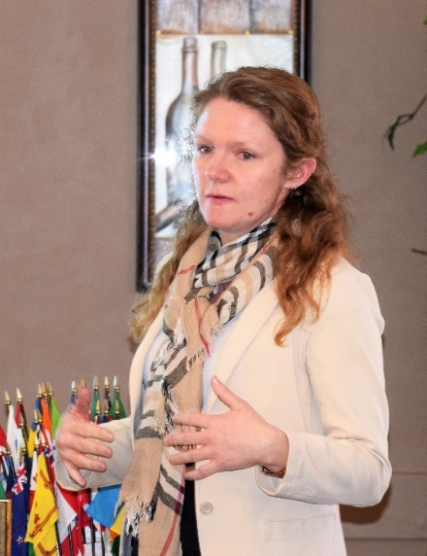
- Bullying prevention work and a successful pilot of PBIS and Second Step at a few school sites year 2012-13.
Rinda Bartley
- Zero-tolerance policies and suspensions were consistently being found to be ineffective in changing behavior, and racial & ethnic disproportionality in discipline and academic achievement were continuing to be a pattern.
- CVUSD continued the important work of creating & implementing increased opportunities for educational equity and culturally responsive teaching and learning at the sites.
- Compared to other local jurisdictions, public systems investment for behavioral health in Castro Valley is low, so the need existed to build in-house capacity to meet the behavioral health needs of students.
- The Educational Services Department received multiple grants to implement mental health consultation, PBIS, and Second Step in partnership with Special Education and the school sites.
Marian Meadows

As a result of the MTSS approach, the district has seen the following results:

- 3000 students receiving social-emotional learning lessons
- 6000 students receiving positive behavior instruction
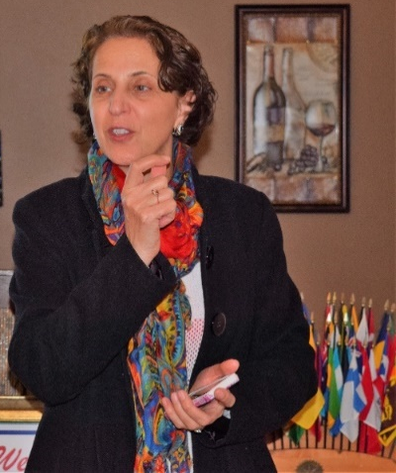
- Overall stable attendance rate of 97%
- Suspension rates have dropped 1.4 % over the last two years
- Impressive jumps in Math and English scores
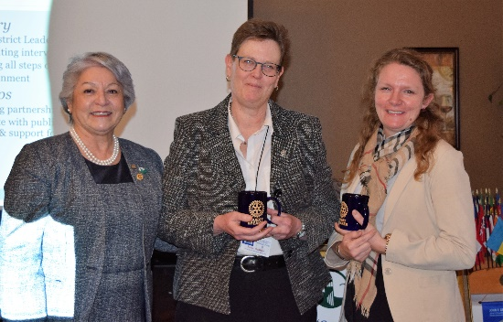
      - 3rd Grade Math: 10% jump for students overall meeting or exceeding standards
    - 3rd Grade English: 11% jump for students overall meeting or exceeding standards
    - Socio-Economically Disadvantaged: 15% jump in 3rd Grade Math and English
- Alignment with the Local Control Accountability Plan (LCAP)
Superintendent Parvin Ahmadi describing the impact of MTSS on academic achievement.

The entire presentationcan be viewed at https://www.slideshare.net/secret/36R9m7O3inC1kf
Service Above Self – Opportunities to Serve
At the end of the presentation, Rinda Bartley shared three opportunities for Rotarians to be more involved with the Castro Valley Unified School District:

- Local Control Accountability Plan (LCAP) Community Input meeting
- Community Conversations for Middle and High School Families
- The Parent Project

Even if you do not have students in the district, it is a great opportunity to give back to the district. Copies of the fliers regarding these opportunities will be emailed to all Club members.

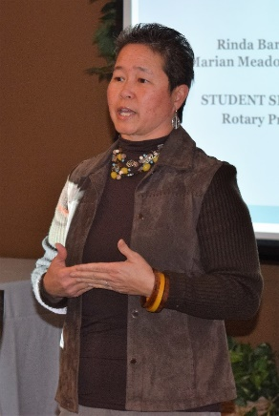
Service Above Self Part 2 – Youth to Youth (Y2Y)
Natalie Hung, the Youth to Youth Conference Coordinator, described the Youth to Youth Program. On March 4th, Castro Valley Community Awareness Network (CV CAN), the Castro Valley USD, and the San Ramon Valley USD will host an all-day conference for over 250 middle school students that helps them learn about the danger of alcohol and drugs. Approximately 75 trained high school and college students, many who participate in Y2Y as middle school students, will serve as facilitators for the day. For the past seven years, the conference has been held in the San Ramon Valley USD. Through the efforts of Natalie, the conference is returning to Castro Valley High School this year.

The Rotary Clubs of Danville and San Ramon have provided financial support for the Y2Y Conference for many years. This year, Y2Y is seeking volunteers from the Rotary Club of Castro Valley to serve dinner at the conference (5:00 – 7:00 p.m.) This event another opportunity to demonstate Service Above Self to the youth of our community. Copies of the Y2Y fliers will be emailed to all Club member as well as the opportunity to volunteer online. Volunteer sign-up sheets will be availabe at the weekly meetings throughout February. Please consider volunteering two hours of your time.

Announcements
- You still have time to make a donation to the Breathing for Life (BFL) Project. We are nearing our goal of $335,000. No donation is too big or too small. Donate online via ClubRunner. You can make a difference.
- It’s Poker Tournament time. We need players and sponsors. See the flier below and check out the Club website for more information.

