Rotary Club of Castro Valley
Meeting Highlights - January 29,2019

Ashley Strasburg, Executive Director of the Castro Valley/Eden Area Chamber of Commerce
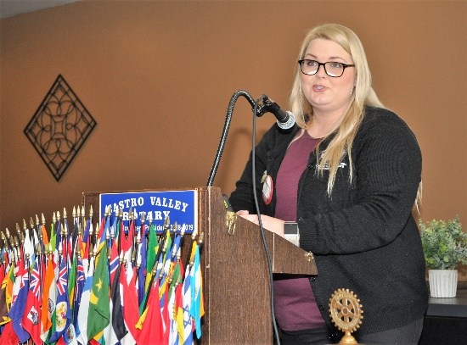
Ashley Strasburg, a member of the Rotary Club of Castro Valley, was the day’s speaker and described the work and upcoming activities for the Castro Valley/Eden Area Chamber of Commerce. The Chamber is a member-driven association of businesses and community organizations that work together for the betterment of the communities through the promotion of economic and civic health.

The mission of the chamber is to lead the communities toward sustainable economic growth, to advocate a pro-business climate for the members, to honor the historical foundations and future promise of the area, and to establish, advocate and execute the community's vision. The Chamber works to be a visible, active, and valuable part of the larger community through hosting or supporting the following events:

- Annual Castro Valley Fall Festival
- Castro Valley Street Eats
- Castro Valley Meet in the Street & Street Light Parade
- Boos & Barks Halloween Parade
- San Lorenzo Parade
- Cherryland Easter Egg Hunt
- Ashland's Cinco de Mayo Festival
- Castro Valley and Ashland Family Fest
- Business Expo of Castro Valley
- Castro Valley/Eden Area Student Citizen Awards and Business Leader Recognition Awards
- Chamber Mixers sponsored by various businesses
- Participation and supporting CV Rotary Club as a sponsor of the Chili Cook-off and Rodeo Parade
- New Business advocate and ally for businesses
- Provides information for new businesses and citizens and helps them find Local Services

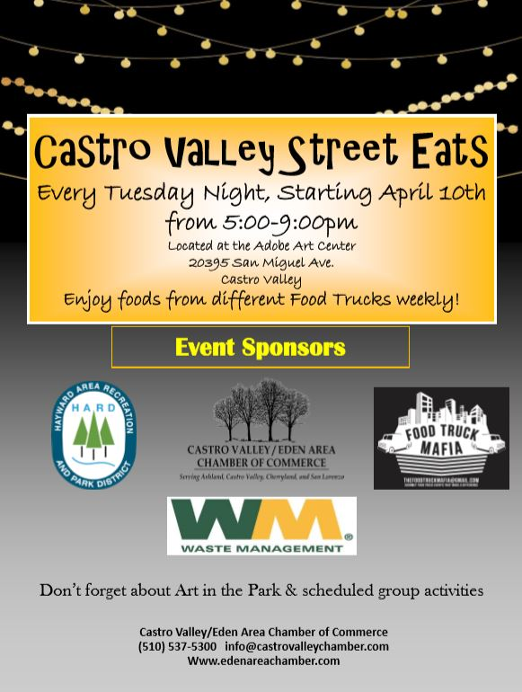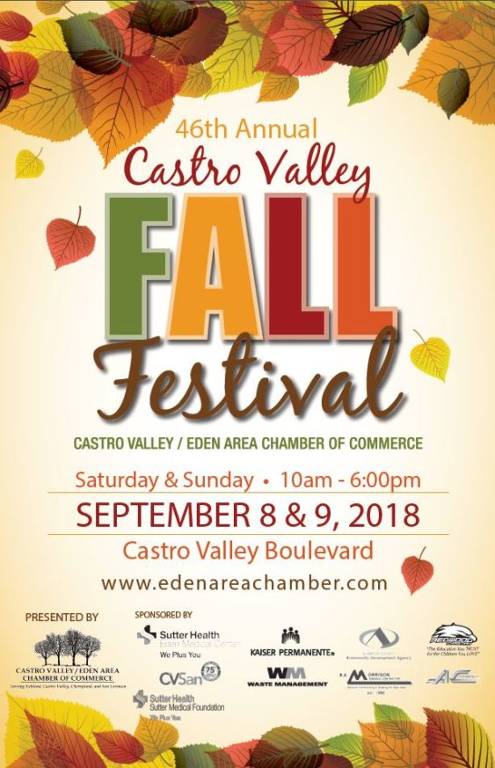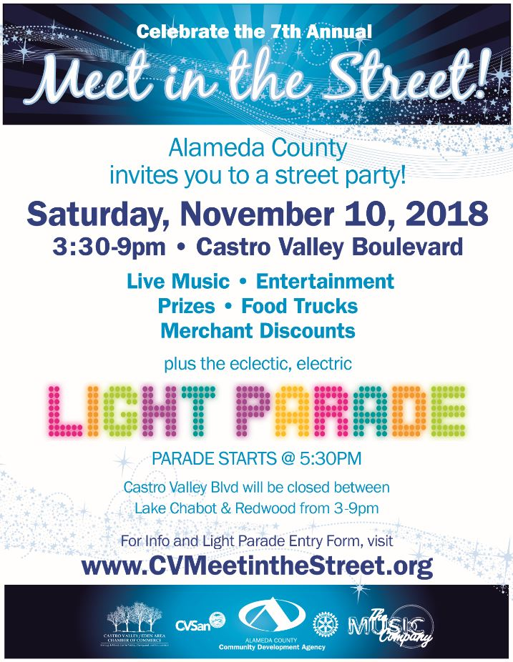
Rotarians Brian Morrison, Parvin Ahmadi, Stephen Gray, David Gehrke, and Jim Phillips current serve on the Board of Directors and over the years, many other Rotarians have served on the board.

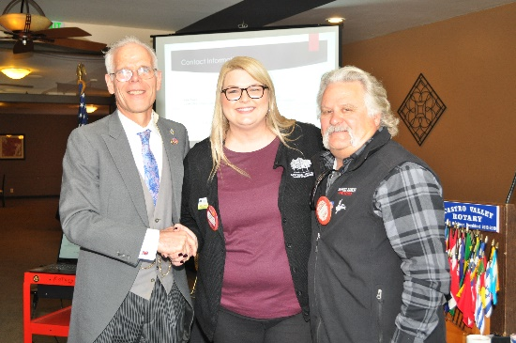

More information regarding the Castro Valley/Eden Area Chamber of Commerce and its events is available at
http://www.edenareachamber.com/

Upcoming Events – Mark Your Calendar (Check ClubRunner for details)
February 5 | Lunch meeting with Marian Meadows
February 6 | Texas Hold’em Planning Meeting @ 5:30 pm at Law Offices of Mark Poniatowski
February 12 | Annual Richard D. King Student Speech Contest at the Lunch Meeting
February 19 | Lunch Meeting with Castro Valley & Redwood Christian High School students who attended Camp RYLA
February 20 | Chili Cook-off & Rodeo Parade Planning Meeting @ 5:30 pm at Direct Sales Floors
February 26 | Lunch Meeting with Denyse McCowan, Program Director - Alameda County Ombudsman
March 9 | TEXAS HOLD’EM FUNDRAISER @ 5:00 p.m. at Our Lady of Grace Church – Stack Center

Scenes from the Meeting
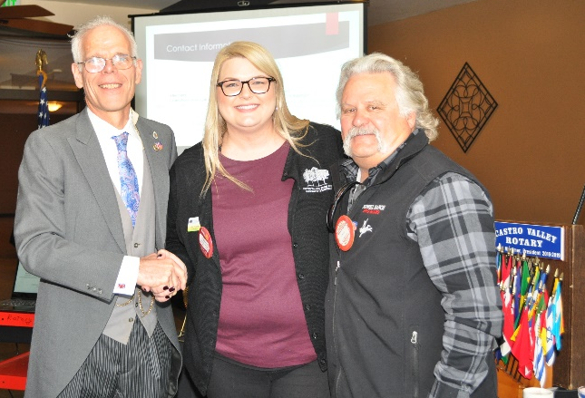

Photos by Murline Monet
Notes by Ajay Ahluwalia
Jim Negri, Editor

