Rotary Club of Castro Valley
Meeting Highlights – January 31, 2017

Andy Lopasnak - Manager of Mike's Camera – “What Was Hot and What Was Not for Christmas 2017"
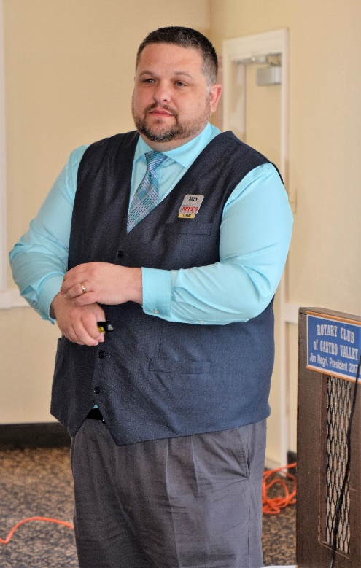
Mike's Camera is a family owned business and was originally started in 1947 in Boulder, Colorado. Currently, it has seven branches in Colorado and five branches in California including Dublin Andy Lopasnak is the manager. Mike’s Camera is full service camera store that sells and provides types of cameras and photographic equipment with a wide range of services that are valuable to the amateurs, professionals and businesses.

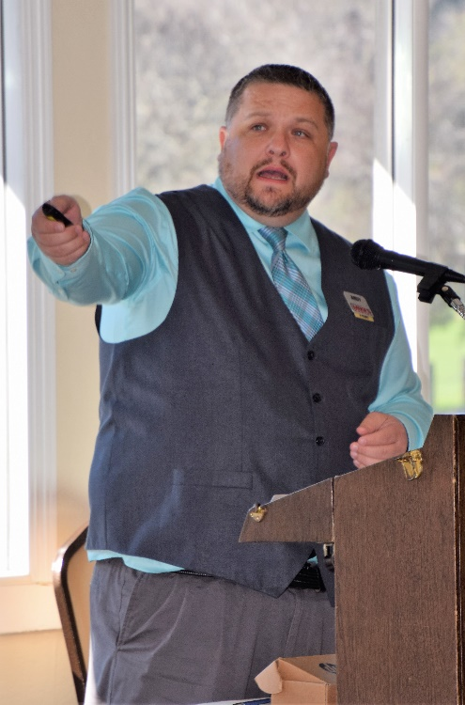
The main feature of their service is that whatever they sell they provide hands on training for using and servicing the equipment. Mike’s Cameras main emphasis is on customer service and providing advice during selection of the equipment as per the need of the customer, providing hands on instruction on the use and care of the purchased equipment, and consulting with the customer to provide satisfactory results for the customer. Mike’s does not hesitate to recommend a lower price alternative equipment or service depending on the need of the customer.

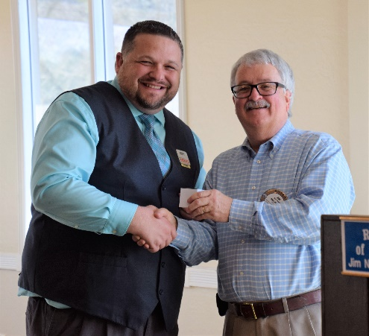
Mike’s Cameras has experienced an increasing sales and promotions for any type of business. Andy stressed that while the quality of cameras in a cell phone Cameras have improved significantly improved by increasing the number of mega pixels in the camera, the quality of a cell phone camera still does not match the quality of a good digital camera like the one President Jim was using at the meeting.

Mike’s Cameras takes great pride in their in-store service and advice by their employees. Any distributed information on the wide range of regular training classes covering all aspects of photography and photographic equipment. Services include developing, printing, and mounting photographs on appropriate surfaces/textures. They also provide assistance in professional grade pictures using unmanned flying objects (i.e., drones), and preparing professional brochures and other presentation materials. Mike’s Cameras is full service professional photographic equipment supplier and servicing company.

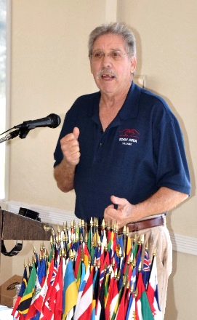
Blair Barnett – Eden Area Village
Eden Area Village (EAV) is a member-driven, non-profit organization serving older adults living in San Lorenzo, Hayward, and Castro Valley. Blair Barnett explained that Eden Area Village is an affordable alternative to living with adult children, moving to a retirement facility; safe way to receive the services we need or want with just one phone call; remain connected to family and friends and community without feeling isolated; and to be part of a larger and growing network of villages across the country, which were first formed in Boston. Eden Area Village, currently provides a peer-to-peer network with call circles, events and activities, member- to-member forum, and a call-back information line. EAV is looking for members and volunteers who are interested in helping it grow and provide more services, like technical assistance and light household tasks, for seniors in our area.
Information meetings are held first Friday of the month from 2:00-4:00 pm at Hayward City Hall. More information is available at http://edenareavillage.org/.

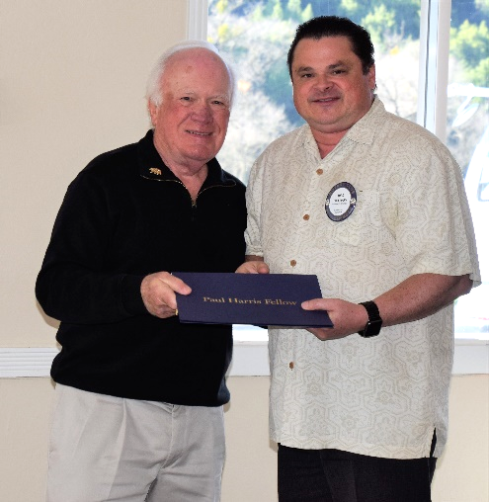
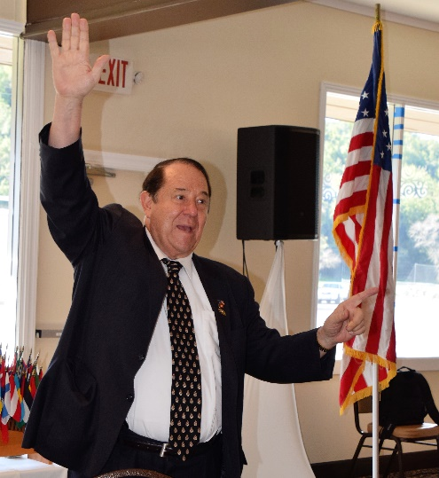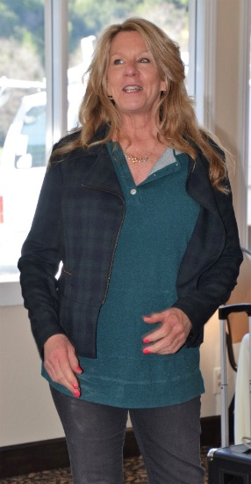
Left to Right: Dwight Perry presents our newest Paul Harris Fellow, Todd Anglin with his certificate and pin. Jerome Blaha describes the February 15th Chamber Mixer that the Rotary Club of Castro Valley is sponsoring. All members are encouraged to attend, bring a spouse/significant other, bring guests, participate in the horse race, wear a crazy hat, and have a good time. Dawn Ortiz describing plans for the Texas Hold ‘em Tournament on March 10th.
Upcoming Speakers and Events
- February 6 – Lunch Speaker – Susan Ewing Haley, Curator of the Golden Gate National Recreation Area, speaking on the history of the GGNRA
- February 6 – What’s New in Castro Valley – Ashley Strausburg, CEO of the Castro Valley/Eden Area Chamber of Commerce
- February 8 – Planning Meeting for Chili Cook-out and Rodeo Parade at Direct Sales Floors at 5:00-6:30 pm
- February 10 – Eden Awards at Redwood Canyon Golf Course – Heidi Hausauer is being honored as the Volunteer of the Year
- February 13 – Lunch Speaker - Craig Semmelmeyer, Developer - Main Street Property Services, speaking on the development of the Daughtrey's Building
- February 20 – Lunch Program – Richard King Speech Contest with students from Castro Valley and Redwood Christian High Schools
- February 27 – Lunch Speaker – Paul Wildrick, Action Coach, speaking on What Businesses Do Right and What Businesses Need to Do Right
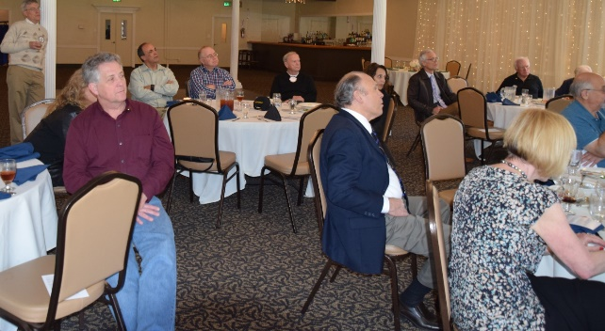

Making A Difference Starts in Castro Valley

